|  |
| --- |
|  |
| hi_1_rgbsolo |
|  |

Ground deformation induced by geothermal utilization at Reykjanes, SW-Iceland, inferred from interferometric analysis of Sentinel-1 Synthetic Aperture Radar images (InSAR)

Mylène Receveur



**Faculty of Earth Sciences**

**University of Iceland**

**2018**

Ground deformation induced by geothermal utilization at Reykjanes, SW-Iceland, inferred from interferometric analysis of Sentinel-1 Synthetic Aperture Radar images (InSAR)

Mylène Receveur

60 ECTS thesis submitted in partial fulfillment of a

*Magister Scientiarum* degree in Geology

MS Committee

Freysteinn Sigmundsson

Guðfinna Aðalgeirsdóttir

Master’s Examiner

Gudni Axelsson

Faculty of Earth Sciences

School of Engineering and Natural Sciences

University of Iceland

Reykjavik, May 2018

Ground deformation induced by geothermal utilization at Reykjanes, SW-Iceland, inferred from interferometric analysis of Sentinel-1 Synthetic Aperture Radar images (InSAR)

InSAR analysis of ground deformation at Reykjanes

60 ECTS thesis submitted in partial fulfillment of a *Magister Scientiarum* degree in Geology

Copyright ©2018 Mylène Receveur

All rights reserved

Faculty of Earth Sciences

School of Engineering and Natural Sciences

University of Iceland

Sturlugata 7

101, Reykjavik

Iceland

Telephone: 525 4000

Bibliographic information:

Mylène Receveur, 2018, Ground deformation induced by geothermal utilization at Reykjanes, SW-Iceland, inferred from interferometric analysis of Sentinel-1 Synthetic Aperture Radar images (InSAR), Master’s thesis, Faculty of Earth Sciences, University of Iceland, pp. 141.

Printing: Háskólaprent, Fálkagata 2, 107 Reykjavík

Reykjavik, Iceland, May 2018

Abstract

The Reykjanes geothermal system is a high-temperature seawater system situated at the southwestern tip of the Reykjanes Peninsula, SW-Iceland. Data from Sentinel-1A and 1B satellites have been used to evaluate ground deformation induced by geothermal utilization between April 2015 and October 2017, using Interferometric Synthetic Aperture Radar (InSAR) methods. Cumulative near-vertical and near-east displacements were inferred by stacking and combining two-year interval interferograms formed from SAR images acquired from ascending and descending orbits. Velocity maps were generated for each track from time series analysis of the displacement of coherent pixels, revealing a steady subsidence within a sub-circular bowl centered on the well field, together with horizontal contraction towards the deformation center. The average rate of change is about 16 mm/yr in the satellite line-of-sight, in the area of maximum deformation. The characteristics of the deforming source were inverted using analytical models assuming the geothermal reservoir behaves as a pressure source embedded in an elastic half space. The best fit was obtained for penny shaped and sill-like sources at about 1 km depth contracting at a rate of -0.9 × 105 m3/yr. This inferred volume change was compared to estimations of the expected amount of contraction of rock under pressure and temperature decline measured at 900 m depth in boreholes in the geothermal field. Considering the geological structure of the reservoir, it is suggested that the observed deformation results from a combination of compaction and thermal contraction caused by lack of steam recharge within a steam zone in the upper-most part of the geothermal reservoir.

Útdráttur

Jarðhitakerfið á Reykjanesi, yst á Reykjanesskaganum, er háhitakerfi með jarðhitavökva sem er sjór að uppruna. Gögn frá Sentinel-1A og 1B gervitunglunum voru notuð til að meta jarðskorpuhreyfingar á svæðinu vegna jarðhitavinnslu frá apríl 2015 til október 2017, með bylgjuvíxlmælingum á ratsjármyndum úr gervitunglundum. Heildarbreyting var metin fyrir nær-lóðréttan þátt og nær-austur þátt hreyfisviðsins út frá bylgjuvíxlmynum sem spanna tvo ár, teknar úr brautum gervitunglanna bæði þegar þau voru á norður- og suðurleið. Hraðasvið var metið fyrir hvort sjónarhorn með tímaraðagreiningu á bylgjuvíxlmyndum, í myndreitum sem höfðu góða endurkastseiginileika. Gögnin sýna hér um bil hringlaga sigsvæði þar sem stöðugt sig á sér stað, ásamt láréttri færslu í átt að sigsvæðinu. Hámarkshraði breytinga í fjarlægð frá jörð til gervitungls er um 16 mm/ári. Uppspretta aflögunarinnar var metin með reiknilíkönum þar sem gert er ráð fyrir að jarðhitageymirinn hegði sér eins og uppspretta breytilegs þrýsting í fjaðrandi hálfrúmi. Besta samræmi við mæld gögn fæst fyrir uppsprettu sem er í laginu eins og flöt ellipsóíða með lóðréttan skammás, eða í laginu eins og lárétt silla, sem liggur á um eins kílómetra dýpi og dregst saman um 0.9 ×105 m3/ári. Þessar áætluðu rúmmálsbreytingar voru bornar saman við áætlaðan samdrátt jarðlaga vegna þrýstifalls og kólnunar sem mælt var á 900 m dýpi í borholum á jarðhitasvæðinu. Stungið er upp á, með hliðsjón af jarðlagagerð jarðhitageymisins, að jarðskorpuhreyfingarnar sem mælast stafi af samþjöppun og kólnun í jarðlögum vegna skorts á endurnýjun á gufu í gufupúða efst í jarðhitageyminum.

*I want to dedicate this thesis to all the people who encouraged me throughout this intensive year, especially to Freysteinn Sigmundsson for his availability, support and for all the opportunities he offered me to present my results to research and professional communities. I also want to dedicate this final work to my family thanks to whom I could complete my studies in Iceland, to my boyfriend for giving me self-confidence, and to all of them for their essential support despite the distance.*

Preface

This thesis is divided in two main parts.

The first part consists of a general introduction including Chapters 1 to Chapter 3. Chapter 2 contains a detailed description of the Reykjanes high-temperature geothermal system, including the geological context and a summary of the previous analysis of ground subsidence induced by geothermal utilization at Reykjanes. Chapter 3 consists of a general presentation of the principle of InSAR (Interferometric synthetic Aperture Radar), of the Sentinel-1 data used and of the modeling approaches used to study deformation at Reykjanes between April 2015 and October 2017. In that Chapter, I present the analysis of two-year stacked ascending and descending interferograms initially created to determine the cumulative displacement throughout the study period. Modeling results from this first dataset are found in Supplementary Materials at the end of the thesis.

The bulk of the thesis, in Chapter 4, consists of the draft of a manuscript by Receveur, M., Sigmundsson, F., Drouin, V., Parks, M., in preparation for submission to Geophysical Journal International. The manuscript is based on time series analysis of deformation at Reykjanes for the 2015-2017 period. It presents the modeling results associated with the inversion of average velocity maps and contains a detailed discussion on the interpretation of the results (i.e. mechanisms responsible for the observed deformation). The modeling results obtained from the average velocity maps are displayed in appendices to the manuscript (Section 4.8). As Chapter 4 is prepared as an independent manuscript, it contains some repetitions of material in the general introduction. A general discussion and conclusion to the thesis is presented in Chapter 5 and 6.

All the SAR data have been downloaded from the freely accessible Copernicus Open Access Hub (ESA). The algorithms used to process, model and plot the data have been provided by the ISCE (InSAR Scientific Computing Environment) software (Rosen *et al*., 2012), GBIS (Geodetic Bayesian Inversion Software) v1.0 ©2017 Marco Bagnardi (Bagnardi & Hooper, 2017) and from scripts developed by Vincent Drouin, from the University of Iceland. The preparation and processing of data, modeling, and interpretation presented in this thesis has all been carried out by me, under guidance from others, mainly the co-authors of the manuscript in preparation. Vincent Drouin has in particular assisted with the analysis of the Sentinel InSAR data.

Mylène Receveur

April 28, 2018

Table of Contents

List of Figures xi

List of Tables xiii

Acknowledgements xv

1 Introduction 17

2 The Reykjanes geothermal system 19

2.1 Geological context 19

2.1.1 Tectonic setting 19

2.1.2 Geology of the Reykjanes geothermal system 21

2.1.3 Resistivity structure and alteration mineralogy 22

2.2 Reykjanes geothermal reservoir 24

2.2.1 Heat sources 25

2.2.2 Productive layers 25

2.2.3 Formation temperature and pressure 25

2.2.4 Reservoir fluid 27

2.3 Geothermal production 27

2.4 Seismic activity 30

2.5 Previous studies of ground deformation 31

3 Data and methods 37

3.1 InSAR Processing 37

3.1.1 Data 37

3.1.2 Time series analysis 46

3.1.3 Signal decomposition 48

3.2 Modeling Methods 52

3.2.1 Point pressure source (Mogi, 1958) 52

3.2.2 Finite spherical source (McTigue, 1987) 53

3.2.3 Rectangular plane with uniform opening (Okada, 1992) 53

3.2.4 Penny-shaped crack (Fialko *et al.,* 2001) 54

3.2.5 Mogi source at each borehole based on extraction and injection rates 54

4 Manuscript in preparation for submission to Geophysical Journal International 55

Abstract 55

4.1 Introduction 56

4.2 InSAR data and analysis 61

4.3 Geodetic modeling 66

4.4 Relationship between volume change and physical processes 73

4.4.1 Comparison with previous results and geological profile 73

4.4.2 Deformation and physical processes 76

4.4.3 Relationship between volume and pressure changes 77

4.4.4 Cooling of a horizontal layer 82

4.5 Discussion 83

4.6 Conclusion 86

4.7 Acknowledgements 86

4.8 Appendices 87

5 General discussion 101

6 General conclusion 103

References 105

Supplementary Materials 115

List of Figures

Figure 2.1. Volcanic systems of Iceland.. 19

Figure 2.2. Tectonic map of the Reykjanes Peninsula. 20

Figure 2.3. Progressive accumulation of Pleistocene hyaloclastites tuffs, sedimentary sediments, sub-aerial lavas and post-glacial Holocene lavas. 21

Figure 2.4. Reykjanes geothermal field showing the extent of the low resistivity cap. 22

Figure 2.5. NW-SE resistivity cross section 24

Figure 2.6. Steady state temperature-depth profiles 26

Figure 2.7. Pressure and temperature monitoring in wells RN-12 and RN-16. 28

Figure 2.8. Pressure and temperature measured in wells RN-27 and RN-28 29

Figure 2.9: Initial formation temperature and formation temperature in 2014-2016 29

Figure 2.10. Map and EW profile showing the location of the earthquakes at Reykjanes 30

Figure 2.11. Average subsidence rate from January 2009 to July 2013 33

Figure 2.12. Cumulative LOS displacements maps. 34

Figure 2.13. Vertical displacements from continuous GPS stations 35

Figure 2.14. Gravity changes 36

Figure 3.1. NDVI image 38

Figure 3.2. Geometry for ascending and descending polar orbits 39

Figure 3.3. Examples of geocoded interferograms from Sentinel-1A. 41

Figure 3.4. 20150813-20170614 interferogram on a Google Earth view 42

Figure 3.5. Example of coherence images 43

Figure 3.6. Stacked interferograms for Track 16 and Track 155. 44

Figure 3.7. Average LOS velocity maps for Track 16 and Track 155 45

Figure 3.8. Star graphs showing the temporal and perpendicular baselines for the Track 16 and Track 155 time series analysis. 47

Figure 3.9. Time series analysis of an averaged set of points situated in the middle of the deforming area. 48

Figure 3.10. Decomposed near-vertical and near-east maps. 49

Figure 3.11. Decomposed signal from two-years interferograms. 51

Figure 4.1. Geological maps. 57

Figure 4.2. Pressure drawdown at 925 and 1625 m b.s.l.. 60

Figure 4.3. Velocity maps showing average LOS velocities 2015-2017 63

Figure 4.4. Time series analysis of an averaged set of points in the middle of the deforming area 64

Figure 4.5. LOS velocities for ascending Track 16 and descending Track 155, near-vertical velocity and near-east horizontal velocity component. 65

Figure 4.6. Velocities (mm/yr) along a profile across the Reykjanes geothermal field. 66

Figure 4.7. Data, model and residuals for the Track 16 and Track 155 datasets for the penny shaped crack model and the horizontal square sill. 70

Figure 4.8. Histograms of samples from the posterior distributions of the model parameters 71

Figure 4.9. Near-vertical displacement velocity field together with the location of most probable square sill and the penny shaped crack models 72

Figure 4.10. Average values of the rate of best-fitting volume change for different time periods and cumulative volume change relative to 2005 73

Figure 4.11. Geological well logs along a WNW-ESE cross section in the Reykjanes geothermal system 75

Figure 4.12. Interpretative scheme for compacting layers under pressure decrease and contraction of rock by cooling. 81

List of Tables

Table 2.1. Summary of the deformation studies at Reykjanes since 2009 32

Table 3.1. Orbital parameters for Track 16 and Track 155 of Sentinel-1 40

Table 3.2. Perpendicular baseline for the two-year interferograms for Track 16 42

Table 3.3. Perpendicular baseline for the two-year interferograms for Track 155 43

Table 3.4. Positive and Negative LOS unit vectors 50

Table 4.1. Inversion results for the point pressure source, the penny shaped crack model, the finite spherical source and horizontal sills 68

Table 4.2. Comparison of the length and areal extent for the spherical source, the Penny shaped crack and the Okada sill.. 76

Table 4.3. Summary of the parameters used for the estimation of the compressibility in the liquid dominated part of the reservoir and in the steam zone 79

Table 5.1. Acquisition geometry for different satellites used in the study of ground deformation at Reykjanes since 2005 101

Acknowledgements

I first want to thanks Freysteinn Sigmundsson for his support, guidance and precious advices to conduct serenely my project, and for having supported financially my participation to several conferences (e.g. EGU Vienna, final IMAGE meeting in Akureyri, Geothermal Cross-Over Technology workshop in Utrecht). I then want to thank Vincent Drouin for having transmitted his knowledge and providing me with all the tools necessary to conduct my project. His availability, precious advices and technical expertise in analysis of Radar Interferometry data have been of great help throughout this year of research. Thanks to Daniel Juncu and Michelle Parks for their help concerning the modeling approaches and the interpretations. Thanks to Asta Rut for providing me with the structural data on Reykjanes from Clifton *et al*. (2003). Thanks to Guðfinna Aðalgeirsdóttir for her external support and encouragement and Gudni Axelsson to have accepted to be the external examiner of my Master thesis defense. Thanks to the University of Leeds and in particular to Marco Bagnardi and Andy Hooper for sharing the modeling code through the GBIS v1.0 ©2017 Marco Bagnardi software. Finally but not least, great thanks to representatives of HS-Orka and Vatnaskil, Omar Sigurdsson, Gudmundur Omar Fridleifsson, Vala Matthiasdottir, Gudjon Helgi Eggertsson, Thor Gislason, Albert Albertsson and Jean-Claude Berthet, for accepting sharing their data, their technical knowledge, for giving their time in meetings and providing feedbacks on my results.

# Introduction

The Reykjanes geothermal system is a high temperature sea-water geothermal system located at the southwestern tip of the Reykjanes Peninsula, where the Mid-Atlantic Ridge connects to Iceland. Large-scale geothermal utilization started at Reykjanes in May 2006 for electricity generation purposes with the commissioning of a 100 MWe power plant. Following the dramatic increase in extraction rate from 50 to 800 kg/s at that time, a pressure drop of 3.2-3.4 MPa was measured in the center of the well field after three years of production (Fridriksson *et al.*, 2010). This process resulted in increased boiling of the initially liquid dominated geothermal system and the development of a steam cap in the uppermost few hundred meters (about 400 m) of the reservoir, expressed by an increase in enthalpy of fluids extracted from geothermal wells and an increase in geothermal surface activity. Subsidence has also been measured in the center of the geothermal field as a result of this large-scale production, by levelling, GPS and InSAR methods (Keiding *et al.*, 2010; Michalczewska *et al.*, 2014; Parks *et al.*, in review). The highest rates (about 40 mm/yr) were observed during the initial 2-3 years of production. After 2009, the rate of subsidence inferred from interferometric analysis of synthetic aperture radar images acquired by satellites (InSAR), decreased down to about 20 mm/yr, accompanied by a modification of the deformation pattern and a migration of the modeled deformation source toward shallower depth (Parks *et al.*, in review).

InSAR is a satellite imaging technique used to detect large scale deformation of the Earth’s surface (e.g. Falorni *et al.,* 2011). Initially used to study deformation caused by earthquakes and magma movements in volcanoes, this technique has now proved its ability to monitor various deformation processes, including changes within geothermal systems under production. In April 2014 and April 2016, two radar satellites, Sentinel-1A and Sentinel-1B, were launched by the European Space Agency, providing new opportunities to study ground deformation over large areas and with a high temporal resolution, due to a satellite revisit time every 12 days since 2014 and every 6 days since 2016.

This project aimed to extend the time series of ground deformation over the Reykjanes geothermal system for the period 2015-2017, using the data from the Sentinel-1 mission, in order to increase the understanding of processes taking place in the geothermal reservoir and their influence on the observed surface deformation. We first generated two-year interferograms to determine the cumulative displacement over the geothermal field for the whole study period. Then, we generated ascending and descending time series allowing a visualization of the temporal evolution of the deformation in the line-of-sight (LOS) direction towards the satellites. From this time series, we created average velocity maps over the geothermal field. The cumulative displacement and velocity maps were then used as input data to invert for the parameters of deformation sources at depth. Four different types of analytical sources were considered, representing the geothermal reservoir as a body of simple geometry, contracting or dilating in a homogeneous and isotropic elastic half-space under pressure change. In these models, a volume change at depth is related to predicted surface deformation through a set of equations dependent on the source and host rock properties.

In parallel, we estimated the expected amount of contraction of a rock volume under changes in pressure and temperature observed at 900 and 1600 m depth in boreholes in the geothermal field, considering simple poro-elastic and thermo-elastic models. The inferred volume change from the geodetic observations was compared to potential processes taking place in the geothermal reservoir, taking into account the geological structure of the system. This comparison allows increased understanding the poro-elastic and thermo-elastic processes responsible for deformation during the 2015-2017 period.

# The Reykjanes geothermal system

## Geological context

### Tectonic setting

The Reykjanes Peninsula Oblique Rift is situated in south-west Iceland and represents the onshore continuation of the Mid-Atlantic Ridge (Fig. 2.1). It consists of a N°70E striking oblique rifting plate boundary connecting toward the west to the Reykjanes Ridge. The eastern boundary of the rift is at the Hengill Triple junction, where it meets the South Iceland Seismic Zone (SISZ) and the Western Volcanic Zone (Arnadottir *et al.*, 2008; Sigmundsson *et al*., in review).

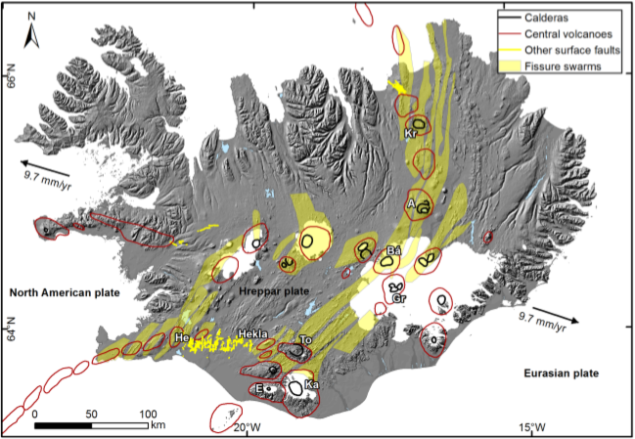

**Figure 2.1**. Volcanic systems of Iceland. Names of selected systems are indicated: Kr=Krafla, A=Askja, Bá=Bárðarbunga, Gr=Grímsvötn, E=Eyjafjallajökull, Ka=Katla, He=Hengill, To=Torfajökull, and Hekla. Central volcanoes are from Einarsson & Sæmundsson (1987), fissure swarms are from Hjartardóttir et al. (2016) and Einarsson & Sæmundsson (1987). Calderas are from Einarsson & Sæmundsson (1987), Gudmundsson & Högnadottir (2007) and Magnússon et al. (2012). Active faults and fractures in the South Iceland Seismic zone are from Einarsson (2010) and the Husavík-Flatey fault zone in North-Iceland from Hjartardóttir (2016) In: Sigmundsson et al. (in review).

Highly oblique rifting on the Reykjanes Peninsula accommodates the spreading of the European and North American plates, at a rate of about 1.8 cm/yr in direction approximately N104°E. The most common set of fractures consists of NE-SW extensional normal faults (Fig. 2.2), associated with open fractures and eruptive fissures formed perpendicularly to the direction of maximal horizontal extension striking N120-130°E (Clifton & Schlische, 2003; Keiding *et al*., 2008). Additional north-south oriented right-lateral strike-slip faults, consisting on the surface of a series of right-stepping *en échelon* fractures, represent the surface expression of the left-lateral E-W oriented shear zone at depth, inferred from geodetic measurements between 1986 and 1998 (Sturkell *et al.*, 1994; Hreinsdottir *et al*., 2001; Vadon & Sigmundsson, 1997). These structures are found in a narrow zone in the center of the rift, mainly accommodating the transform movement during periods of no magmatic activity (Einarsson, 1991; Clifton & Schlische, 2003).

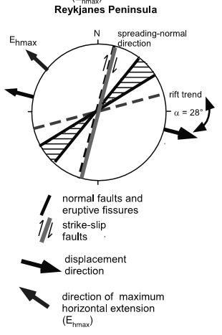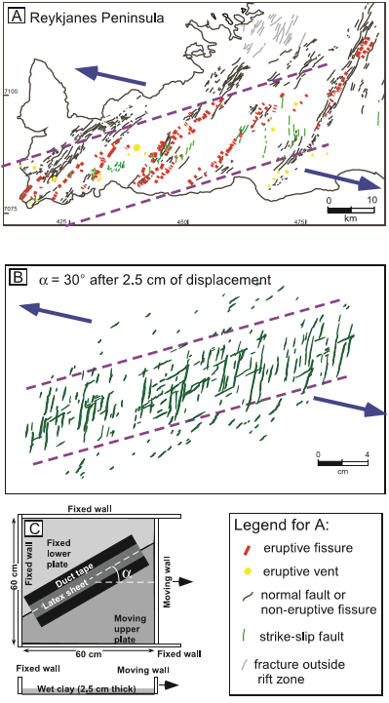

**Figure 2.2.** Tectonic map of the Reykjanes Peninsula. Purple dashed lines mark the zone of active volcanism along the rift trending N°70E. Arrows show the direction of plate motion, striking about 30° from the rift trend. Grid in UTM, Lambert Projection (Data from Saemundsson & Einarsson, 1980 In: Clifton & Schlische, 2003).

Two main earthquake swarms occurred in the Reykjanes Peninsula in the early 20th Century, during the 1929-1935 and 1967-1973 swarm episodes, mostly associated with strike-slip and normal faulting (Klein *et al.*, 1977). During the 1972 earthquake swarm, the hypocenter of most of the earthquakes was located between 2 and 5 km depth, concentrated along a 12 km long and 2 km wide ENE seismic zone (Klein *et al*., 1977). This maximum depth coincides with the depth to the brittle-ductile boundary of about 5.5-6 km suggested by Friðleifsson *et al.* (2003), above which 90 % of the seismicity occurs.

The extensive faulting has resulted in the formation of clusters of closely spaced normal faults and extension fractures, grouping into fissure swarms (e.g., Saemundsson, 1979; Einarsson, 2010). When magma is available, the crustal deformation along the active plate boundary can be accompanied by eruptions along these fissure swarms, generally forming arrays of monogenetic crater rows (Sigmundsson *et al*., in review) or dyke intrusions (Hreinsdóttir *et al*., 2001).

The divergent plate boundary in Iceland is divided up into volcanic systems, typically consisting of central volcano (some with caldera) and an intersecting fissure swarm (Fig. 2.1). On the Reykjanes Peninsula, the definition of central volcanoes is not particularly clear. Four distinct volcanic systems with their own magma supply were there identified by Saemundsson (1979), and shown in Fig. 2.1. The westernmost of these is the Reykjanes volcanic system. However, other studies suggest volcanic activity in this area is better described as taking place in two volcanic systems, the proper Reykjanes system at the very tip of the Reykjanes Peninsula where the Reykjanes geothermal area is, and the Svartsengi system with center at the Svartsengi geothermal area where the Blue lagoon is located.

High-temperature geothermal systems on the Reykjanes Peninsula are therefore situated where the active fissure swarms intersect the central axis of the plate boundary, where seismicity is the highest (Arnorsson, 1985). The release of stresses during strike-slip earthquakes or diking events results in the reactivation of fractures, enhancing the permeability in the geothermal systems (Einarsson, 2008; Keiding *et al*., 2009). These fractures represent a preferential permeable path for steam up-flow to the surface forming alignments of fumaroles and controlling the surface alteration within the geothermal fields.

### Geology of the Reykjanes geothermal system

The Reykjanes geothermal system can be described as a highly fractured superimposition of volcano-sedimentary strata (Fig. 2.3) typical of a submarine environment, intersected by a few crystalline sub-aerial Pleistocene lava flows at 600 and 1200 m depth (Friðleifsson *et al.*, 2014). Between 1200 and 3000 m depth, the sequence is dominated by pillow basalts formed in deep marine environment. As the volcanic units progressively built-up to shallower depth during the Pleistocene, the mode of eruption became more explosive, forming phreato-magmatic tuffs, hyaloclastite and breccias (Sigurdsson, 2010). This sequence of shallow water lithology is principally found between 400 and 1200 m depth. It is locally intersected between 400 and 800 m depth by thin interbeds of shallow marine fossiliferous and reworked sediments (Friðleifsson & Richter*.*, 2010) dated to be of Late Weichselian/Early Holocene age (19 000-9 000 years old). At the top of the succession, sub-glacially erupted hyaloclastites form hyaloclastite cones (i.e. Sýrfell) poking through a series of Holocene post-glacial/sub-aerial basaltic lava fields that covers on surface most of the faults situated in the rift zone at Reykjanes (Bjornsson *et al.*, 1970; Franzson *et al.*, 2002). At least four post-glacial fissure eruptions took place during the Holocene. This includes the lavas from the 1226 AD Stampar eruption, covering a 12,500 years old picrite lava shield emitted from the Sandfellshæð fissure eruption (Franzson, 2004).

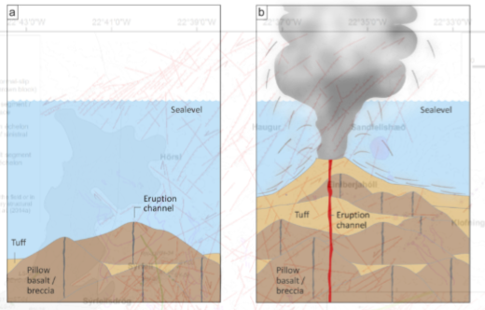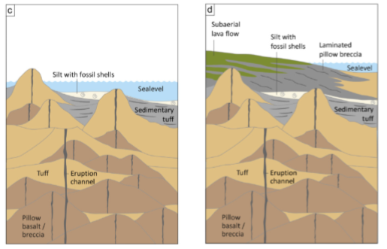

**Figure 2.3.** Progressive accumulation of Pleistocene hyaloclastites tuffs, sedimentary sediments, sub-aerial lavas and post-glacial Holocene lavas over a paleo-environement characterised by pillow lava and breccia in the Reykjanes geothermal system, based on drill cuttings down to 2.8 km (modified from Franzson, 2004, In: Khodayar et al., 2016).

Sequences of 100 to 200 m thick dyke or sill intrusions can be found below 1.5 km depth in the center of the well field and at greater depth on the periphery, alternating with dyke-free pillow basalt and breccia intervals. The number of intrusions increases with depth until dominating the series at 2.8-3 km depth (Franzson, 2004), where they are likely to form a sheeted dyke complex (Friðleifsson *et al.* 2014).

### Resistivity structure and alteration mineralogy

The Reykjanes geothermal system (Fig. 2.4) is characterized by high degree of fracturing that has resulted in intense rock-water interactions responsible for the alteration of the rock. High-temperature hydrothermal alteration mineral assemblages associated with the greenschist facies can indeed be found from shallow depth together with secondary mineralization (Franzson *et al.*, 2002; Fridleifsson & Elders, 2005). Higher grades of metamorphism were found below 2400 m in well RN-17 associated with a high-temperature amphibole zone (Marks *et al.,* 2010).

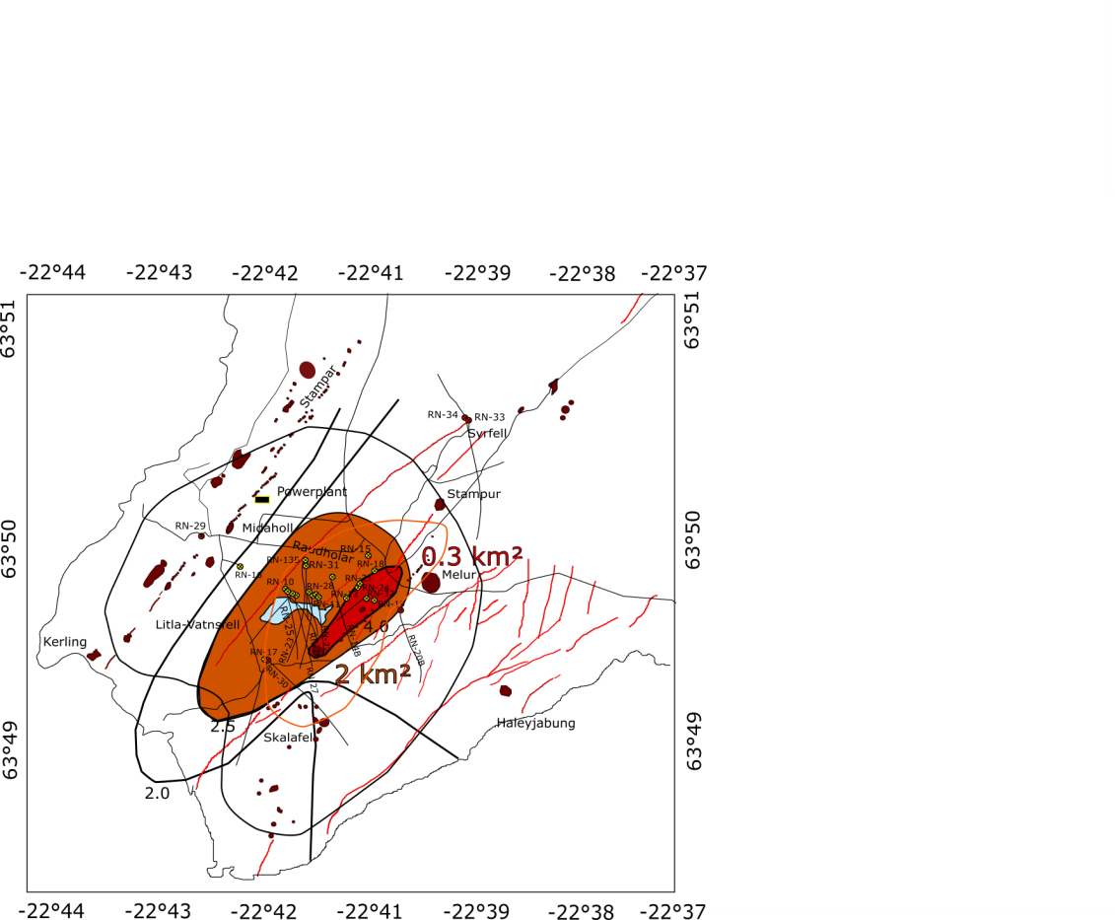

**Figure 2.4**. Reykjanes geothermal field showing the extent of the 8-10 km² low resistivity cap (gray outline) at a depth of 800-1000 m (Friðleifsson et al., 2011) defined by Transient Electro-Magnetics (TEM) surveys and the pressure drawdown isolines in MPa as black open curves (Khodayar et al., 2016). The orange and red areas indicates the areas in the central part of the reservoir affected in 2015 by a total pressure drawdown of about 2.5 and 4 MPa, respectively. The inferred main upflow zone is shown as an orange line (Karlsdottir, 2005). Faults and fractures are shown as red lines (Clifton and Schlische., 2003). The red/yellow circles linked to thin black lines indicate the production/injection wells and their trajectory at depth. The NW-SE oriented thick black line indicates the location of the temperature profile in Fig. 2.9. Modified from Libbey et al. (2016).

Smectite-zeolite facies mineralogy occurs in some wells from the surface down to the epidote zone. Zeolites commonly disappear at about 400 m depth while smectite is progressively replaced by chlorite, forming a smectite-chlorite mixed-layered clay (MLC) and epidote zone associated with quartz, calcite, pyrite, prehnite and anhydrite precipitations between 300 and 500 m depth (Marks *et al*., 2010). Here, chlorite becomes the main alteration mineral. The chlorite-epidote zone, then dominant until 1200 m depth is followed by the epidote-actinolite zone down to 2-2.5 km (Fridleifsson & Elders, 2005) and finally by the amphibole zone below 3 km depth (Friðleifsson *et al*., 2017). Marine sedimentary sequences found at 390-472 m and 550-800 m depth are affected by the chlorite-smectite-MLC and illite secondary mineral assemblage, respectively (Marks *et al.*, 2010). The alteration of these tuffaceous and sedimentary successions and their cementation by secondary quartz, calcite and anhydrite has reduced the permeability of these layers, effectively transforming them into an impermeable cap rock of the geothermal system (Friðleifsson *et al.*, 2011).

ISOR-Iceland GeoSurvey has carried out surface resistivity soundings (Schlumberger, TEM, MT) in the Reykjanes area for many years, revealing the existence of a resistivity structure typical of high temperature geothermal systems in Iceland (Friðleifsson *et al.*, 2014). This structure consists of a low resistivity cap centered on the fumarole field underlain by a high resistivity core (Friðleifsson *et al*., 2011). The low resistivity cap (<10 Ωm), interpreted as a 8-10 km² up-domed area elongated in the ENE direction at 800-1000 m depth (Fig. 2.4), was associated with conductive minerals in the smectite-zeolite zone (alteration temperature of about 200-220°C). The high-resistivity core (10-30 Ωm) generally reflects the reduced pore-fluid conduction associated the more resistive chloride-epidote minerals, associated with an alteration temperature of about 230-250°C. At Reykjanes, this high resistivity core reaches the shallowest level at the Gunnuhver hot spring at about 100-200 m b.s.l. However, drill cuttings indicate that smectite may exist at temperatures up to 280-290°C along with chlorite, suggesting that the low to high resistivity transition in sea-water system is not as sharp as in geothermal system with fluid of meteoric origin (Sigurdsson, 2010). Surfacing resistivity also indicated the existence of a main up-flow zone in the central part of the field, controlled by the deep permeable NE-SW eruptive fissures and intersected by up-flows along the N-S trending faults (Karlsdóttir, 2005). In addition, Karlsdóttir *et al.* (2012) developed a 3D inversion model of more recent magneto-telluric data (Fig. 2.5) that indicated the existence of a zone of lower resistivity (< 50 Ωm) prominent below 3 km depth, within a surrounding of higher resistivity (> 70 Ωm). This feature was interpreted as a zone of higher permeability and/or temperature indicating a hot convective up-flow zone, targeted by the second Icelandic Deep Drilling well, IDDP-2 (Friðleifsson *et al*., 2014).

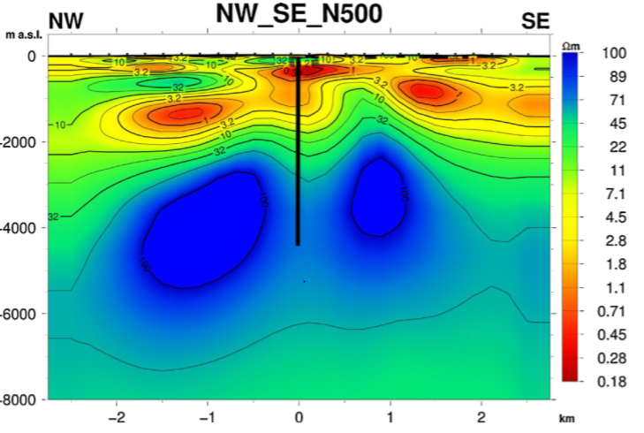

**Figure 2.5.** NW-SE resistivity cross section down to 8 km depth extracted from 3D resistivity model from Karlsdottir et al. (2012). The black line represents the planned location and depth for IDDP-2, down to 5 km depth (Friðleifsson et al., 2014)

In spite of the apparent good correlation between the alteration mineralogy, the resistivity models and the initial formation temperature (Franzson, 2004; Friðleifsson *et* *al.,* in review) suggested that the alteration mineral assemblage of the reservoir rocks is not in equilibrium with the fluid at present pressure/temperature conditions, due to a complex history of dyke intrusions and changing hydrothermal conditions.

## Reykjanes geothermal reservoir

Tectonic studies suggest that the Reykjanes geothermal system is located in a NE/ENE graben structure controlled by the Litla-Vatnsfell and the Skálafell faults (Fig. 2.4). The primary up-flow zone is controlled by the intersection between the NE-SW trending zone of normal faults and a shorter N-S fracture, centered on wells RN-12, RN-21 and on the Gunnuhver thermal area (Sigurdsson, 2010). The highest temperatures below 1 km (up to 20°C higher than anywhere else in the reservoir at the same depth) were however measured in well RN-10 situated 600 m to the west of RN-12, reaching a maximum of 320°C (Franzson *et al*., 2002). On the surface, the central part of the system was delineated based on the extent of a zone of intense geothermal manifestations and surface alteration, associated with the inferred main up-flow zone from the reservoir where permeability and temperature are the highest (Sigurdsson, 2010). Together with heat flux measurements and resistivity analysis, a circular areal extent of about 1.5 – 2 km² was defined. Considering an average extent of 2 km² and assuming an average productive thickness of 1.5 km, Axelsson *et al.* (2015) estimated a minimal volume for the central part of the reservoir on the order of 3 km3 (Fig. 2.4). Khodayar *et al* (2016) however suggested that the total size of the system is actually larger than the volume of the productive reservoir, in accordance with the 19 km3 inferred by a deformation study at Reykjanes by Keiding *et al.* (2010).

### Heat sources

The source of heat for the Reykjanes geothermal system is attributed to the successive cooling of magmatic intrusions within the volcano-sedimentary sequence. The density of these intrusions increases at the base of the sequence, forming below 2.8 km depth a sheeted dyke complex (Friðleifsson *et al.* 2014, 2017). These intrusions, together with the fissure eruptions, are associated with the early stage of rifting due to the extension of the Mid-Atlantic Ridge, without indications of the existence of a magma chamber (Sigurdsson, 2010).

### Productive layers

The main feed zones in the Reykjanes reservoir are situated within porous formations between 800-1200 m depth, initially at boiling but now within the steam cap, and at 1900-2300 m depth (Friðleifsson *et al*., 2014). Below 1200 m, the system is liquid-dominated. Most of the feed zones are associated with fracture permeability irregularly distributed throughout the succession and only a few of them are contained within rocks that have conserved their high primary porosity. The largest aquifers below 1000 m depth are related to the sub-vertical fractures directly along or near the dykes that dissect the well (Franzson *et al.*, 2002).

### Formation temperature and pressure

Temperature profiles (Fig. 2.6) interpreted from several measurements in production wells in the center of the well field (Ó. Sigurðsson, HS-Orka, personal communication) indicate the prevailing temperatures at the beginning of the production in 2006. They suggest that the Reykjanes system is initially liquid dominated below 1-1.3 km depth. In the main up-flow zone, the temperatures follow an adiabatic gradient from 270-290°C up to 320°C, representing a zone of fluid convection.

Below the cap rock situated between 400-500 and 700-800 m depth, and down to 1-1.3 km depth, the formation temperature and pressure follow the boiling point curve (Franzson *et al*., 2002). The occurrence of boiling conditions at 1000-1100 m depth before 2006 was already suggested by the presence of calcite in abundance near the aquifers situated within this depth interval in well RN-10 (Franzson *et al.,* 2002). Such conditions might have been reached intermittently as a result of temporary pressure drops caused by earthquakes, resulting in the ascension of steam carrying heat through the system, sometimes up to the surface. Since May 2006, boiling conditions in the reservoir have been largely enhanced as a result of geothermal production and pressure decline. Part of the steam formed managed to reach the surface through fissures, increasing by 50% the steam flow within the fumarole field. This increase in surface activity was also accompanied by an expansion of the thermal anomaly toward the south-east and a rise in degassing of CO2 by 40% between 2004 and 2007 (Fridriksson, 2010).

Before the drilling of IDDP-2, the highest temperature of about 345°C was measured at 2.8 km depth in RN-17B and below a true vertical depth (TVD) of 2.2 km in well RN-30 (Friðleifsson *et al*., 2011).

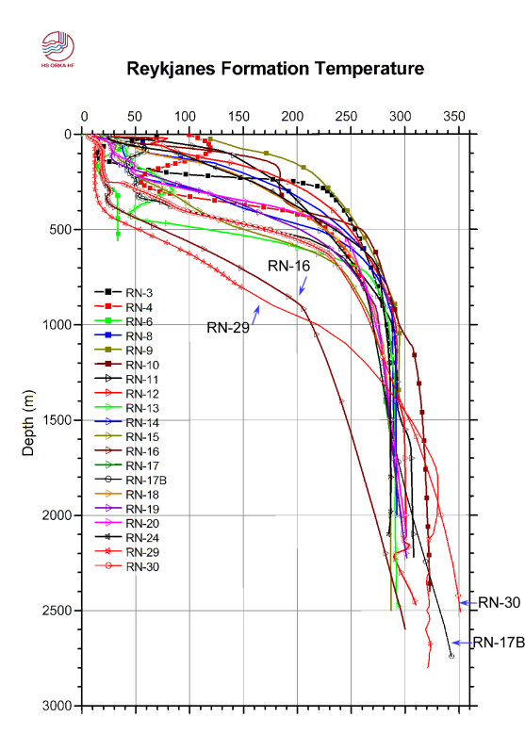

**Figure 2.6.** Interpreted formation temperature-depth profiles for most of the wells currently situated within the produced up-flow zone of the Reykjanes high-temperature system (Friðleifsson et al., in review). This formation temperature indicates the initial reservoir temperature (Ó. Sigurðsson, HS-Orka, personal communication, 2018). The location of the wells is shown in Fig. 2.4.

Outside the main up-flow zone, the geothermal gradient and the heat transfer are mainly conductive. Wells RN-16 and RN-19 (Fig. 2.6), located west of the main up-flow zone, indeed indicate conductive heat transfer from 400-500 m depth (initial depth to the water table) to about 1 and 1.5 km depth, respectively. Below, RN-16 still has a conductive profile with however a lower thermal gradient, while RN-19 displays a convective profile. In the deviated wells RN-17B and RN-30, the lowermost one km of the wells trajectories extends towards the south and southeast outside the main up-flow zone. This explains the linear conductive gradient at the base of the temperature profiles (Friðleifsson *et al.*, 2017).

### Reservoir fluid

The Reykjanes geothermal system has the special feature of being directly recharged by saline sea-water, which infiltrates the porous rock from the southwest, channeled by the NE-SW oriented graben structure (Sigurdsson, 2010). Fluid inclusion analyses do however suggest that the system was fed by meteoric and glacial melt waters during the last ice age (Franzson, 2004). Fluid composition today results from a combination of processes including the mixing of sea and meteoric waters, basalt dissolution, secondary mineral precipitations and the possible addition of magmatic gases (Arnórsson, 1978). Since 2006, slight changes in the fluid composition have moreover been observed, explained both by the decline in pressure in the system due to production and by the reinjection into the system of a less saline mixture of separated brine and condensate (Oskarsson *et al.*, 2015).

## Geothermal production

The first well was drilled at Reykjanes in 1956. After several decades of small scale utilization for fish farming and industrial purpose through nine relatively shallow wells (less than 1 km depth), the exploration of the system started again in 1999 with the drilling of RN-10. Until 2006, 16 wells of about 2-2.8 km depth were drilled. The 100 MWe Reykjanes geothermal power plant began operation in May 2006 for electricity generation purpose by the mean of two 50 MWe single-flash steam condenser turbines (Ravazdezh, 2015). Since then, 10 additional wells have been drilled (RN-26 in 2007 to RN-35 in 2017) and some of the old wells have been shut down, re-drilled into deviated wells (RN-13b, RN-14b, RN-17b, RN-20b) or converted into re-injection wells. In January 2017, IDDP-2 reached its supercritical target at 4.5 km depth from deepening of the well RN-15. This project gives new opportunity to explore an accessible seawater system, representing a chemical analogue to the roots of a mid-ocean ridge hydrothermal system (Friðleifsson *et al.*, 2017).

With the commissioning of the power plant, the production rate at Reykjanes increased from 50 kg/s to about 800 kg/s, causing significant pressure drop in the reservoir. After three years following the start of the production at Reykjanes, a drawdown of about 3.2-3.4 MPa was measured at 1600 m depth in well RN-12 (Fig. 2.7a), situated in the central part of the system (Sigurdsson, 2010). As pressure decreases in a high-temperature liquid dominated geothermal system, boiling conditions can be reached, leading to the formation of two-phase zones. Depending on the vertical permeability and the extent of these boiling conditions, water and steam can be segregated into a vapor-dominated zone, forming a *steam cap* in the upper part of the reservoir, and into a liquid-dominated zone in the lower part of the reservoir (Grant & Bixley, 2011). At Reykjanes, this process has resulted in the expansion of a pre-existing boiling zone and the development of a steam cap between 800 and 1100-1200 m depth in the center of the field, below the irregular cap rock consisting of altered hyaloclastite and marine sediments (Friðleifsson *et al.*, 2014). Below the steam zone, the Reykjanes system is liquid dominated and a slight increase in temperature from 270-290°C to 280-290°C (Fig. 2.7b) has been measured within the main production area between 2006 and 2009 (Fridriksson *et al.,* 2010).

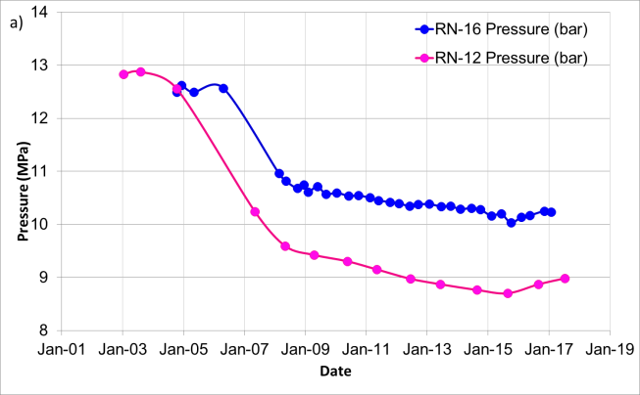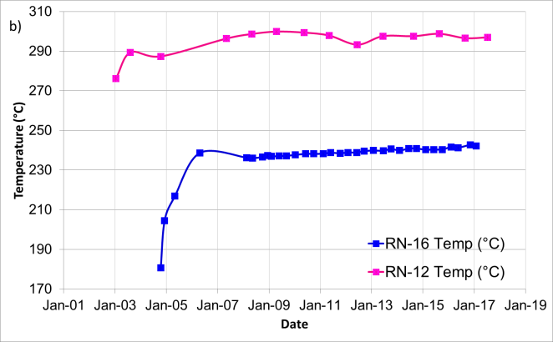

**Figure 2.7.** Pressure and temperature monitoring in the production well RN-12 situated in the center of the well field and the observation well RN-16 situated at the periphery, at 1600 m b.g.l (Parks et al., in review).

In 2008, two relatively shallow wells, RN-27 and RN-28, were drilled down to 1225 and 960 m depth, respectively, to produce steam directly from the steam cap. Discharge tests indicated that these wells were very productive, yielding more than 30 kg/s of dry steam at a wellhead pressure of 4.5 MPa (Fridriksson *et al*., 2010). After separation at an inlet pressure of 1.8 MPa and a temperature of 210°C, the saturated steam had an enthalpy of 2700 kJ/kg (Ravazdezh, 2015). The contribution of many other deep wells in the extraction of high enthalpy steam (RN-13b, RN-18, RN-19, RN-21, RN-22, RN-23, RN-24, RN-25, RN-27, RN-28, and wells RN-31 and RN-32 after 2010) led to the increase of the average well discharged enthalpy from 1290 kJ/kg in 2006 to 1450-1950 kJ/kg in 2010 (Fridriksson *et al*., 2010). It also contributed to the decrease in the mass production rate from 800 to 500 kg/s between 2007 and 2015. Reinjection of 160°C separated geothermal brine was moreover initiated in July 2009 at 2500 m depth into well RN-20b to counterbalance the pressure drop (Flovenz *et al.*, 2015). It was intermittently supplemented by injection into wells RN-33, RN-34, RN-29 and RN-30 in 2013, 2015 and 2016 accompanied by tracer tests (Khodayar *et al.*, 2016). In the period from 2009 to 2015, pressure at 1625 m b.s.l. decreased linearly by 0.1 MPa/yr in the center and 0.07 MPa/yr at the periphery of the system (Fig. 2.7a). This is inferred to be due to the combination of the decrease in the mass production rate and also the increase in reinjection. In 2015, the maximum cumulative pressure drawdown measured at 1625 m b.s.l was about 3.8 MPa. Since then, a minor increase in pressure has been measured at that depth.

Additional observations have been made in the steam zone, where pressure and temperature changes are controlled by boiling and condensation processes. Measurements at 925 m b.s.l, performed since the end of 2008 in the two shallow wells RN-27 and RN-28 (Fig. 2.8a), do indicate a continuous decline in pressure at a rate up to 0.2 MPa/yr (Guðmundsdóttir, 2016), resulting in 2017 in an additional pressure drawdown of about 1.7 MPa in the upper part of the system. This is accompanied by a cooling at an average rate of 4-5°C/yr (Fig. 2.8b). Temperature models produced by ISOR (Fig. 2.9) indicate that these cooling trends occur in the upper part of the system, between 600 and 1200 m (Khodayar *et al*., 2016).

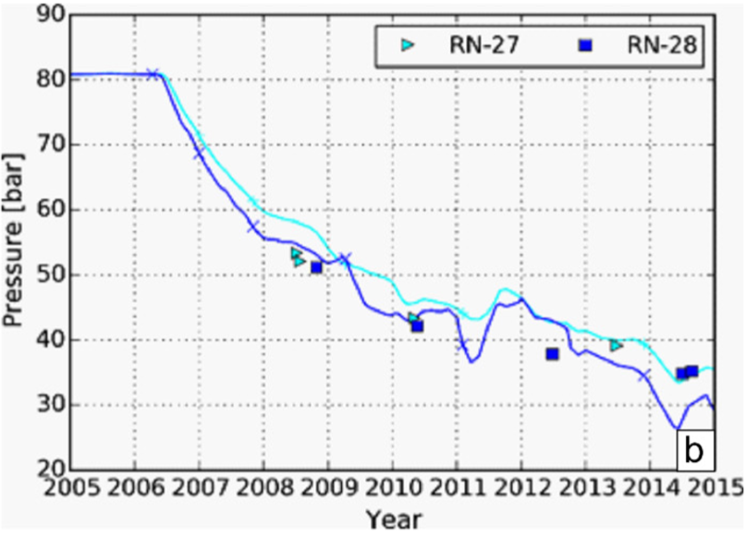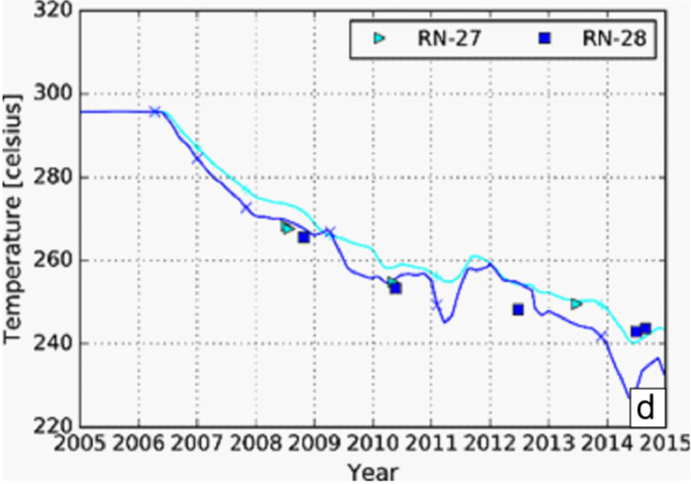

**Figure 2.8.** Pressure (left) and temperature (right) measured in wells RN-27 (light blue markers) and RN-28 (dark blue markers) at 925 m b.s.l. The line indicates the modeled pressure and temperature, respectively. These results are from Berthet & Arnaldsson (2016), based on data from Guðmundsdóttir (2016) In: Khodayar et al. (2016).

**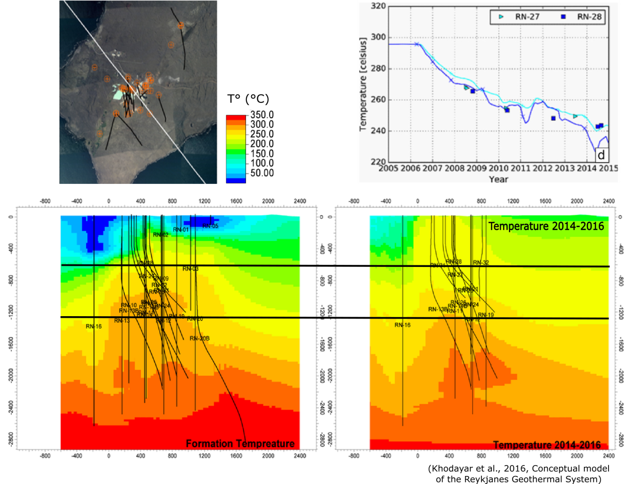**

**Figure 2.9.** Initial formation temperature (left) and formation temperature in 2014-2016 (right) modeled from well data analysis along a NW-SE cross section displayed in Fig. 2.4 (Khodayar et al., 2016). The black horizontal lines indicate the cooling zone.

Between 2006 and 2016, a total of 242 Mtons of fluid have been extracted from the geothermal reservoir (Þorvaldsson & Arnaldsson, 2017). In 2016, 17 wells were extracting the steam-water mixture at an average rate of 425 kg/s corresponding to a total mass of fluid extracted of about 13.5 Mtons at a wellhead pressure of 2.2 – 4 MPa. In addition to the increase in reinjection rate from 15 kg/s in 2009 to 146 kg/s in 2016, a slow but steady decrease in the discharge enthalpy of the deep producing wells was measured, from about 1450-1950 kJ/kg in 2010 to 1270-1600 kJ/kg in 2016 (Weisenberger *et al.,* 2016). Some of the wells producing steam from the shallow feed zones above 1200 m depth became wet in July 2016. To avoid further decline of the steam zone, reinjection was stopped in February 2017 (Ó. Sigurðsson, HS-Orka, personal communication, 2018).

## Seismic activity

The seismic activity within the Reykjanes geothermal field is characterized by a few small and scattered earthquakes (Guðnason & Flovenz, 2014). Between January 2013 and November 2015, about 3170 earthquakes have been located in the area extending from Reykjanes to Svartsengi, by a local network composed of 7 stations operated by ISOR (Guðnason *et al.*, 2015b). Most of the events occurred in natural swarms, where a maximum amplitude of 4.7 was recorded in October 2013 south-east of the Reykjanes well field (Flovenz *et al.*, 2015). The earthquakes occurring below the production area were triggered at reservoir depth with an average magnitude $M_{L}<2$ (Fig. 2.10a). There, an up-doming in the top of the earthquake distribution was observed, reaching a depth of 800 m below the well field and deepening down to 2 km on the periphery. This doming appears to coincide with the contact between the shallow softer volcano-sedimentary series and the deep harder basaltic pillow lava/intrusion succession (Khodayar *et al*., 2016).

|  |  |  |
| --- | --- | --- |
| a) |  | b) |

**Figure 2.10.** Map and EW depth profile showing the location of the earthquakes at Reykjanes a) from January 2013 to November 2015 (Figure from Guðnason et al., 2015a) and b) during the IDDP-2 drilling from September 2016 to January 2017 (Figure from Friðleifsson et al., in review). The events are coloured according to their time of occurrence and sized according to magnitude. In a), ISOR seismic stations are shown in black triangles and SIL seismic stations operated by the Icelandic Meteorological Office with purple triangles. During 2013-2015, the stimulated wells RN-20b and RN-34 are marked with pink triangles and the path of well RN-34 is shown with a black line on the EW depth profile. Seismic activity in 2015 is related to reinjection in RN-34 (red circular patch in the northernmost area) and contemporary to reinjection in RN-20b in the north of an aseismic zone centered on the well field. In b), the IDDP-2 wellhead is shown with a yellow cross, seismic stations with green triangles and a SIL seismic station with a blue triangle. In the W-E depth profile, the trajectory of the IDDP-2 well is shown with a black line.

Minor earthquakes were also attributed to reinjection in wells RN-20b, RN-33 and RN-34. About 260 earthquakes have indeed been located approximately where the injected fluid escapes the borehole during the injection of 50 kg/s of fluid in RN-34 (Khodayar *et al.*, 2016). This well is located within the 1972 seismic belt in the northern boundary of the reservoir, where no production has disturbed the pressure conditions and where the rock is weaker (Khodayar *et al*., 2016). In contrast, the high injection rate in well RN-20 (about 200 kg/s), situated in the southern part of the reservoir, did not induce any earthquake within the production field. This was interpreted to reflect the fact that the pressure drawdown induced by production has propagated through permeable fractures from the core of the reservoir to the reinjection site of RN-20 (Khodayar *et al.,* 2016). The reduction in pore pressure is likely to have prevented failure within the production field, creating a build-up of pressure resulting in a series of events concentrated within a half-circle around a “local seismic gap” in the reservoir (Fig. 2.10a).

The 2013-2015 earthquake distribution also confirmed the presence of the brittle – ductile transition at about 5.5-6 km depth and revealed the existence of an aseismic body between 3 and 6 km depth below the reservoir (Guðnason *et al.*, 2015a). However, about 650 $M_{L}<2$ earthquakes were triggered within this aseismic body during the drilling of IDDP-2 in 2017 (Fig. 2.10b). Friðleifsson *et al.* (in review) suggest that the lack of seismicity during the 2013-2015 time period was due to temperatures of the “aseismic body” very close to the temperature of the brittle-ductile boundary for normal strain rates, preventing the triggering of natural earthquakes. Cooling around the IDDP-2 drillhole caused by the drilling mud circulating in the well or local high strain rates during drilling may be the cause of the 2017 seismic activity.

In addition, a more local aseismic gap was also observed at reservoir level during the 2013-2015 time period, between 1.5 and 2.8 km depth, showing the same up-doming below the production field (Khodayar *et al*., 2016) and coinciding with the up-doming of the alteration and resistivity (Franzson *et al.*, 2002).

## Previous studies of ground deformation

The influence of pressure drawdown since 2006 at Reykjanes on ground deformation has been identified from GPS and gravity surveys performed by ISOR (Magnússon, 2009, 2013, 2015, 2016) and the University of Iceland (Khodayar *et al.,* 2016). The development of interferometric analysis of Synthetic Aperture Radar (InSAR) images acquired by satellites, moreover offered the opportunity to study with a sub-centimeter scale resolution the ground surface displacement generated by geothermal fluid extraction (Keiding *et al.*, 2010; Michalczewska *et al.,* 2014; Parks *et al.*, 2017). Table 2.1 below summarizes the results obtained from a set of deformation studies realized at Reykjanes since 2009.

**Table 2.1.** Summary of the deformation studies at Reykjanes since 2009

|  |  |  |
| --- | --- | --- |
| Source | Method | Results |
| Jonsson, 2009 | InSAR using ERS-1/2 (1992-2009) and Envisat (2003-2008) | Total subsidence in 2006-2008 of 12 cm aligned along an elliptically-shaped subsidence bowl. |
| Keiding *et al.*, 2010 | InSAR using C-band ERS and Envisat satellites (1992-2008)  GPS (2000-2009) | InSAR LOS rate of 30 mm/yr in 2006-2008, total subsidence of 10 cm  GPS vertical rate of 40 mm/yr at the RNES station in 2006-2009  Model based on InSAR and GPS: Ellipsoidal source at 2.2 km depth, 10° plunge toward the N53°E striking direction  Volume decrease - 2.2 × 106 m3 (May 2005-June 2008) |
| Michalczewska et al. 2014 (Report for HS-Orka) | InSAR (Sept. 2009 – Oct. 2013)  GPS (2008-2014) | Steady vertical subsidence of 42 mm/year: total subsidence of 20 cm between 2009 and 2013  GPS 2008-2014: deformation source at 1 km depth |
| Magnússon, 2009, 2013, 2015, 2016 | GPS (2004, 2008, 2010, 2014, 2016)  and gravity (2004-2008; 2008-2010; 2010-2014) | Vertical subsidence of 25 mm/year between 2008 and 2014 and 9 mm/yr in 2014-2016 (HS23). Total subsidence of 17.1 cm in 2014  Gravity change of -30 µgal/year in 2008-2010. Total gravity change since 2008 (HS23): -82 µgal  Optimal depth to the center of the spherical source model (Mogi, 1958) at about 1 km in 2008-2014. |
| Guðnason *et al.*, 2015b, 2018 | Gravity  2008-2010 | Renewal of the reservoir mass ~ 30-50%  Spherical mass-change volume centered on the well-field at a depth of 1400–1700 m. |
| Parks *et al.*, 2017 | InSAR (2003-2016) using C-band Envisat and X-band TerraSAR-X | Maximum rate of LOS change of -33 mm/yr (ascending tracks) and -28 mm/yr (descending track) between 18 June 2005 and 16 August 2008.  -24 mm/yr (ascending track) and -21 mm/yr (descending track) between 24 September 2009 and 17 August 2016. |

The highest rates of deformation (about 30 to 40 mm/yr) were measured after the start of the production and until the end of 2008 (Fig. 2.11), during the same period of time a pressure drop of about 3.0 MPa was observed in the center of the well field (Fig. 2.7). The initial deformation occurred along a relatively narrow 4 × 3 km elliptically-shaped subsidence bowl elongated in the NE-SW direction, together with a 15 mm/yr horizontal contraction toward the center of the geothermal area. The correspondence between the elongation of the 2005-2008 subsidence bowl and the main fault direction in the area illustrates the anisotropic permeability in the system (Jonsson, 2009). Khodayar *et al.*, (2016) suggests that this zone of higher permeability corresponds to the NE-SW oriented Rauðhólar/Sýrfell fault segment, interpreted to control the pattern of the pressure drawdown observed in the center of the production field in 2009.

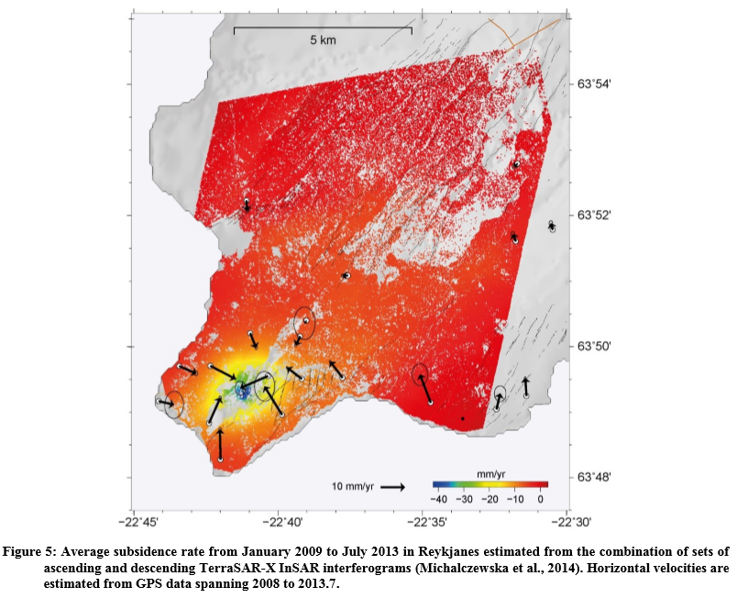

**Figure 2.11.** Average subsidence rate from January 2009 to July 2013 in Reykjanes estimated from the combination of sets of ascending and descending TerraSAR-X InSAR interferograms. Horizontal velocities are estimated from GPS data spanning 2008 to 2013. Reproduced from Michalczewska et al. (2014).

Since 2008, the zone of subsidence narrowed to an area just above the reservoir, displaying a circular shape. The maximum deformation rates, observed within the area of maximum production, reduced to about 20 to 30 mm/yr (Fig. 2.12). In 2016, the inferred cumulative subsidence was estimated to be at 26 cm in the center of the deformation field (Parks *et al.*, in review).

Simple models to explain the observed ground deformation were inferred by Keiding *et al.* (2010) and Parks *et al.* (2017). They determined the parameters of the pressure source responsible for the deformation from inversions of InSAR and GPS data. For the 2006-2008 time period, the best fit was obtained for a near-horizontal ellipsoidal source at 2.2 km depth contracting by -2.1 to -2.3 × 106 m3. For the period 2009-2016, best fit was obtained for a spherical point pressure source at shallower depth (about 1 km) with a volume change of -1 × 106 m3.

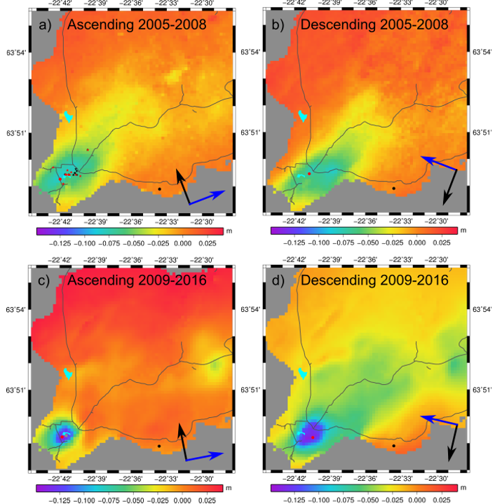

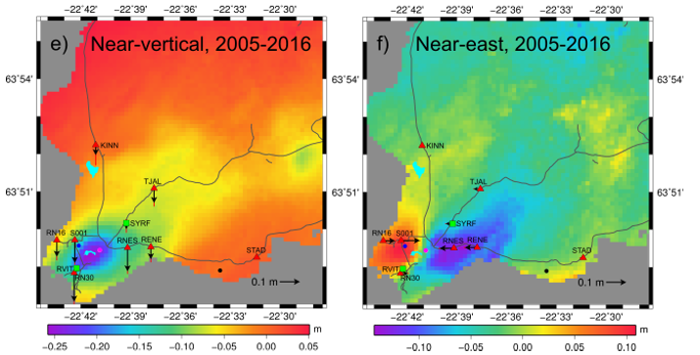

**Figure 2.12**. Cumulative LOS displacements maps derived from PS-InSAR processing. The black circle displays the zero reference point. Thin grey lines display roads. Black and blue arrows represent the satellite’s heading and look directions respectively. LOS displacement is here shown negative away from the satellite. The two images on the lower panel show the near-vertical and near-east decomposed signals for the period 2005-2016, with the location of the GPS stations whose time series are displayed in Fig. 2.13. The black arrows indicate the vertical and east GPS displacements, respectively (Parks et al., in review).

Natural subsidence of the central part of the rift zone has been inferred from 1992-1995 InSAR data (Vadon & Sigmundsson, 1997), and GPS studies (Hreinsdottir *et al.,* 2001), in addition to induced subsidence by the geothermal exploitation. GPS results indicated a subsidence toward the seismic zone at a maximal vertical rate of 8 mm/yr accompanied by a horizontal displacement of about 2 mm/yr. Subsidence over much longer time scale has also been inferred, based on the presence of shallow marine deposit at great depth found in drillholes. They were interpreted in terms of subsidence over at least the last half a milion years, at a rate of about 6 mm/yr (Friðleifsson & Richter, 2010) in accordance with the estimation of Vadon and Sigmundsson (1997). This is about the same rate of subsidence as observed at GPS station STAD station for the period 1991-2006 (Fig. 2.13).

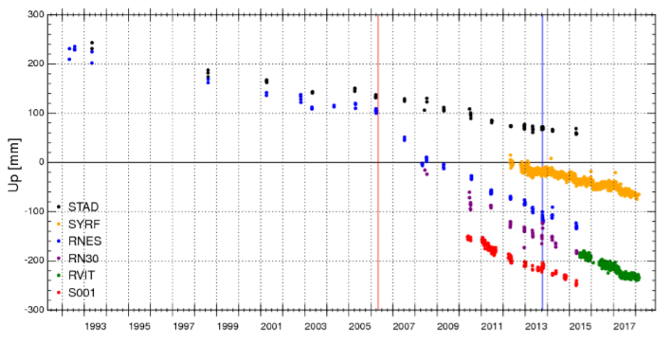

**Figure 2.13.** Vertical displacements from continuous GPS stations RVIT and SYRF, and campaign sites STAD, RNES, RN30 and S001, covering the period 1992 to 2017. The onset of production is marked by the red line and the M4.8 October 2013 earthquake by the blue line (Parks et al., in review). See Fig. 2.13 for location of the GPS stations.

In addition to InSAR and GPS monitoring of ground motion, micro-gravity surveys have been conducted in 2004, 2008, 2010 and 2014 using a Scintrex CG3M gravimeter in a base network of 57 gravity stations over Reykjanes and Svartsengi (Magnusson, 2009, 2013, 2015, 2016). After correction for elevation changes and tidal forces, the gravity data have been used to estimate the mass change in the system during 2004–2008, 2008–2010 and 2010-2014 (Guðnason *et al*. 2015b, 2018), based on Gauss-integral of the observed gravity changes (Fig. 2.14).

During 2008-2010, a gravity change of -30 µgal/year was measured in the center of the production field. Models of simple spherical mass-change volume indicated a volume at 1400–1700 m depth and a renewal of the reservoir mass in the range of 30-50% corresponding to a recharge at a rate of about 250 ± 60 kg/s (Guðnason *et al.*, 2015b). A measuring point in the center of the Reykjanes field was destroyed during the construction of the geothermal power plant in 2006, preventing accurate definition of the gravity change during 2004-2008 (a deeper gravity low would have been expected). For the 2010-2014 period, no significant micro-gravity changes were measured after correction for elevation changes, which suggest a greater mass renewal than up to 2010 (Gudnason *et al.*, 2018).

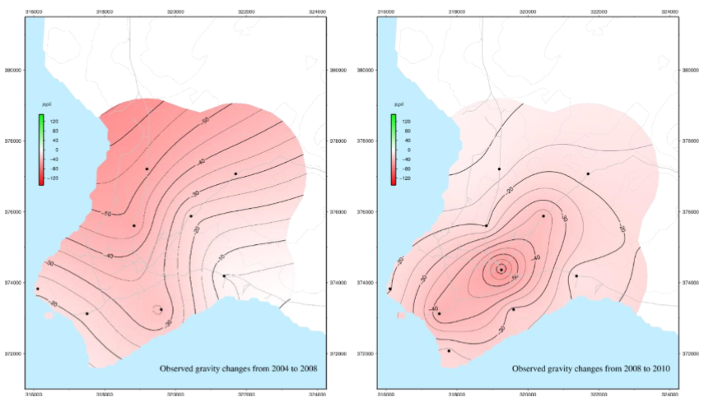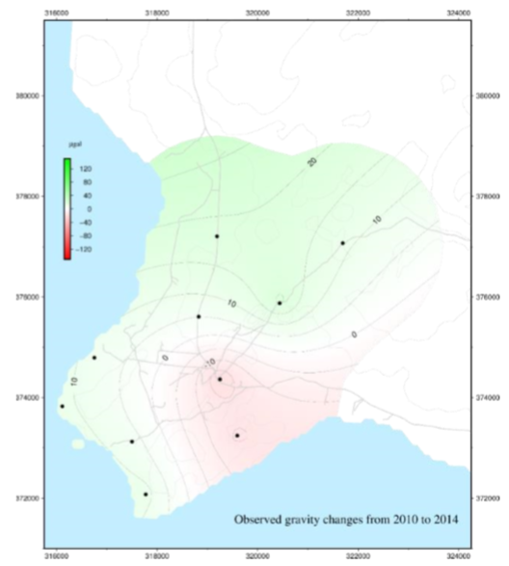

**Figure 2.14.** Observed gravity changes in Reykjanes, for a) 2004-2008, b) 2008-2010 and c) 2010-2014 (modified from Magnússon, 2015). Black points denote the measured points of the gravity surveys at the location of fixed GPS monitoring stations. The colour scale indicates the rate of gravity changes in µgal/year (Figures from Gudnason et al., 2018).

All the geodetic data, including InSAR (Parks *et al.,* in review), GPS (Magnusson, 2015) and gravity (Gudnasson *et al.,* 2015b) appear to be in good agreement, showing a decrease in the maximum subsidence rate after 2008 and a migration of the optimal source of mass/volume change toward a shallower depth after the initial years of production. For the models spanning the 2009-2016 time period, the best fits were all obtained for a spherical deformation source with a center in the 1-1.5 km depth range.

# Data and methods

## InSAR Processing

### Data

Synthetic Aperture Radar (SAR) images acquired by satellites are generated by emitting a radar signal from the satellite towards the ground and by measuring its reflection back to the satellite. Each pixel of the radar image represents a resolution cell on the earth’s surface, which contains different sets and arrangements of scattering elements. When a signal reaches a ground target, it is backscattered to the satellite and recorded as a coherent combination of the returns from each scattering elements within the resolution cell. By analyzing the signals recorded by the satellite, the radar data is transformed into information about amplitude and phase of the reflected signal for each pixel on the ground. Information is typically stored in each corresponding pixel of the SAR image as a complex number with amplitude representing the intensity of the echoed signal and phase being a fraction of the radar signal wavelength. The phase information $φ$ (measured wrapped phase or cycles of oscillations) can therefore be interpreted in terms of round-trip travel distance of the radar wave between a ground target and the satellite, ambiguous within a whole number of wavelengths (e.g. Ferretti *et al.,* 2007):

$φ=\frac{4π}{λ}×ρ_{\left(t1\right)}$ (3.1)

where $ρ_{\left(t1\right)}$ is the slant range from the satellite to a ground target at time *t1* and $λ$ the signal wavelength. Any movement of a target between two SAR acquisitions made from the same location in space at time *t1* and *t2* will result in a phase shift proportional to the change in range $∆ρ$, called interferometric phase $∆φ$ (e.g. Simons & Rosen, 2007).

$∆φ=\frac{4π}{λ}×\left(ρ_{\left(t1\right)}-ρ_{\left(t2\right)}\right)=\frac{4π}{λ}×∆ρ$ (3.2)

This interferometric phase is measured using differential interferometry and represented in interferograms, generated by multiplication pixel by pixel of a “master” image by the complex conjugate of a second “slave” image acquired over the same area at a different time. In wrapped interferograms, the amount of displacement is represented as a succession of colored fringes associated with a 2π phase cycle (in radians) relative to an arbitrary point (Massonnet & Feigl, 1998). Considering the round-trip travel distance of a radar signal of wavelength $λ$, one interferometric fringe therefore corresponds to a change in the LOS distance equal to $λ$/2. When unwrapped, interferograms give the phase change relative to a reference point corresponding to the total LOS change in between the two acquisition times. An increase in range corresponds to subsidence or a horizontal motion away from the satellite, both contributing to increase in the LOS distance to the satellite (e.g. Liu *et al.,* 2017). Equation 3.2 can be rearranged so it reads:

$d_{LOS}=-∆ρ=-\frac{∆φ}{2π}×\frac{λ}{2}$ (3.3)

Where $d_{LOS}$ is the total displacement in the satellite LOS, $∆φ$ the interferometric phase and $λ$ the radar wavelength.

InSAR has the advantage of much denser spatial sampling of the ground deformation when compared to GPS and levelling. However, repeat-pass interferometry using conventional C-band data is best implemented in areas with little or no vegetation coverage due to the strong scattering effect of vegetation (Samsonov *et al.,* 2014). This scattering effect can be explained by a relative motion of scattering elements in a resolution cell, causing loss of spatial and/or temporal coherence in the interferometric phase and creating substantial uncorrelated noise.

ASTER (Advanced Spaceborne Thermal Emission and Reflection Radiometer) satellite images can be used to study land covers and create maps of vegetation index. We here used the near-infrared NIR band (Band 2) and the red band (Band 3) of a ASTER image covering the Reykjanes Peninsula to derive a map of the Normalized Difference Vegetation Index (NDVI), defined by the relation NDVI = (NIR – red) / (NIR + red). The value of a NDVI ranges from -1 to 1, with negative values corresponding to water, values between -0.1 to 0.1 to barren surfaces (i.e. fresh rocks) and values between 0.2 and 1 indicating the density of vegetation. The NDVI map (Fig. 3.1) shows that most of the Reykjanes area, especially near the Reykjanes geothermal system, is covered by barren rocks. InSAR is therefore particularly well suited to map deformation at Reykjanes, where the ground mainly consists of young lava field, guaranteeing sufficient and constant reflectivity of the radar wave over time.

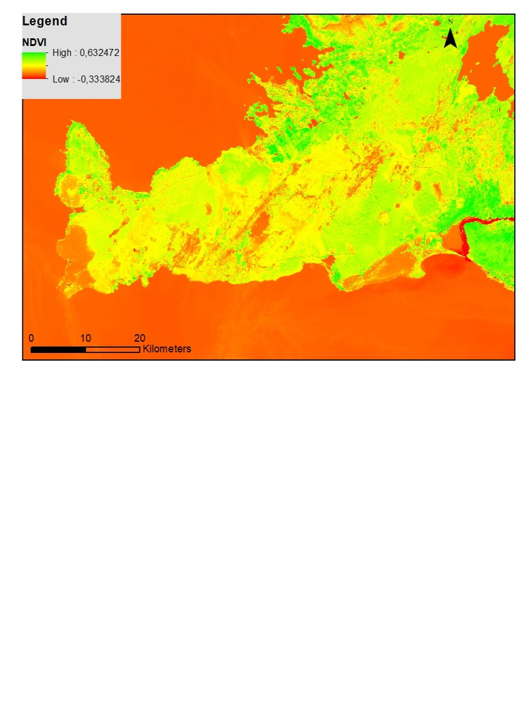

Reykjavik

Reykjanes geothermal field

**Figure 3.1.** NDVI image created from a combination of four ASTER Level 1T images acquired on the 4 July and 13 July 2016, showing the vegetation index over the Reykjanes Peninsula. Vegetated areas are represented in green, barren surface in yellow and the water in orange.

In addition to deformation signal and uncorrelated noise, interferograms may also contain unwanted signal contributions from spatially and temporally correlated noise. These signals can be due to atmospheric and ionospheric phase delay, but also due to orbital errors, processing errors (i.e. unwrapping error) or topographic residuals caused by errors in the Digital Elevation Model (DEM) used for topographic correction. Thus, the interferometric phase in each pixel can be written as:

$∆φ=φ_{deformation}+φ_{atmospheric}+φ_{orbit}+φ_{DEM error}+φ_{noise}$ (3.4)

In this study, we used C-band ($λ=5.6 cm$) SAR images from the right-looking Sentinel-1A and 1B satellites, to evaluate the extent and the amplitude of the deformation induced by production at Reykjanes. Both satellites, launched on 3 April 2014 and 22 April 2016, respectively, share the same near-polar, sun-synchronous orbital plane, each of them offering a repeated area monitoring within a 12-day cycle. Since 2016, it is possible to combine the images from both satellites, allowing creating interferograms from images acquired every 6 days. The images we used are acquired in so called Interferometric Wide (IW) swath mode, by transmitting bursts of radar pulses toward three sub-swaths combined together to form a 250 km wide image. Sentinel-1 IW Single Look Complex (SLC) products contain one image per sub-swath, each composed of a series of bursts that have been processed as a separate SLC image. These SLC data consists in focused SAR data containing amplitude and phase information in slant range geometry (radar range observation coordinate in the satellite LOS), resampled to a similar grid spacing. The final image has a ground resolution of about 5 m in range and 20 m in azimuth (Fletcher, 2012).

The near-polar and right looking configuration of the SAR satellites result in two observation possibilities of a single target, whether it is imaged on ascending or descending satellite path (Fig. 3.2). During an ascending path (Track 16 over the study area; T16), the satellite travels from the south to the north and looks to the east. During a descending path (Track 155 over our study area; T155), the satellite heads to the south and looks to the west. The displacement value $d_{LOS}$ measured with InSAR therefore corresponds to the projection of the 3D surface displacement field $\overline{d}=[d_{E},d_{N},d_{Up}]$ onto the LOS unit vector $\vec{u}=[u_{E,}u_{N},u_{Up}]$ pointing from the ground to the satellite written as $d_{LOS}=-\overline{d} •\vec{u}$, with $\sqrt{u_{E}²+u_{N}²+u_{Up}²}=1$ (Hanssen, 2001).

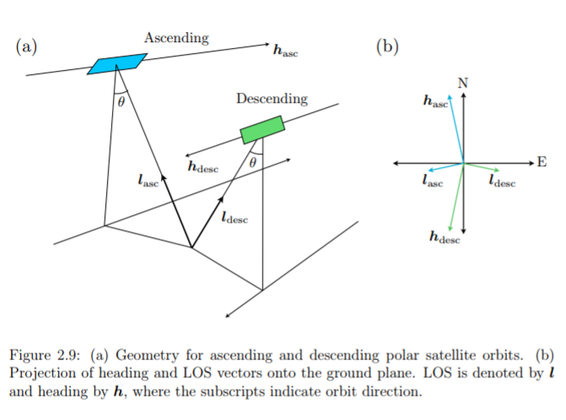

**Figure 3.2.** a) Geometry for ascending and descending polar orbits. B) Projection of heading h and LOS unit vectors l onto the ground plane (Wortham, 2014).

The satellite unit vectors can be calculated for both ascending (${\vec{u}}_{T16})$ and descending views ( ${\vec{u}}_{T155})$ using the term on the right in Equation 3.5.

$\left({d_{Asc} \atop d_{Des}}\right)=\left(\begin{matrix}d_{E} \\ d_{N} \\ d_{Up}\end{matrix}\right)•\left({-\sin\left(θ_{Asc}\right)\sin\left(α_{Asc} \right) -\sin\left(θ_{Asc}\right)\cos\left(α_{Asc} \right) \cos\left(θ_{Asc}\right) \atop -\sin\left(θ_{Des}\right)\sin\left(α_{Des} \right) -\sin\left(θ_{Des}\right)\cos\left(α_{Des} \right) \cos\left(θ_{Des}\right)}\right)$ (3.5)

Here, $θ$ is the incidence angleof the radar wave (with respect to the perpendicular to the ground) and $α$ is the azimuth look direction of the right looking satellite, where $α=α_{H}$- 3 $π$/2, with $α_{H}$ the satellite heading (direction of local azimuth on the ground surface measured clockwise from the north, in radians), given in Table 3.1. The subscripts *Asc* and *Des* refer to the orbital parameters in the corresponding ascending (T16) or descending (T155) view. As the heading is oriented to the north or to the south, the radar signal is mostly sensitive to the vertical and horizontal east-west displacements, while the contribution from the north component of the measured LOS displacement is almost insignificant. This is expressed by higher absolute values of $u_{Up}$ in comparison to $u_{E}$ and $u_{N}$, with $u_{N}$ being the smallest (Table 3.1).

**Table 3.1.** Orbital parameters for Track 16 and Track 155 of Sentinel-1, indicating the average azimuth and ancidence angle of the pixels situated in the study area. In the 2-year time spanned by this study, we assume that those orbital parameters are constant over time and so are the calculated satellite unit vectors.

|  |  |  |
| --- | --- | --- |
| At Reykjanes center | Track 16 | Track 155 |
| Azimuth (°) | -257.2 | -101.5 |
| Heading $α_{H}$ (°) | -12.7 | -168.5 |
| Incidence angle $θ$ (°) | 33.9 | 38.1 |
| Unit vector $[u_{E},u_{N},u_{Up}]$ | [0.545 -0.123 0.830] | [-0.605 -0.123 0.787] |

In this study, the interferometric analysis and the formation of interferograms have been realized using the ISCE (InSAR Scientific Computing Environment) software (Rosen *et al*., 2012). A total of 104 and 107 SLC images from the Sentinel-1 ascending Track 16 and descending Track 155 covering the Reykjanes Peninsula over the period 2015-2017, respectively, were downloaded freely from the Copernicus Open Access Hub of the European Space Agency (ESA).

The quality of the images was evaluated through the generation of consequent 12-day interval interferograms for both ascending and descending data sets. A coarse multi-looking of 50 × 100 m in range and azimuth was performed and the unwrapping process was skipped to reduce the computational time. The multi-looking consists of averaging adjacent pixels in azimuth and range directions to increase the phase accuracy, which also results in a decrease of the interferogram resolution (Ferretti *et al.,* 2007). This filtering approach, which allows minimizing the temporally uncorrelated noise, does not, however, have any effect on the spatially correlated noise (i.e. atmospheric artifact or DEM errors). It has been subjected to a sensitivity analysis presented in Supplementary Material SM1.

|  |  |
| --- | --- |
| a)  b) |  |

**Figure 3.3.** Examples of geocoded interferograms from Sentinel-1A multilooked 50 m × 100 m to speed up the processing aiming to evaluate the quality of the SAR images. a) Interferogram with atmospheric noise spanning 20161019-20161007. b) Interferogram of good quality spanning 20160808-20160820. Each color fringe shows a 2 $π$ change in the interferometric phase relatively to an arbitrary point.

As no significant deformation is expected within a 12-day interval, all images displaying signatures of atmospheric fringes due to atmospheric phase delays or other uncorrelated noise (*i.e.* Fig. 3.3a) were removed from the study before the generation of the final interferograms. The analyzing process is described in section 4 of the manuscript in preparation for submission to Geophysical Journal International.

Ground deformation induced by fluid extraction from geothermal reservoirs is expected to occur slowly. We therefore initially used a set of good quality images separated by a temporal baseline of 732 days to generate two-year interferograms over the whole Reykjanes Peninsula in each of the two tracks, in order to evaluate the signal as whole expected during this period. Fig. 3.4 shows an example of such an interferogram obtained from the processing of 9 bursts divided in two swaths in T155. The final image, multi-looked 40 m in range and azimuth, contains 18764 × 9157 pixels after geocoding.

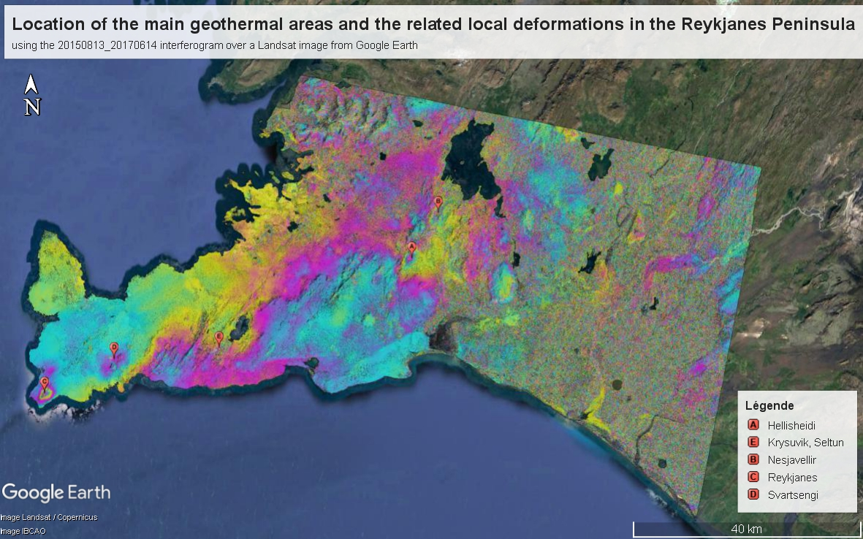

$$-π 0 +π$$

**Figure 3.4.** 20150613-20170614 interferogram on a Google Earth view along with the location of the main geothermal areas in the Reykjanes Peninsula. The interferogram output grid file obtained from ISCE was converted to a kml file. Circular and elliptical deformation patterns can be seen around the four produced geothermal fields (Reykjanes, Svartsengi, Hellisheidi and Nesjavellir) and above the Krysuvik geothermal area. These local deformations are superimposed on a regional NW-SE color gradient resulting from the trans-tensional left-lateral plate spreading of the Mid-Atlantic Ridge. Important noise can be seen north of Reykjavik (in mountains) and in the eastern part of the image (decorrelation causes by vegetation in the agricultural plains of South Iceland).

A total of six regional interferograms were processed in each track and geocoded in a similar grid delimitated by the coordinates [-22.74°E; -22.20°E; 63.79°N; 64.10°N] for Track 16 (Table 3.2) and [-22.74°E; -21.23°E; 63.79°N; 64.10°N] for Track 155 (Table 3.3). After cropping on the area of interest, the geocoded images contain 6796 × 2791 pixels for Track 155 and 3331 × 2791 for Track 16. Due to the acquisition geometry of the ascending Track 16, only two to three bursts needed to be processed to cover the area of interest, reducing considerably the processing time compared to the images from Track 155.

Table 3.2 and 3.3 indicate for each interferogram their average perpendicular baseline, corresponding to the perpendicular distance to the look directions between the locations of the satellite at the two acquisition times.

**Table 3.2.** Perpendicular baseline for the two-year interferograms for Track 16

|  |  |
| --- | --- |
| T16 image pairs | Average perpendicular baseline (m) |
| 20150615-20170616 | 123.9 |
| 20150802-20170803 | 13.1 |
| 20150814-20170815 | 162.6 |
| 20150826-20170827 | 41.3 |
| 20151013-20171014 | 134.7 |
| 20151025-20171026 | 136.5 |

**Table 3.3.** Perpendicular baseline for the two-year interferograms for Track 155

|  |  |  |
| --- | --- | --- |
| T155 image pairs | | Average perpendicular baseline (m) |
| 20150613-20170614 | 98.4 | |
| 20150625-20170626 | -64.7 | |
| 20150707-20170708 | -140.1 | |
| 20150719-20170720 | 66.7 | |
| 20150731-20170801 | 105.6 | |
| 20150824-20170825 | -39.5 | |

A coherence map was generated for each of the SAR image pairs used to form interferograms, (*i.e.* Fig. 3.5). The coherence (value between 0 and 1) indicates the level of correlation of the phase values in each pixel in the two SAR images used in the interferograms. It is influenced by the phase variance due to noise, giving an indication of the accuracy of the data (the ratio of phase signal to phase noise, SNR) and thus of the quality of the interferogram (Hanssen, 2001).

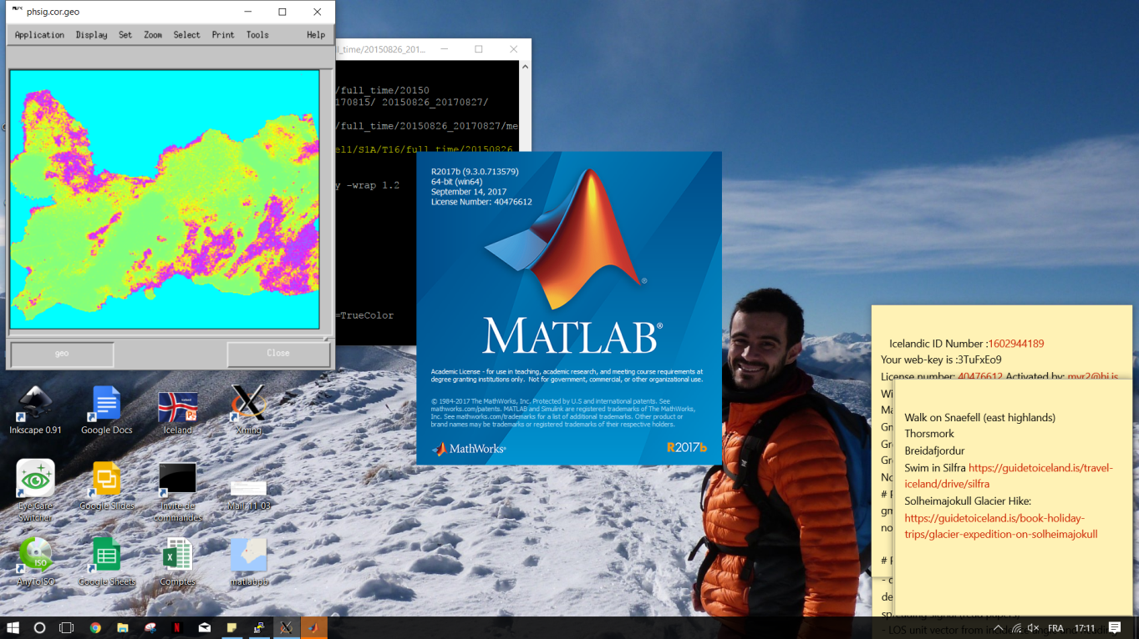 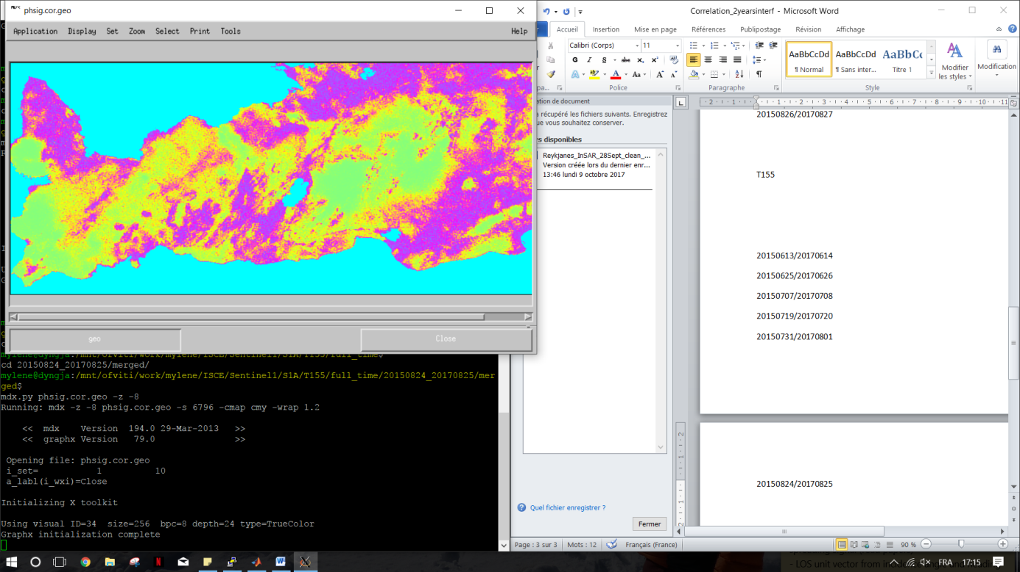

a)

b)

**Figure 3.5.** Example of coherence images for a) the 20150814-20170815 interferogram for Track 16 and b) the 20150824-20170825 interferogram for Track 155. The green/yellow colors indicate good coherence (>0.8) and the red/purples areas the areas where coherence is poor (<0.5). Low coherence can be seen on the east part of the Peninsula, but also around Keflavik and in the center of the Reykjanes geothermal system, indicating high temporal decorrelation of the interferometric phase.

All the interferograms of the same track were finally stacked together into a single image (Fig. 3.6). This stacking process, which assumes that the deformation rate is linear, consists of averaging the same pixels from each image in order to reduce the contribution of temporally uncorrelated atmospheric noise and increase the coherent signal (*e.g.,* Sandwell & Price, 1998).

|  |  |
| --- | --- |
|  |  |

**Figure 3.6.** Stacked interferograms for Track 16 (left) and Track 155 (right) showing the cumulative displacement in 732 days (in millimeters), relatively to an arbitrary point. The reversed blue-to-green color gradient in both image is due to the different viewing geometry of the ascending and descending acquisitions. As the motion of a ground target toward/away from the satellite is expressed as a decrease/increase in range (or an increase/decrease in the LOS displacement in metric units, respectively), a same displacement of the ground surface will appears reversed depending if the satellite is ascending (looking to the east) or descending (looking to the west). In these stacked ascending and descending interferograms, the dark blue therefore indicates a motion toward the west and the light blue indicates a displacement of the ground toward the east.

We then imported all the interferograms used in the stacked images in a grid format into Matlab to perform additional analysis. Considering the arbitrary starting point used by ISCE to unwrap the signal phase, all the pixel values (LOS phase change) from each interferogram were shifted to the same reference point (zero phase change), corresponding to the pixel of coordinate (-22.564°E; 63.814°N). The total phase changes were then converted into meters using Equation 3.3 and the average LOS displacement rates and standard deviation of each pixel was estimated.

Fig. 3.7 shows the resulting LOS average velocity maps obtained from the two-years stacked interferograms over the Reykjanes area, as well as an east-west cross section at latitude 63.821°N showing the corresponding average LOS deformation rate across the system, together with an estimation of the uncertainty (standard deviation around the mean velocity). These profiles indicate an average LOS velocity of about -18 mm/yr in the area of highest deformation, located around the point of coordinates (-22.689°E; 63.821°N). A localized maximum of about -25 mm/yr is observed in Track 155. It is however possible to note the significant uncertainty in the displacement rate estimates of the pixels situated in the center of the most deforming area in this track (Fig. 3.7d). It reflects the low phase coherence observed for pixels in the center of the geothermal field in the interferograms from Track 155 (*i.e.* Fig. 3.5b).

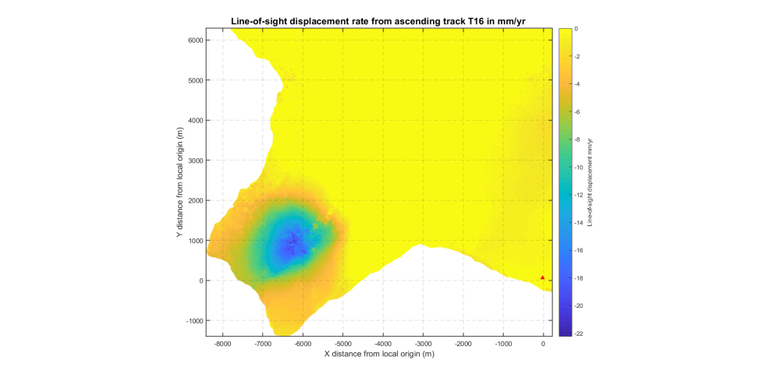 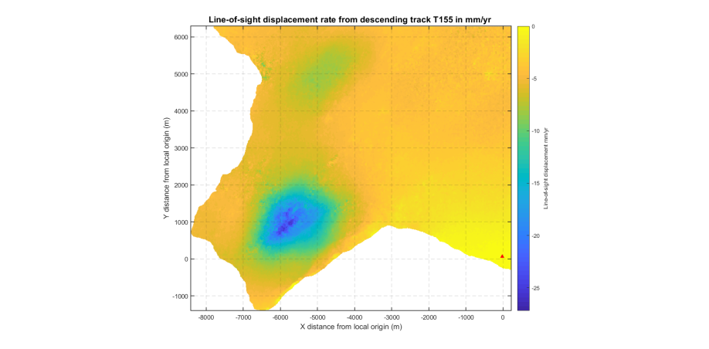

LOS rate (mm/yr)

b)

a)

-8 -7 -6 -5 -4 -3 -2 -1 0

-8 -7 -6 -5 -4 -3 -2 -1 0

X distance from origin (km)

-1 0 1 2 3 4 5 6

0

5

10

15

20

25

0

2

4

6

8

10

12

14

16

18

20

22

Y distance from origin (km)

Y distance from origin (km)

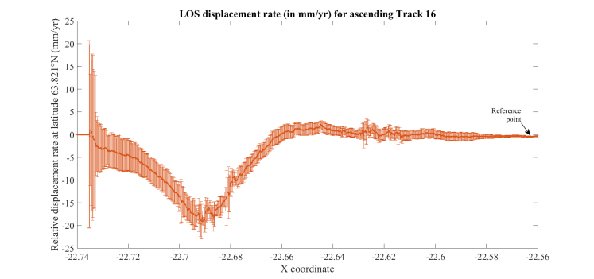 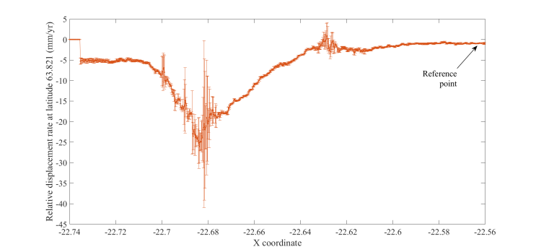

d)

c)

**Figure 3.7**. The upper panel shows the average LOS velocity maps for T16 (a) and T155 (b) calculated from the stacked interferograms over the Reykjanes geothermal area (coordinates of the box [-22.74°E; -22.56°E; 63.79°N; 63.87°N]. The red triangle indicates the reference point (zero phase change) at (-22.564°E; 63.814°N) and the brown line represents the profiles for the E-W cross sections displayed in the lower panel. In the maps, pixels along the coastline have been removed due to their lack of coherence. The lower panel displays the E-W cross sections at latitude 63.821°N across the Reykjanes geothermal field, showing the LOS displacement rate (in mm/yr) obtained from the two-year stacked interferograms from T16 (c) and T155 (d). The areas with higher uncertainty are reflected in the scatter of the phase values of the corresponding pixel in each of the six interferogram used in the stacks. They are indicated by large error bars, representing the standard deviation from the averaged displacement value of the pixels.

Large error bars can also be seen on the western part of the cross section from Track 16 (Fig. 3.7c), revealing large uncertainties in the displacement rate estimates. This appeared to be related to the presence in all the interferograms of the Track 16 of a regular fringe along the western coastline, characterized by a random shift in the phase value of the pixels along the coast relatively to the pixels located a few meters away inland. In Track 155, this persistent shifted fringe was mostly observed along the southern coastline. It was interpreted as the result of possible lack of precision in the superimposition of the SAR images during the formation of the interferograms, DEM errors or potential decorrelation related to the ocean tide/waves. All the pixels situated within this low-coherence fringe along the coastline were therefore removed using a cropping tool from the QGIS software, before using the images as input for modeling.

### Time series analysis

Time series of deformation have been created for both ascending and descending data sets from all the pre-selected good-quality images. This technics, used to evaluate the temporal evolution of the deformation throughout the whole study period, consists in estimating the relative ground displacement between a large set of SAR acquisitions (Haque, 2016). The formation of the time series is well developed in section 4 in the manuscript in preparation for submission to Geophysical Journal International.

In this analysis, we chose to form all the interferograms of a same data set (from Track 16 and Track 155) relatively to a same Master image situated in the middle of both temporal and spatial baseline spaces. On the first hands, this approach allows reducing potential decorrelation between the images due to a long temporal spacing, provided the chosen Master image has a good quality. This procedure is on the other hands generally used in deformation analysis since it allows, by minimizing the perpendicular baseline $b$*,* reducing the sensitivity to topographic residuals that might remain in the interferogram after correction for topography, due to error in the DEM. The altitude of ambiguity $h_{a}$, which corresponds to the amount of height necessary to produce a topographic fringe in an interferogram (Dzurisin & Lu, 2007), can be estimated as followed.

$h_{a}=\frac{Hλ tanθ}{2b}$ (3.6)

With *H* the altitude of the satellite orbit (about 693 km for Sentinel-1A and 1B), $θ$ the incidence angle of the radiation (Table 3.1) and $λ$ the radar wavelength (5.6 cm). Using the Master images from the 20 August 2016 for Track 16 and 30 August 2016 for Track 155, we found a minimal altitude of ambiguity of 338 m and 531 m, respectively (Supplementary Material SM2). It is therefore not likely, considering the relatively flat reliefs in the area and the high DEM resolution (about 12 × 12 m), that topography might contribute to any topographic fringes in the interferograms. After generation of the interferograms, all of those still polluted by significant noise or processing errors at this stage were removed from the study prior the final analysis. A total of 39 and 46 interferograms geocoded in a similar grid within a box of coordinates [ -22.75°E; -22.33°E; 63.79°N; 63.94°N] were used for the time series analysis in Track 16 and Track 155, spanning a total time of 804 and 942 days, respectively (Fig. 3.8a and 3.8b).

Maps of average change in range were then generated for each track based on a linear regression between the phase values of the corresponding pixels in all the interferograms of each time series. Fig. 3.8 (lower panel) shows the resulting average rates of LOS change in range for all the pixels having a coherence higher than 0.3 during the April 2015- October 2017 period. We can note that all the incoherent pixels situated in the center of the geothermal field in Track 155 and where the highest deformation rates were observed (Fig. 3.5b & Fig. 3.7d) have here been removed. These maps were used to determine the average displacement rate of a set of coherent pixels situated in the center of the area of highest deformation (Fig. 3.9) as explained in section 4.2.

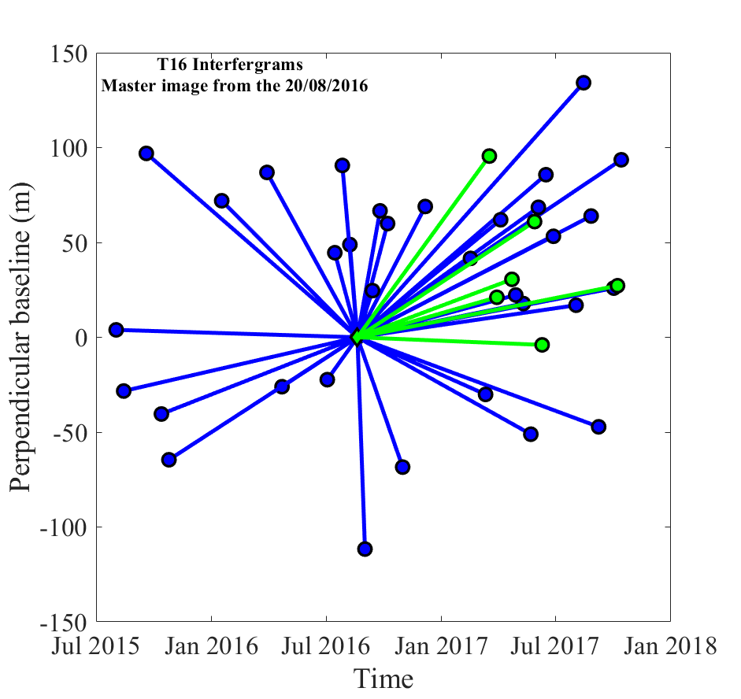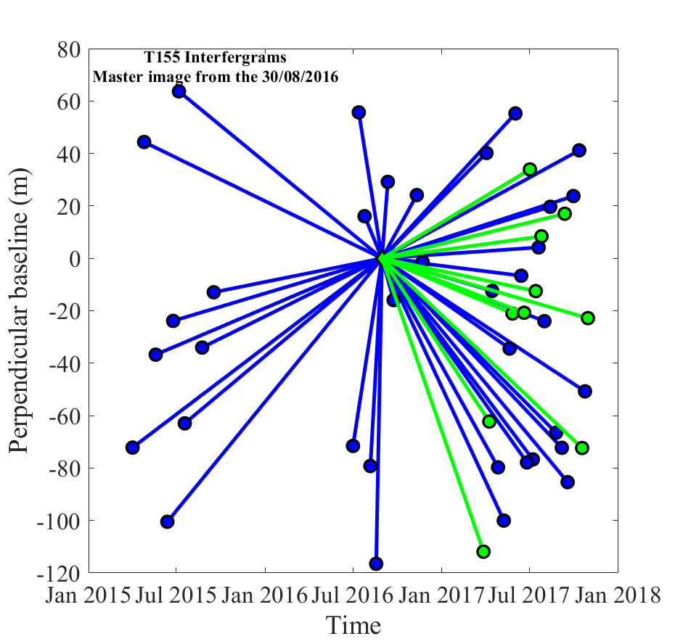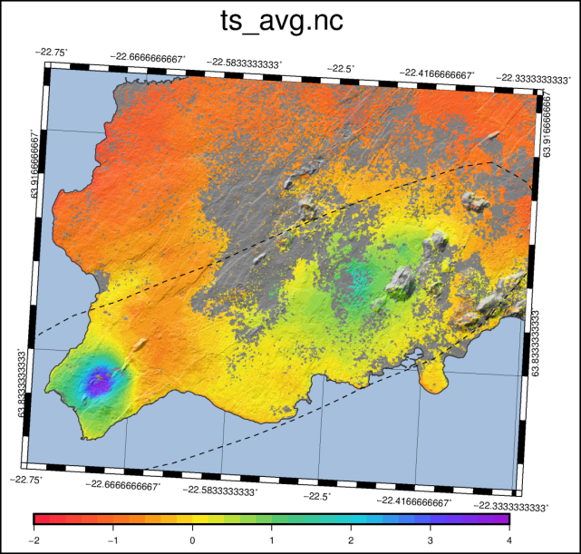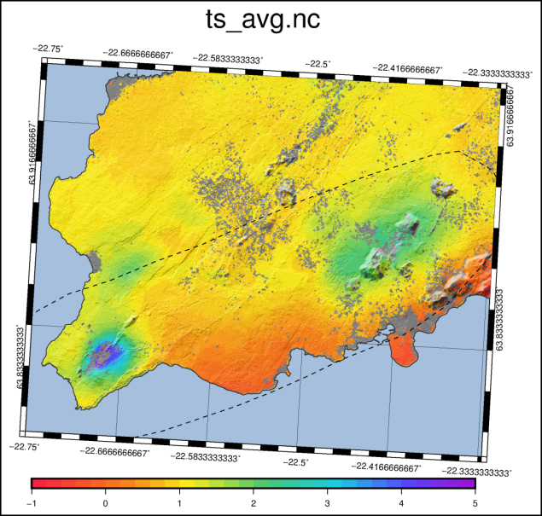

c)

d)

b)

a)

**Figure 3.8.** Upper panel: star graphs showing the temporal and perpendicular baselines of a) the 39 interferogramsof the T16 time series and b) the 46 interferograms of the T155 time series. Lower panel: velocity maps (in phase change in range) showing the LOS displacement rate for c) T16 and d) T155, for pixels with a coherence higher than 0.3. The black dashed contour line represent the Reykjanes-Svartsengi volcanic system

We estimated data variance using a geostatistical approach described in Supplementary Material SM3. For the time series analysis the variance was about 7 × 10-7 rad² and 4 × 10-7 rad² for T16 and T155, respectively (per year) and for the cumulative phase change estimated from the stacked interferograms it was about 2 × 10-6 rad² and 1 × 10-6 rad² for T16 and T155, respectively. The data variance for the yearly change inferred from the time series is less than the variance for the two year stacked interferograms. The geostatistical approach (use of covariance functions to extract the trend of the data values) mainly relates to the spatially correlated noise (i.e. atmospheric noise, orbital errors) that we expect to be minimized through the stacking process. Any loss of pixel coherence in an interferogram resulting from temporal decorrelation will also cause an increase in the interferometric phase noise variance (see coherence maps Fig. 3.5). Improvement in the quality of the data extracted from the time series analysis compared to the two two-year stacked interferograms relates partly to the removal of the pixels with a low coherence (<0.3).

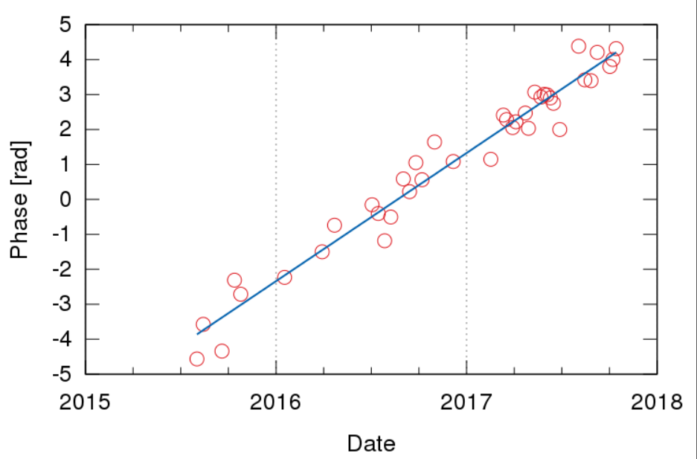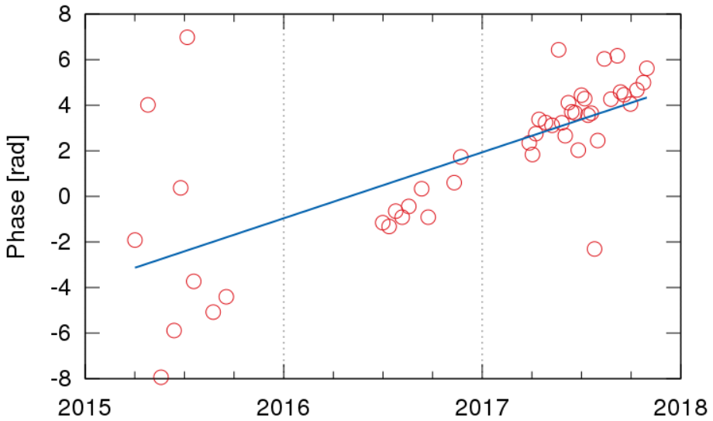

Date

Date

3.4 rad/yr

3.6 rad/yr

**Figure 3.9**. Time series analysis of a an averaged set of points situated in the middle of the deforming area for a) the ascending Track 16 and b) the descending Track 155. The LOS velocity is expressed in phase change in range (in radians). Thus, the observed increase of the signal over time corresponds to an increase in the distance between the ground and the satellite, either a horizontal displacement away from the satellite or a subsidence.

Fig. 3.9 indicates average LOS displacement rates of about -16 mm/yr for Track 16 and – 15 mm/yr for Track 155. This is in the order or magnitude with the average LOS velocities estimated in the area of maximum deformation from the two-year stacked interferograms (Fig. 3.7). As they use only the coherent pixels over the whole image, we can infer that this estimation is better constrained and thus most accurate. However, this displacement rate corresponds to an averaged velocity of pixels situated within a 200 m ×100 m area. Despite this method allows minimizing risks to get offsets linked to possible low coherence in single pixels, averaging the maximum LOS velocity with values of pixel outside the area of highest deformation might under-estimate the actual maximum displacement rate. This would explain the difference with the maximum rate of about -25 mm/yr observed in Track 155 (Fig. 3.7b). Important scatter in the phase values can however be seen in the period 2015-2016 for Track 155, resulting in a higher uncertainty in the estimation of the displacement rate for this data set. This might be due to the quasi-systematic lack of coherent pixels in the center of the deforming area in the 2015-2016 interferograms of the T155 data set relatively to T16 (Supplementary Material SM2).

### Signal decomposition

Several methods have been developed to decompose the LOS signal into a 2D or 3D displacement field using the ascending and descending viewing geometries of the same scene (Wright *et al.*, 2004). The decomposition process is based on Equation 3.5.

These methods include the two-component linear *a-priori* inversion (*i.e*. Keiding *et al.,* 2010, Samsonov *et al.,* 2014) and the linear combination method. Due to the low sensitivity of the radar signal to the north component of the displacement field, these methods solve the under-estimated problem of finding three displacement components from two observations by neglecting the north-south displacement. This is the case of the first method used in this study, where the near-vertical and near-east displacements (approximate vertical and east components of displacements) have been estimated assuming that both ascending and descending images are acquired in the same N-S striking plan, with $d_{N}=0$.

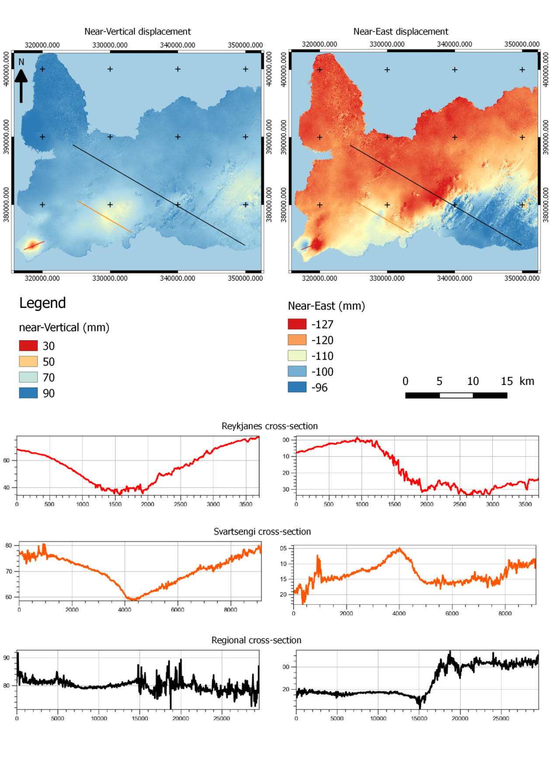

3 km

**Figure 3.10.** Decomposed near-vertical and near-east maps (upper panel) showing the total displacement in millimeters and the location of thre three cross sections displayed in the lower panel, across the Reykjanes Peninsula (NW-SE black profile), the Reykjanes (NE-SW red profile) and Svartsengi (NW-SE orange profile) geothermal fields. The horizotal axis of each plot indicates the distance along the profiles in meters. Results are displayed in QGIS.

Results of the decomposition using the ascending and descending stacked interferograms are shown in Fig. 3.10. Three profiles have been drawn across the Peninsula (black line) and the Reykjanes (red line) and Svartsengi (orange line) geothermal fields on both cumulative near-vertical and near-east displacement maps. On the near-vertical map, two main zones of subsidence can be identified. The most pronounced one is above the Reykjanes geothermal field, where deformation is concentrated in a small area. The second one, more spread but less pronounced in terms of amplitude, is situated around the Svartsengi geothermal field. Finally, a broad area of slight subsidence can be seen on the east, in the Krisuvik area.

The near-east displacement map is characterized by a regional transition zone striking N°70E, which corresponds to the direction of the active rifting boundary in the Reykjanes Peninsula. The deformation gradient, associated with the left-lateral oblique rifting, appears to be concentrated within a narrow distance of only 3 km, visible along the black profile drawn perpendicular to the striking direction of the rift axis. This profile indicates a total near-horizontal displacement in the order of 30 mm, corresponding to an average displacement rate of about 1.5 cm/yr which is slightly lower than the estimated spreading rate of the Reykjanes Peninsula Oblique Rift (about 1.8 cm/yr).

The simple approach of ignoring the north displacement component can therefore give an evaluation of the vertical and east-west displacements but may result in an over-estimation of the vertical component of the displacement field, especially in the case of Sentinel-1 where the incidence angle is high (Samieie-Esfahany *et al.*, 2009). We therefore used in a second phase the linear combination approach described e.g. by Keiding e*t al. (*2010) and by Parks *et al.* (in review) to recover the near-vertical $n_{V}$ and near-east $n_{E}$ displacement component from the stacked interferograms. This method is best applied when the satellite heading and incidence angles in both ascending and descending acquisition geometry are similar ( $θ_{Des}|=|θ_{Asc}|=θ$ and $|α_{Des}|={|α}_{Asc}|=α$). Linear combinations of the LOS changes observed by an InSAR pair are formed, taking into account the geometry of the acquisition. By summing and subtracting the phase change values obtained from the two-year stacked interferograms and scaling the result by the proper LOS coefficient (Table 3.4), it is possible to infer an estimate for $n_{V}$ (Equation 3.7) and $n_{E}$ (Equation 3.8), respectively.

**Table 3.4.** Positive and negative LOS unit vectors obtaind from suming and subtracting the values of the components of the ascending and descending satellite LOS unit vectors, respectively.

|  |  |
| --- | --- |
|  | [East, North, Up] |
| $$[u_{T16,}+u_{T155}]$$ | [-0.060, -0.246, 1.617] |
| $$[u_{T16}-u_{T155}]$$ | [1.149, 0.000, 0.043] |

$n_{V}\sim \frac{d_{Asc}+d_{Des}}{1.617}$ (3.7)

$n_{E}\sim \frac{d_{Asc}-d_{Des}}{1.149}$ (3.8)

Here $d_{Asc}$ is the phase change in the ascending Track 16 and $d_{Des}$ the phase change in the descending Track 155.

The results of the decomposition of the two-year stacked images, cropped over the Reykjanes geothermal area, are shown in Fig. 3.11. They indicate a maximum vertical deformation relatively to the reference point situated in the south east of the study at a rate of about -28 mm/yr. This point (-22.564°E; 63.814°N) was also used as the reference point for the inversion models described in section 3.2. As it is located near the STAD GPS station (Fig. 2.13) where a natural subsidence of 6 mm/yr was observed before production started, using this point as a reference allows reducing the contribution of natural deformation signals in the measured displacements.

The near-east displacement is characterized by a boundary zone striking in the N°50E direction in the middle of the geothermal field. On the west and east side of this boundary, an eastward and westward displacement of 5 and -13 mm/yr is calculated, respectively, revealing a contraction toward the center of the subsiding area. A slight signal can also be seen on the south east of the horizontal plot and might emerge from the plate spreading of the Mid-Atlantic Ridge. As this signal not directly affects our relatively small area of study, no corrections have been applied for the plate motion on the InSAR data.

Y distance from origin (km)

-8 -7 -6 -5 -4 -3 -2 -1 0

0

-5

-10

-15

-20

-25

Y distance from origin (km)

-8 -7 -6 -5 -4 -3 -2 -1 0

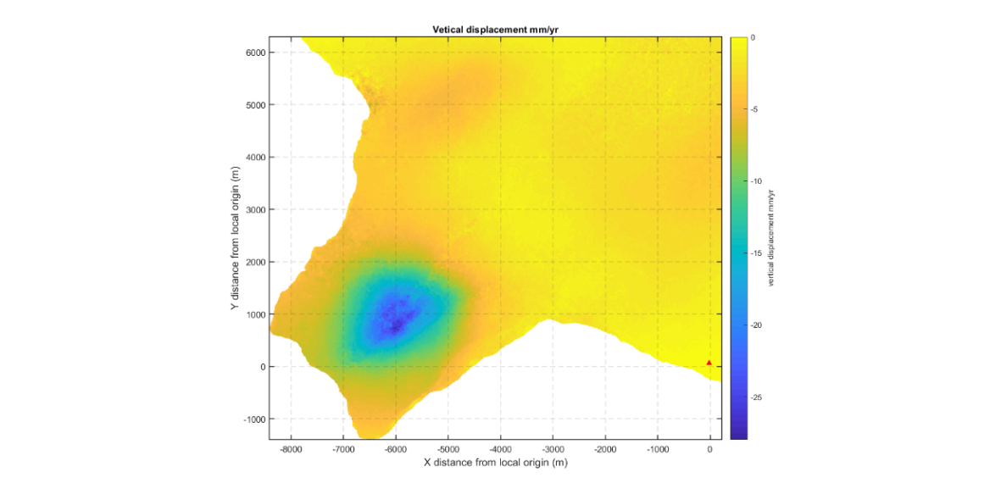 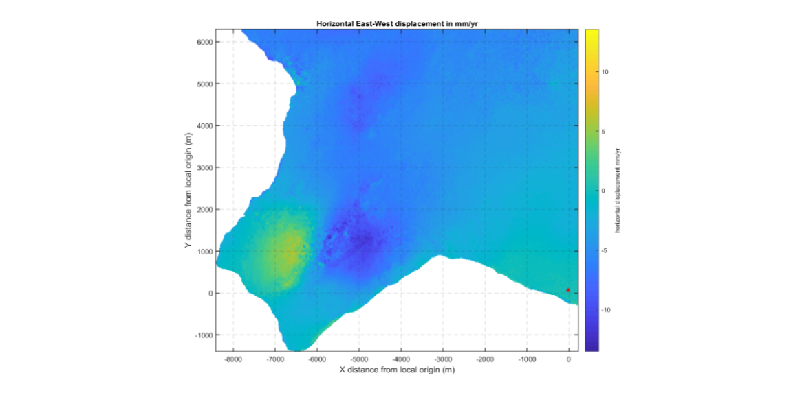

LOS rate (mm/yr)

10

5

0

-5

-10

X distance from origin (km)

-1 0 1 2 3 4 5 6

**Figure 3.11.** Decomposed signal from two-years interferograms, showing the near-vertical (left) and near-east displacement rates (right) in mm/yr relative to the reference point at (-22.564°E; 63.814°N) .

More details are given in section 4, where the same approach has been used to decompose the ascending and descending LOS displacement rates obtained from the time series analysis into near-east and near-vertical velocities for the period 2015-2017.

## Modeling Methods

Ground deformation above utilized geothermal system can be seen as an expression of deep processes occurring in a reservoir in response to fluid extraction and/or injection. Modeling of the temporal evolution of deformation can thus be used to get an insight on the characteristics of the deformation source at depth and on the sub-surface mechanisms responsible for the deformation. Here we used analytical models relating the observed linear subsidence during 2015-2017 to a volume of simple geometry representing the geothermal reservoir, contracting at a constant rate within a homogeneous and isotropic elastic half-space due to a pressure decrease. In spite of the fact that these analytical models do only consider poro-elastic processes in a simplified manner, they can provide a reasonable simulation of the deformation of the Earth’s crust outside the reservoir due to a pressure or volume change. They are particularly adapted in the study of geothermal system, where subsidence is often attributed to the contraction of the rock matrix under a decrease in the pore pressure. This drop in reservoir pressure, related to a drop in the water level, occurs when natural or artificial recharge does not compensate for the volume of fluid extracted (Eysteinsson, 2000). Such analytical models can also be used to relate the observed surface deformation to possible thermal contraction of the reservoir rock at depth (Ali *et al.*, 2016), using simple equations for thermo-elastic deformation (Equation 4.9).

Considering the large potential number of solutions that can fit the observed data, we used a Bayesian optimization approach in combination with non-linear inversion algorithms to determine the best fitting source. Five modeling approaches were tested in this study, using a single point pressure source (Mogi, 1958), a finite spherical pressure source (McTigue, 1987), a Penny shaped crack (Fialko *et al.*, 2001), a horizontal rectangular or square sill closing by a constant amount (Okada, 1992) and finally using an array of Mogi sources whose volume changes are based on the production data. These models are briefly presented in the following sub-sections.

Both two-year stacked interferograms and average displacements maps obtained from the time series analysis have been successively used as input to the different inversion models. Results from the inversion of the LOS velocities obtained from the time series analysis are shown in section 4 presenting the manuscript in preparation for submission to Geophysical Journal International. The best fitting models are presented in the main text of the manuscript and additional modeling results are shown in the corresponding Appendix A. The manuscript also summarizes the modeling procedures and software we used to perform the inversions (section 4.3). In Supplementary Material SM4, we report the results obtained initially from the joint inversion of the LOS ascending and descending cumulative displacements obtained from the stacked interferograms.

### Point pressure source (Mogi, 1958)

The Mogi (1958) model relates isotropic radial displacement to a volume change in a point pressure source at depth (the point pressure source approximation assumes radius $r$ is much smaller than its depth *d*). This model is based on four parameters: three position parameters (latitude, longitude, depth) and one parameter corresponding to the volume change.

The surface displacement produced by pressure change $∆P$ within the spherical source is expressed as

$\left(u; v ;w\right)=\left(r^{3}∆P\frac{1-v}{µ}\right)\left(\frac{x}{R^{3}}; \frac{y}{R^{3}};\frac{d}{R^{3}}\right)$ (3.9)

where (u; v; w) are the displacements values at the point of coordinate (*x,y*,0) and $R=\sqrt{x²+y²+z²}$ is the radial distance between the point on the free surface and the center of the spherical source located at (0,0,*-d*). The pressure change $∆P$, the radius of the sphere $r$, the Poisson’s ratio of the half space $v$ and the uniform shear modulus $µ$ define the strength of the source (Lisowski, 2007). Assuming $v=0.25$, the volume change in a spherical source ${∆V}_{Mogi}$ can be related to a change in hydrostatic pressure using Equation 3.10.

${∆V}_{Mogi}=∆P \frac{πr^{3}}{µ}$ (3.10)

Ambiguity exists between the radius of the source and the pressure change. Indeed, a small pressure change in a large source can produce the same surface deformation as a large pressure change in a small source (Lisowski, 2007). In spite of the broad simplification and assumptions of the Mogi model, it is still very used for modeling geothermal reservoirs (i.e. Mossop & Segall, 1997; Vadon & Sigmundsson, 1997). This is explained by the ability to provide a reasonable simulation of the deformation of the crust outside the reservoir compared to more complex models.

### Finite spherical source (McTigue, 1987)

Solutions for stresses and displacement fields can be approximated using a pressurized spherical source of finite size in an elastic half-space (McTigue, 1987). This model solves for the ambiguity between pressure and volume change in the Mogi solution (Lisowski, 2007). The McTigue (1987) solution is based on series expansions in powers of ε = r/d, where *r* is the radius of the source and *d* the depth to its center, that scales the strength coefficient of the Mogi source by corrections for a finite-sized source. These corrections offer the opportunity to fit data of surface displacement for the radius and the pressure increment, in additions to the depth of the source (5 model parameters in total). This solution results in a somewhat more rapid decline of the modeled vertical displacement in the radial direction, implying that fitting a point source solution tends to underestimate the depth of the spherical solution (McTigue, 1987).

### Rectangular plane with uniform opening (Okada, 1992)

The Okada solution relates the surface deformation to a tensile dislocation along a dipping planar ﬁnite rectangular source. It is generally used to represent movement along the faults when studying focal mechanisms of earthquakes (Okada, 1992), but can also be appropriate when modeling geothermal system to represent reservoirs whose thickness is generally much smaller than its length and width (Ali *et al.*, 2014). Parameters for the Okada model include the position (e.g. latitude, longitude and depth), geometry (e.g., length, width, dip and strike), the amount of slip and the opening of the source. The volume change produced by uniform opening or closing of a fracture, crack or tabular body corresponds to the product of the amount of closing/opening rate by the surface area of the plane (e.g., Sarychikhina *et al.*, 2011).

In this study, we used a solution derived from special type of Okada dislocation containing only 5 model parameters, assuming the two slip parameters, the plunge and the striking direction being equal to 0, as well as a uniform dimension value for the length/width. It is referred to here as horizontal square plane/sill.

### Penny-shaped crack (Fialko *et al.,* 2001)

Other types of sources can be used to represent geothermal reservoir. This includes the penny shaped crack model, characterizing pressure change in an oblate spheroid embedded in an elastic half space (Fialko *et al.,* 2001). This model contains five parameters: latitude, longitude and depth to the center, ratio of pressure change over shear modulus and length of the major axis.

### Mogi source at each borehole based on extraction and injection rates

This model, inspired by the study of Drouin *et al.* (2017), consisted of setting one point pressure source (Mogi, 1958) at each producing borehole in the geothermal field, where the rate of volume change is proportional to the known mass injection/extraction rate at each well. In order to determine the parameters that minimize the residuals between the data and the model, a high number of configuration files integrating different combinations of source depth and coefficient of production/injection are created. In the interest of simplification, we assume that the depth of all the sources at each borehole is the same, thus ignoring the distinction between steam-zone wells and deep liquid wells. These files are then used in a series of forward models run automatically as a grid search. The best combination of depth and coefficient of volume change per mass of fluid extracted/injected is chosen based on the model that minimizes the residuals (difference between the modelled values and the data), given by the smallest Chi-square (Chi² or $χ_{v}^{2}$) value.

# Manuscript in preparation for submission to Geophysical Journal International

# Ground deformation due to steam cap processes at Reykjanes, SW-Iceland: Effects of geothermal exploitation inferred from interferometric analysis of Sentinel-1 images 2015-2017

Receveur, M1, Sigmundsson, F1, Drouin, V1,2, Parks, M3

1Nordic Volcanological Center, Institute of Earth Sciences, University of Iceland, Reykjavik, Iceland

2National Land Survey of Iceland, Akranes, Iceland

3Icelandic Meteorological Office, Reykjavik, Iceland

## Abstract

The Reykjanes geothermal system is a high-temperature seawater system situated in SW-Iceland. Interferometric analysis of the new Sentinel-1 satellite synthetic aperture radar (SAR) data has been used to determine a time series of ground deformation induced by geothermal utilization between April 2015 and October 2017. Surface displacements have been estimated at coherent pixels, indicating a steady and linear subsidence within a sub-circular bowl centered on the well field at a maximum near-vertical rate of about 25 mm/yr, together with horizontal contraction. The average line-of-sight (LOS) displacement from ascending and descending tracks are inverted to determine the characteristics of the deformation source at depth, modeling the geothermal reservoir as a body of simple geometry within an elastic half space. The results indicate a deformation source at about 1 km depth contracting at a rate of -0.9 × 105 m3/yr in the 2015-2017 period. Using pressure and temperature monitoring data at 900 m depth as well as the reservoir structure and the reservoir properties, we find that the recent estimated volume change can be attributed to a combination of compaction under pressure decrease and/or thermal contraction due to cooling of the rocks within or near a steam cap situated in the topmost part of the geothermal reservoir, in the 800–1200 m depth range. The steam cap formed as a response to a sudden increase in extraction of geothermal fluids in 2006 for a new power plant, which caused approximately a total pressure drop of 4 MPa and an associated expansion of a steam zone in the topmost part of the reservoir.

## Introduction

Studies of ground deformation induced by geothermal utilization have been applied to many high-temperature geothermal systems worldwide, using geodetic methods such as GPS-geodesy or levelling. Since the 1990s, interferometric synthetic aperture radar (InSAR) satellite imaging methods have been increasingly used to characterize and monitor changes within geothermal reservoirs, for example at Krafla, Iceland (Drouin *et al.,* 2017), Cerro Prieto, Mexico (Sarychikhina *et al.,* 2007), Coso (Fialko & Simons, 2000) and Salton Sea Geothermal Field, California (Eneva *et al.,* 2014), and the Taupo Volcanic Zone, New Zealand (Bromley *et al.,* 2009). The launch of the Sentinel-1A satellite in April 2014 and of Sentinel-1B in the same near-polar orbital plane in April 2016 offers now unprecedented opportunities to measure ground deformation thanks to image acquisitions every six days over many geothermal areas (Gonzalez *et al.,* 2015; Mora *et al.,* 2016; Zhou *et al.,* 2017; Mellors *et al.,* 2018). The good temporal resolution and free access to data allows the creation of detailed time series. Several studies have used the Sentinel Terrain Observation by Progressive Scans (TOPS) data for measuring ground displacement over geothermal fields (e.g. Xu *et al.,* 2017). Here we use Sentinel-1 datasets to extend the time series of deformation at the Reykjanes geothermal system, SW-Iceland (Fig. 4.1). Deflation due to geothermal utilization (subsidence and horizontal contraction towards a well field) has been measured there since 1992 using GPS-geodesy and since 2003 using InSAR analysis of ENVISAT and TerraSAR-X SAR data (Michalczewska *et al.,* 2014; Keiding *et al.,* 2010; Parks *et al.,* in review).

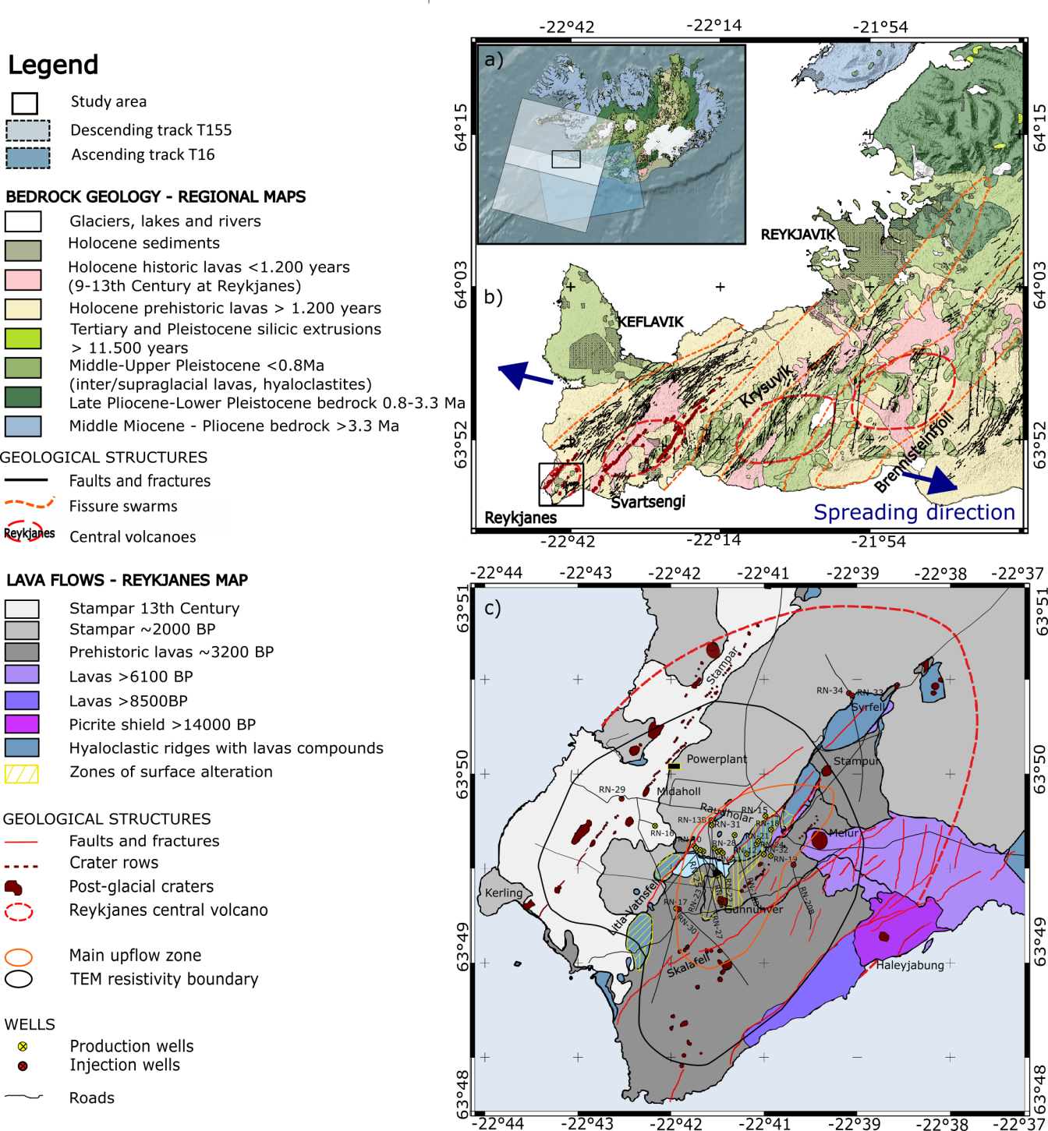

**Figure 4.1**. Geological maps a) Iceland, with the location of the Sentinel-1 images from ascending and descending tracks. b) Reykjanes Peninsula, showing central volcanoes (red dashed lines), contours of the fissures swarms (orange dashed lines) and faults (black lines) from Clifton et al. (2003). Direction of plate spreading shown as blue arrows. Geology and geological structures in panels a and b from the Icelandic Institute of Natural History (Jóhannesson, 2014). The black boxes in panels a and b indicate the location of the figures b and c, respectively. c) The Reykjanes geothermal system (after Friðleifsson et al., in review) with the location of drillholes (red and yellow circled crosses) and the ground surface traces of directionally drilled wells (black lines). Most of the wells are situated within the hydrothermally active or altered field (thin dashed yellow lines) and in the main upflow zone (orange contour line) identified from resistivity surveys by Karlsdóttir and Vilhjálmsson (2014). The youngest eruptive fissures (red features) and lavas are located west of the area of highest surface manifestation of hydrothermal activity. See legend for explanations of all symbols.

The Reykjanes geothermal system is a high temperature geothermal system located where the Mid-Atlantic Ridge emerges on the southwestern tip of the Reykjanes Peninsula in Iceland (Bjornsson *et al.,* 1970; Franzson *et al.,* 2002). The circulating fluid has a very high salinity due to the sea-water recharge of the system. The geological structure consists of a highly fractured superimposition of volcano-sedimentary strata typical of a submarine environment (Saemundsson & Einarsson, 1980; Franzson, 2004) intersected by a few sub-aerial Pleistocene lava flows at 600 and 1200 m depth (Friðleifsson *et al.,* 2014). The upper part of the series is dominated by shallow water lithologies including Pleistocene phreato-magmatic hyaloclastite tuffs and breccias, intersected by thin layers of reworked shallow marine fossiliferous sediments between 400 and 800 m depth (Friðleifsson & Richter*,* 2010). Below 1100 m depth, the sequence is dominated by crystalline pillow basalts and breccias formed in a deep marine environment. Intrusions can be found with increasing density from 1500 m depth, dominating the series below 2.8 km depth (Franzson, 2004, Friðleifsson *et al.,* 2014). This interval of mixed coarse- to fine-grained gabbroic intrusions and extrusive rocks between 1500 and 3200 m has been interpreted as a transition zone between the overlying extrusive volcanic rocks and an underlying sheeted dyke complex, interpreted as the heat source to the system. In January 2017, the deepest drillhole in Iceland, the Icelandic Deep Drilling Project well IDDP-2/RN-15 at Reykjanes reached supercritical conditions at 4.5 km depth (Friðleifsson *et al.,* 2017). The measured temperature at the bottom of the hole reached 426°C after 6 days of heating for a fluid pressure of 34 MPa. Good permeability was found in the basalt and dolerites in several locations below 3.2 km depth, with the main feed points identified at around 3300, 4000, 4300 and 4500 m depth (Friðleifsson *et al.,* 2017).

An area of intense hydrothermal alteration and surface activity of about 1.5 - 2 km² has been delineated on the surface at Reykjanes (Palmason *et al.,* 1985), interpreted to reflect the main upflow zone from the central part of geothermal reservoir, where the permeability and temperatures are the highest (Fig. 4.1c). The total volume of the assumed 1500 m thick productive reservoir was estimated to be about 3 km3 on the basis of these surface manifestations (Fridriksson *et al.,* 2010, Axelsson *et al.,* 2015). This is smaller than the total volume of 19 km3 estimated from TEM resistivity surveys that have been used to identify the outer boundary of the system, indicating a lateral extent of 8 - 10 km2 at 800 m depth (Karlsdóttir and Vilhjálmsson, 2014). The Reykjanes geothermal system is located within a highly oblique rift on the Reykjanes Peninsula, and tectonic studies suggest that the system is confined to a NE/ENE aligned graben structure controlled by the Litla-Vatnsfell and the Skálafell faults (Fig. 4.1c). The hottest part of the system is located in the deepest part of this graben, where a natural subsidence of the plate boundary area has been observed prior to utilization at a rate of about 6 mm/yr from levelling (Eysteinsson, 2000), InSAR (Vadon & Sigmundsson, 1997), GPS (Hreinsdottir, 2001) and lithological studies (Friðleifsson & Richter, 2010). The graben constitutes a narrow corridor channeling seawater recharge towards the well field from the southwest. Recharge is however limited by a low-permeability area around wells RN-17b and RN-30 in the south and by an impermeable WNW-striking barrier near RN-16 (Axelsson, 2012b; Khodayar *et al.,* 2016). Some productive layers have been identified within porous formations at 800–1200 m depth, but most of the fractures intrusion-related feed zones are irregularly distributed within the sequence. The largest are associated with sub-vertical fractures along or near dykes between 1900 and 2300 m depth (Franzson *et al.,* 2002).

Extensive fracturing has allowed intense water-rock interaction responsible for high hydrothermal alteration of the system (Sigurdsson, 2010). A high-temperature alteration profile is clearly revealed in MT resistivity models (Karlsdóttir and Vilhjálmsson, 2014). A low resistivity cap (<10 Ωm), interpreted as a 8 km2 up-domed area (2.5 km × 3 km) elongated in the ENE direction, has been associated with a conductive smectite zone. Between 300 and 500 m, smectite is replaced within a mixed-layer clay zone by more resistive chlorite minerals that become dominant at 500 m depth. A high resistivity core (10-30 Ωm) below 500 m reflects pore fluid conduction within the chlorite-epidote zone extending from 500 to 1200 m depth in the geothermal reservoir. It reaches the shallowest level at the Gunnuhver fumarole (100-200 m b.s.l.) and is followed by the epidote-actinolite zone down to 2500-3000 m depth (Friðleifsson & Elders*.,* 2005). Finally, the basalts and dolerites found below 3 km depth are affected by alteration ranging from the upper greenschist to the amphibolite facies (Friðleifsson *et al.,* 2017). Marine tuffaceous sediments found between 390-472 and 550-800 m are intensely affected by chlorite-smectite and illite alteration, respectively, that also contain secondary crystallization of quartz, calcite and anhydrite precipitations tending to have transformed these layers into cap rocks of the geothermal system (Marks *et al*., 2010; Friðleifsson *et al.,* 2011). Calcite was found in abundance near aquifers at 1000-1100 m depth in well RN-10. This indicated the occurrence of boiling conditions before production started, in the depth interval situated between the cap rock (500-800 m depth) and the beginning of the convecting zone at about 1300 m depth (Franzson *et al.*, 2002).

Geothermal fluid extraction at Reykjanes started in 1970 although the first well was drilled in 1956. Large-scale utilization began in May 2006 with the commissioning of a 100 MWe power plant. A sudden increase in the yearly average production rate from 50 to 800 kg/s resulted in a pressure drop of about 3.0 MPa between May 2006 and May 2009 in well RN-12, located in the central part of the system (Fridriksson *et al.,* 2010). High rates of ground deformation of about 30 mm/yr were also measured during the two years following the start of the production, along a 4 × 3 km elliptically-shaped subsidence bowl elongated in the NE-SW direction (Keiding *et al.,* 2010, Parks *et al.,* in review). The response of the geothermal system to utilization includes the expansion of the pre-existing boiling zone as a result of pressure drawdown into the system. This process was associated with an increase in both surface geothermal activity and in the average discharge enthalpy of the producing wells, from 1210-1400 kJ/kg in 2006 to 1450-1950 kJ/kg in 2010 (Fridriksson *et al.,* 2010; Friðleifsson *et al.,* 2011; Axelsson *et al.,* 2015). While the main feed zones at 1.9-2.3 km depth are still liquid dominated, the upper feed zones between 800 and 1200 m depth began to supply the wells with saturated steam in 2008, with an enthalpy of 2700 kJ/kg (Sigurdsson, 2010). That year, two relatively shallow wells, RN-27 and RN-28, were drilled down to 1225 and 960 m depth, respectively, to produce directly from this steam cap (Fridriksson *et al.,* 2010). In addition, reinjection of colder separated brine at 15 kg/s was initiated in July 2009 at more than 1000 m depth into well RN-20b to counterbalance the pressure drop in the reservoir (Flovenz *et al.,* 2015). Between 2009 and 2017, reinjection was performed at irregular rates into five wells, averaging to 80 kg/s over the whole time period with a maximum of 146 kg/s in 2016. Between 2009 and 2015, the rate of pressure drop at 1625 m b.s.l reduced down to -0.1 MPa/year in the center of the system and -0.07 MPa/yr on its periphery. A cumulative drawdown of -3.8 MPa was reached in 2015 relatively to 2005 and between 2015 and 2017 a minor increase in pressure of 0.3 MPa was reported (Fig. 4.2).

The contribution of the deep two-phase wells in addition to the two shallow dry steam wells (RN-27 and RN-28) in the extraction of steam led to the reduction in the rate of total mass withdrawal from 800 to 430 kg/s between 2008 and 2016 (Khodayar *et al.,* 2016). In 2016, 17 deep production wells were extracting geothermal fluid at an average annual mass extraction of 430 kg/s, representing a yearly mass of 13.5 Mt (Þorvaldsson & Arnaldsson, 2017). Some wells are cased down to the bottom of the steam zone to produce the liquid phase only and therefore generally display higher mass extraction rates (Ó. Sigurðsson, HS-Orka, personal communication, 2018). Not only has pressure declined in the liquid part of the reservoir, but also in the steam cap where relatively constant pressure decline at a rate up to -0.2 MPa/yr was measured at 925 m b.s.l. between the end-2008 and 2017, resulting in an additional pressure drawdown of about 1.7 MPa (Fig. 4.2).

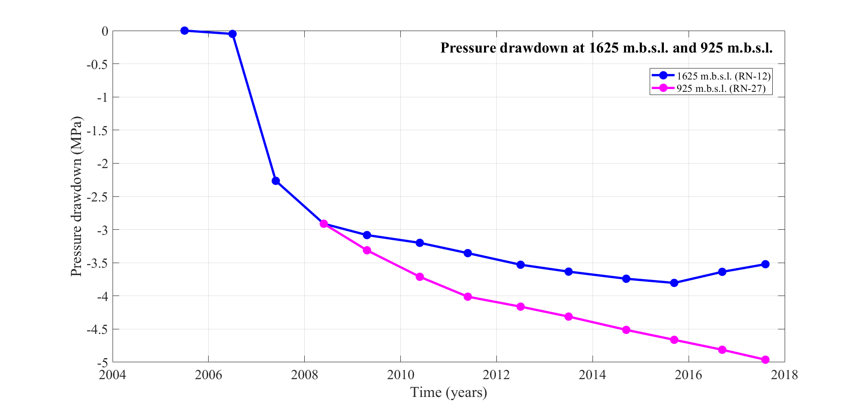

**Figure 4.2**. Pressure drawdown at 925 and 1625 m b.s.l. measured in wells RN-27 and RN-12, respectively, relative to the measured pressure in 2003 (Guðmundsdóttir, 2016; Khodayar et al., 2016; Þorvaldsson & Arnaldsson, 2017). The value of pressure drawdown at 1625 m b.s.l. in May 2008 has been used as starting value for the cumulative drawdown measured at 925 m b.s.l.

Geodetic measurements of subsidence at Reykjanes have been carried out through a combination of GPS-geodesy (Hreinsdottir *et al*., 2001; Sturkell *et al.,* 1994; Keiding *et al.,* 2010; Magnússon 2009, 2013, 2015, 2016) and InSAR data analysis (Michalczewska *et al.,* 2014, Keiding *et al*., 2010, Parks *et al.,* in review). Since 2008, the subsidence zone has narrowed to an area just above the central part of the reservoir, displaying a circular shape where the maximum LOS deformation rate has been lowered down to about 25 mm/yr. Inferred cumulative subsidence is about 26 cm in the center of the deformation field between 2005 and 2016 (Parks *et al.,* in review). The parameters of the source responsible for the observed ground surface deformation since production started have been found by inversion of InSAR data, using analytical models (Parks *et al.,* in review). These models assume that ground subsidence is the result of a pressure decrease in a body of simple geometry within a homogeneous and isotropic elastic half space representing the Earth. For the 2005-2008 period, the best fit was obtained for a near-horizontal ellipsoidal source at 2.2 km depth displaying a rate of volume change of -7.3 × 105 m3/yr.

Deformation modeling for the period 2009-2016 indicated a decrease in the rate of volume change down to -1.5 × 105 m3/yr, for a best fitting point pressure source situated at about 1 km depth. This is in accordance with the independent modeling based on GPS data from 2008 – 2014 (Magnússon, 2015, 2016). In addition, renewability aspects of the geothermal reservoir have been evaluated by modeling observed gravity changes from 2004 to 2014 (Magnússon, 2009, 2013, 2015). Gravity changes, corrected for estimated elevation changes, during the 2008-2010 period were interpreted in terms of mass renewal of the reservoir fluid in the range of 30-50%, representing a recharge rate of about 250 ± 60 kg/s (Guðnason *et al.,* 2015b). The data were modeled considering mass-change in a spherical volume, with best fitting depth of about 1300-1700 m depth (Axelsson *et al.,* 2015). Smaller yearly changes in micro-gravity after 2010 show greater renewal than up to 2010, indicating an increase in the rate of mass recharge to the system since production started (Gudnason *et al.,* 2018).

The objective of this study is to pursue the analysis of the ground deformation at Reykjanes through time series analysis of the new Sentinel-1 data from 2015 to 2017 and further constrain the nature of the physical processes responsible for the observed deformation at present. Analytical models are used to fit observed surface deflation, assuming the reservoir is a contracting source at depth. The best fitting models and the estimated volume changes are then compared to the reservoir pressure and temperature data and the production history to understand the relationship between the deformation and the potential poro-elastic and thermo-elastic processes. Emphasis is on physical processes that may occur in a steam cap, which has developed in the upper part of the system and may be the main source deformation seen in our InSAR analysis for the 2015-2017 period.

## InSAR data and analysis

Synthetic Aperture Radar (SAR) images of Reykjanes from the Sentinel 1-A and 1-B satellites, collected in Interferometric Wide (IW) swath mode in the period 2015-2017 have been utilized to study ground motion over the geothermal reservoir (Fig. 4.1a). The radar wavelength is 5.6 cm and the acquired SAR images have ground resolution of about 5 m in range and 20 m in azimuth. Each pixel of the SAR image contains amplitude and phase information from the radar signals backscattered from ground targets situated within its corresponding resolution cell (Ferretti *et al.,* 2007). Amplitude and phase for each pixel on the ground is stored as a complex number. If two acquisitions are made over the same area at two different times, any motion of the ground surface that occurred in this time interval will result in a phase shift between the SAR images (Liu *et al.,* 2017). This displacement can be detected in interferograms, formed by multiplying a first “master” SAR image by the complex conjugate of the second “slave” image. As the satellite is “side-looking”, the relative displacement value of each pixel $d_{LOS}$ is displayed as phase change, relating to change in range in the line-of-sight (LOS) direction towards the satellite (Massonnet & Feigl, 1998). In absence of errors, it corresponds to the projection of the three-dimensional (3D) displacement field $\overline{d}=\left[d_{E},d_{N},d_{Up}\right]$ onto the unit vector $\overline{u}=\left[u_{E},u_{N},u_{Up}\right]$ pointing from the ground to the satellite:

$d_{LOS}=-\overline{d} • \overline{u}$ (4.1)

We used a total of 104 and 107 SAR images from Sentinel-1 ascending Track 16 (T16) and descending Track 155 (T155), respectively, in the period from the 21/01/2014 to the 22/01/2018. Unit LOS vectors are ${\overline{u}}_{T16}=[0.545, -0.123, 0.830]$ and ${\overline{u}}_{T155}=\left[-0.605, -0.123, 0.787\right]$, respectively. Interferograms were formed using the ISCE (InSAR Scientific Computing Environment) software, for all processing steps from the co-registration of the slave images on a master image to the geocoding of the final interferograms and the generation of coherence maps (Rosen *et al.,* 2015). The removal of the topographic fringes was realized using a Tandem-X digital elevation model (DEM) with a 12-m spatial resolution. Pixels situated over water surfaces, which represent a major source of decorrelation in the interferograms, were masked out. This technique allowed considerable reduction in the time of phase unwrapping, performed after multi-looking the interferograms to 40 m in both range and in azimuth in order to increase the signal to noise ratio. The interferograms were unwrapped using the SNAPHU MCF algorithm (Chen and Zebker, 2001) and finally geocoded using a similar grid whose final resolution has 1891 × 1930 pixels in range and azimuth, respectively (Fig. 4.3).

Short term interferograms with a 12-day temporal baseline were initially formed to analyze the quality of the images, skipping the unwrapping and geocoding steps to gain processing time. As no significant deformation was expected in such a short time interval, all the SAR images leading to spatially correlated interferometric fringes due to a high level of atmospheric phase delays (unstable atmosphere) were removed from the datasets based on visual inspection. Many winter images led to incoherent interferograms, due to snow cover/drift, and these were also removed from the time series analysis before the generation of the final set of interferograms (Ferretti *et al.,* 2007).

After forming and stacking two-year interferograms which enabled visualizing the total cumulative displacement between 2015 and 2017, time series of deformation were constructed for both ascending and descending tracks to evaluate the temporal evolution of the deformation over the study period. The selected SAR images were co-registered to a single master image in each track, acquired on 20 August 2016 in T16 and 30 August 2016 in T155. The master images were chosen to be in the middle of the temporal series to minimize the temporal decorrelations between the whole set of images (Maghsoudi *et al.,* 2017). Minimizing the distance between the locations of the satellite at the two acquisition times (spatial perpendicular baseline) is generally important in deformation studies to reduce the sensitivity of the signal to potential topographic residuals. In the Reykjanes area, the relatively flat topography is however not expected to cause significant topographic fringes, with the highest point situated at less than 200 m height. At this point any final interferograms still containing atmospheric signals or affected by unwrapping errors were removed from the time series prior the final analysis. This procedure resulted in a total of 39 and 46 geocoded interferograms spanning a total time of 804 and 942 days for T16 and T155, respectively, used for time series analyses. For each track, average LOS velocity maps over the Reykjanes-Svartsengi area were formed (Drouin *et al.,* 2017) using pixels remaining coherent during the study period (Fig. 4.3). Displacement rates were determined pixel by pixel using a linear regression of their LOS displacement values within each interferogram of the time series. The LOS displacement for each pixel was determined relative to a reference area (zero LOS phase change) corresponding to the average of about 2000 pixels within the area of 500 × 500 m delineated by a box of coordinates [-22.570°E; -22.558°E; 63.813°N; 63.818°N], situated to the east of the Reykjanes geothermal system (black square in Fig. 4.3).

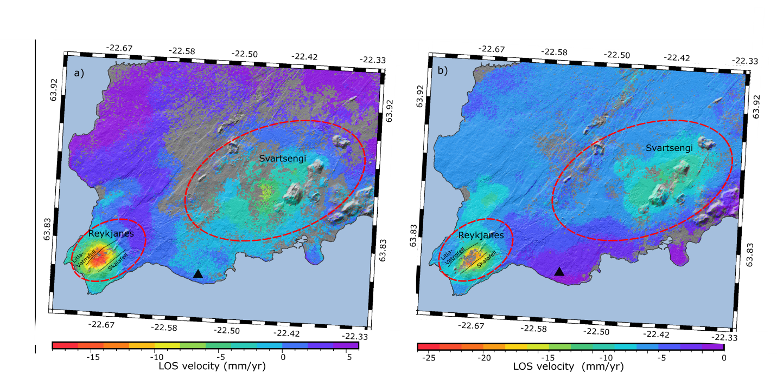

**Figure 4.3.** Velocity maps showing average LOS velocities 2015-2017 in mm/yr. a) Ascending Track 16, and b) Descending Track 155 over the Reykjanes and Svartsengi geothermal fields. The black triangle corresponds to the reference area (zero LOS displacement). The gray areas correspond to areas of low coherence. The negative values indicate increase in LOS distance between the ground and the satellite, either a horizontal displacement away from the satellite or a subsidence. The arrows indicate the heading (black arrow) and the looking directions of the sattelite (orange arrow). Location of two main faults near the geothermal reservoir shown as lines. The red dashed circles indicates the location of the central volcanoes and the gray areas are the areas with no values (pixels with coherence lower than 0.3).

The velocity maps (Fig. 4.3) clearly show a deformation signal at Reykjanes characterized by a sub-circular LOS increase, with highest rates in the center of the field (about -18 mm/yr in Track 16 and -25 mm/yr in Track 155 relatively to the reference area). A signal of lower amplitude but larger spatial extent can also be seen at the Svartsengi geothermal field. We also measure a persistent signal at the location of the Stora-Sandvik fault, north of the Reykjanes area.

Time series of LOS displacements are shown in Fig. 4.4 for the average of set of coherent pixels situated in the area of highest deformation. The set includes 198 pixels for Track 16 and 57 pixels for Track 155, selected from boxes of about 200 m × 100 m (Fig. 4.5a and Fig. 4.5b). Linear regression was used to evaluate the average ascending and descending LOS velocities for each set of pixels. This method of analyzing the temporal evolution of the signal was used to reduce effects from individual pixels with significant noise. For both tracks, the analyses reveal an average LOS velocity of about -16 mm/yr in the selected areas. Results for Track 155 are more uncertain than for Track 16, due to variability in the LOS displacement values in 2015. This might be explained by the lack of coherent pixels in the selected area within some of the 2015-2016 interferograms of the Track 155 dataset, eventually due to larger temporal decorrelation than for Track 16.

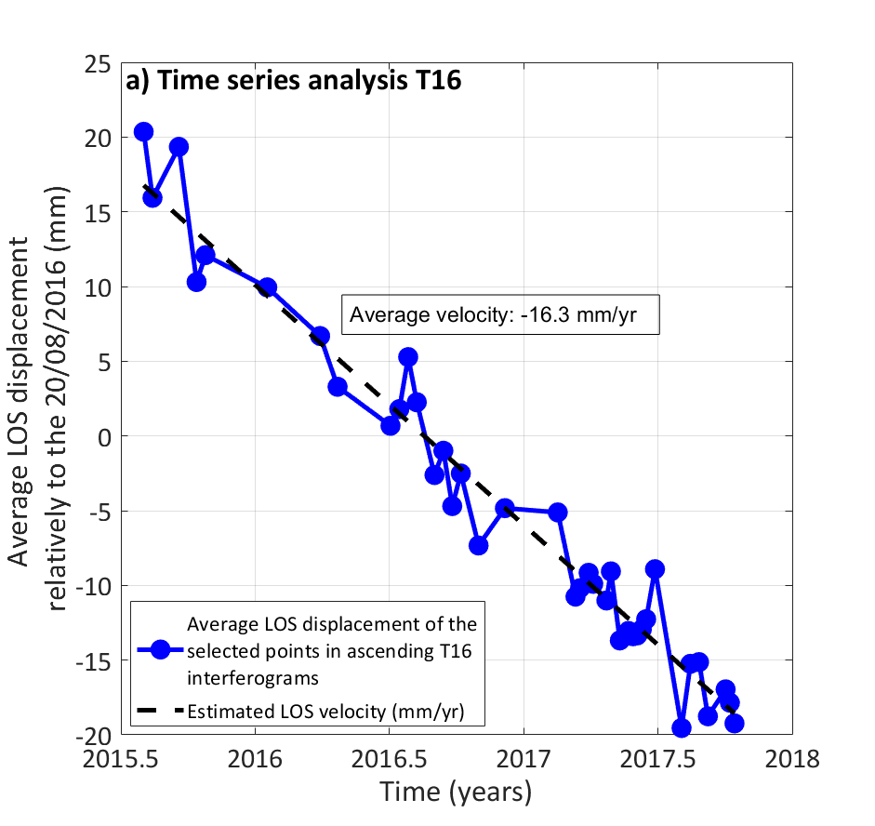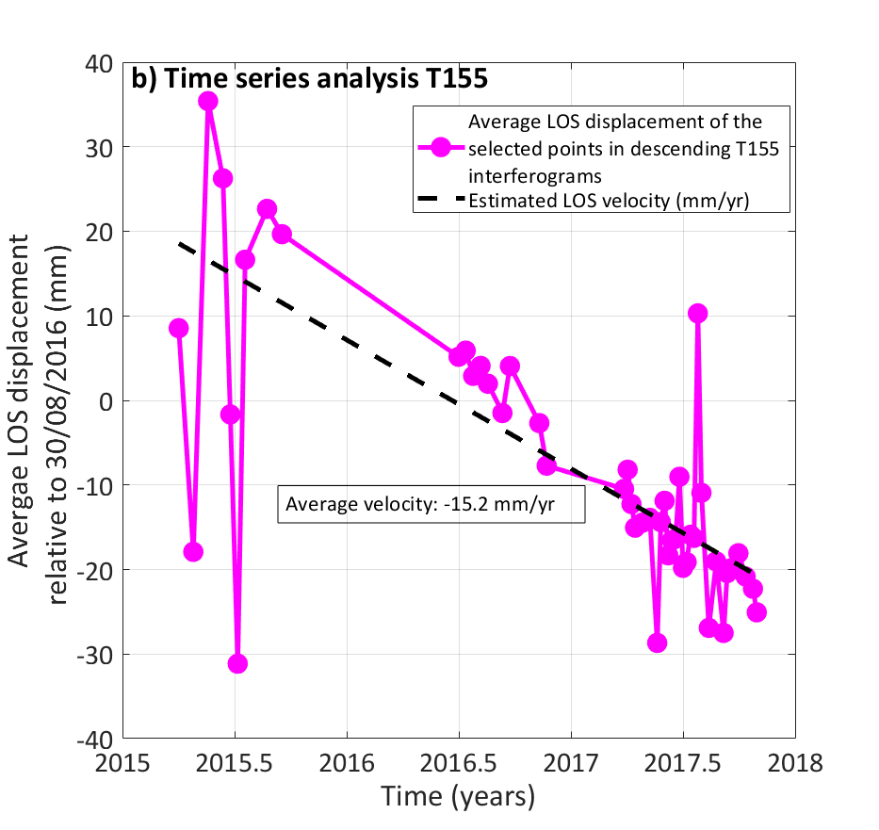

**Figure 4.4.** Time series analysis of a an averaged set of points in sampling areas situated in the middle of the deforming area. a) Average LOS change of 198 points in the area [-22.693°E; -22.688°E; 63.821°N; 63.822°N] for the ascending Track 16 relative to a “master” image acquired on the 20 August 2016. b) Average LOS change of 57 points in area [-22.688°E; -22.683°E; 63.820°N; 63.821°N] for descending Track 155 relative to a “master” image acquired on the 30 August 2016. For location of the sampling areas, see Fig. 4.5.

Components of the 3D deformation field in the area can be visualized by forming a linear combination of the LOS velocities measured in the ascending and descending tracks. By adding them together (Equation 4.2), or subtracting them (Equation 4.3), and scaling the outcome considering sensitivity of LOS displacements to displacement components (see Equation 4.1) and unit vectors for each track, an approximate estimate of the vertical displacement (“near-vertical”) $n_{V}$ and of the east component of the displacement field (“near-east”) $n_{E}$ can be derived (see e.g., Keiding *et al.,* 2010), respectively. In our case we have:

$n_{V}\sim \frac{d_{ASC}+d_{DES}}{1.617}=-\frac{\left[{\overline{u}}_{T16} +{ \overline{u}}_{T155}\right]•\overline{d}}{1.617}= -\frac{[-0.060, -0.246, 1.617] •\overline{d}}{1.617}$ (4.2)

$n_{E}\sim \frac{d_{ASC}-d_{DES}}{1.149}=-\frac{\left[{\overline{u}}_{T16}-{ \overline{u}}_{T155}\right]•\overline{d}}{1.149}=-\frac{[1.149, 0.000, 0.043]•\overline{d}}{1.149}$ (4.3)

The decomposition results are displayed in the lower panels in Fig. 4.5. They indicate a sub-circular subsidence bowl centered on the Reykjanes geothermal field, in an area where geothermal alteration is extensive and the pixel coherence is very low. The maximum near-vertical displacement rate, located in the central part of this bowl, is about -25 mm/yr relative to the InSAR reference area situated to the east of the geothermal field. The near-east displacement field is characterized by a contraction towards the center of this zone of highest deformation, with an eastward displacement of about 5 mm/yr of the western part of the field and a westward motion of about -10 mm/yr of the easternmost part. Velocity profiles across the geothermal field are shown in Fig. 4.6, for the T16 and T155 velocities as well as the inferred near-vertical and near-east displacement rates.

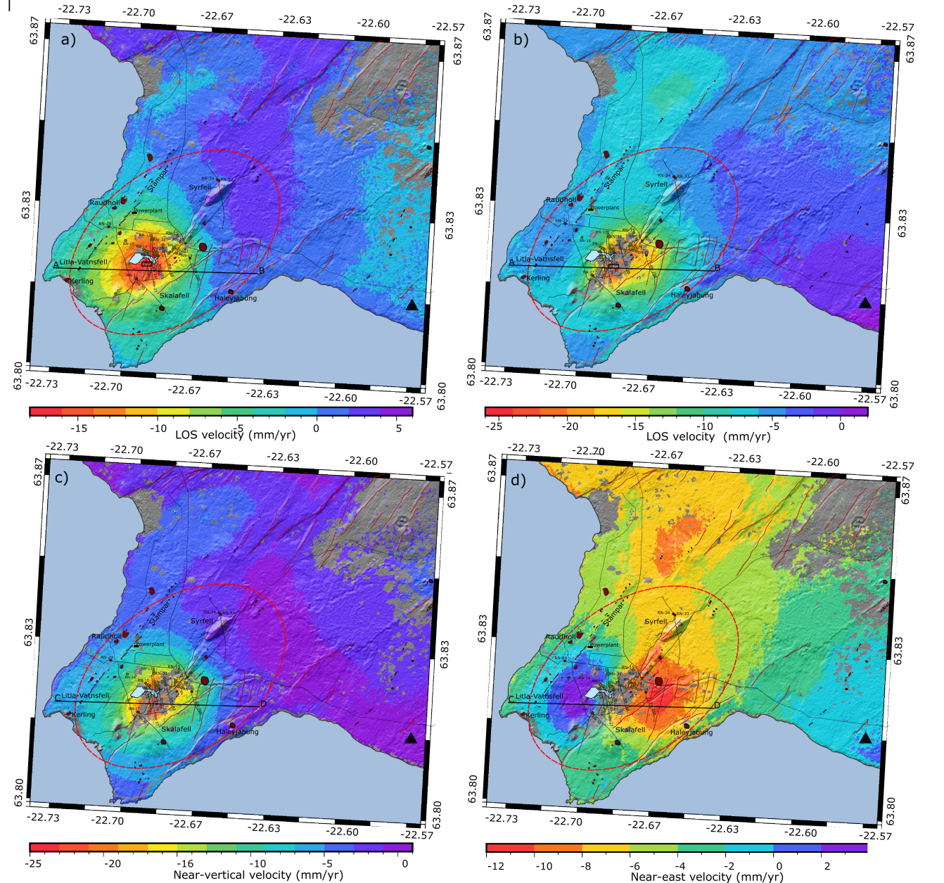

**Figure 4.5**. a) LOS velocities for ascending Track 16, b) LOS velocities for descending Track 155, c) near-vertical velocity component d) near-east horizontal velocity component; all shown in mm/yr. The gray color indicates the areas with low coherence (<0.3), the black triangle corresponds to the reference area. The black boxes in the center of the area of high deformation in panels a and b correspond to the selected areas for the estimation of the average displacement rates for the time series displayed in Fig. 4.4. The black lines represent the location of a profile shown in Fig. 4.6. The red dashed circles indicates the location of the central volcanoes. The outline of these maps [-22.74°E; -22.56°E; 63.79°N; 63.87°N] is the one used in the inversion models presented in section 4.3 and Appendix A.

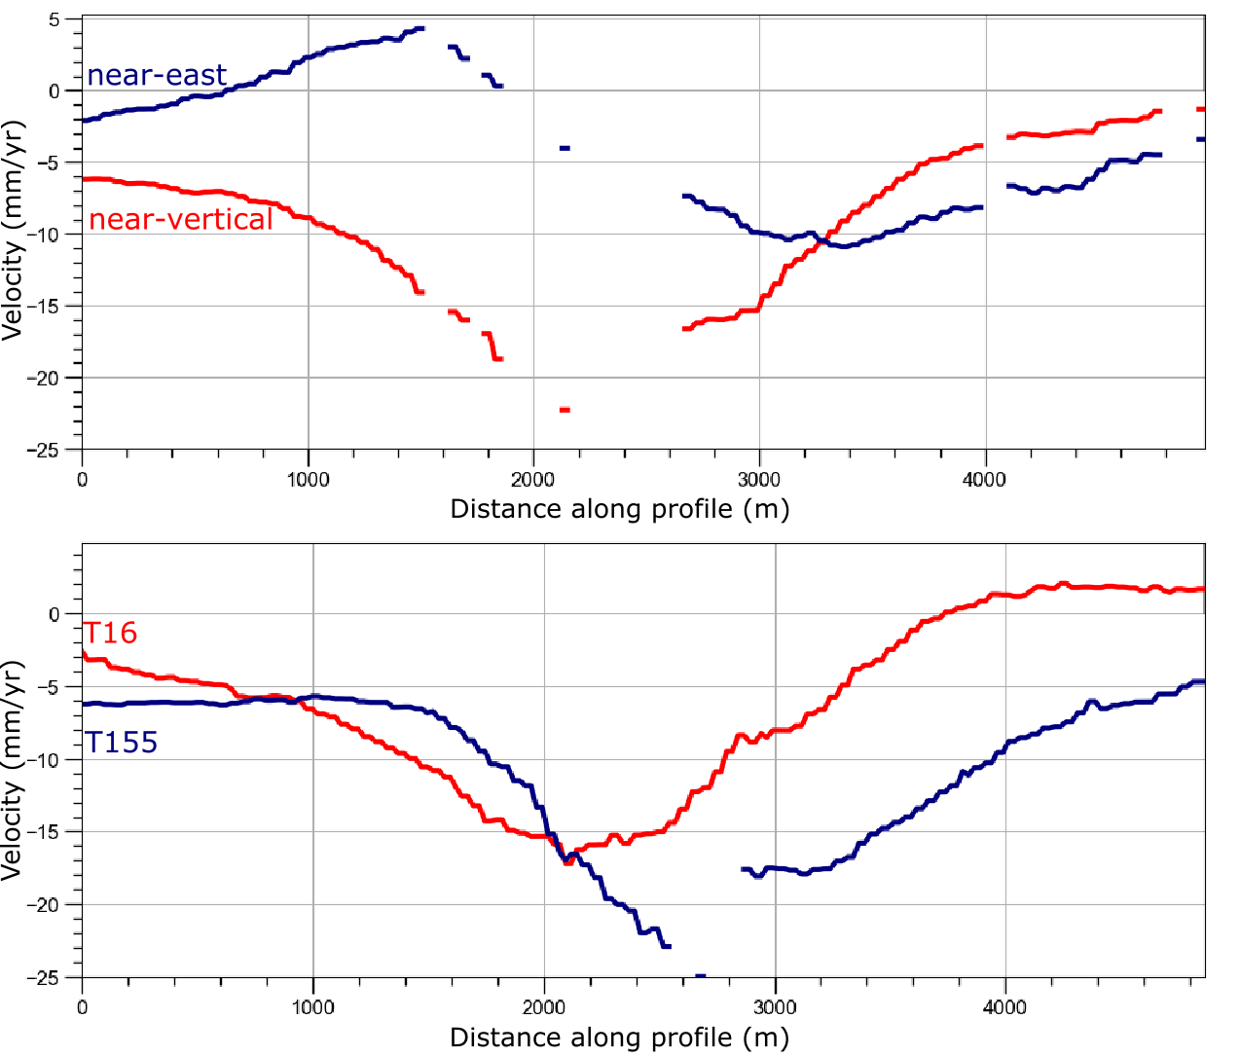

b)

a)

**Figure 4.6.** Velocities (mm/yr) along a profile across the Reykjanes geothermal field (see Fig. 4.5 for full velocity fields, and location of the profile) (a) LOS velocities for ascending (red curve) and descending (blue curve) satellite tracks. (b) Near-vertical (red curve) and near-east (blue curve) velocities. The orange line indicates the average displacement rate in the center of the most deforming area estimated from the average of a set of coherent pixels in each track. It is lower than the maximum LOS velocity observed in Track 155.

## Geodetic modeling

We invert the geodetic data to estimate the parameters of a contracting source at depth that best replicates the observed LOS velocities. A set of model of deformation sources embedded within a uniform elastic half-space with a Poisson’s ratio $v=0.25$ are considered: A point pressure source (Mogi, 1958), a finite sized pressure source (McTigue, 1987), a horizontal penny shaped crack (Fialko *et al.,* 2001) and a planar horizontal rectangular sill with uniform closing (Okada, 1985). These sources are assumed to correspond to the geothermal reservoir or a part of it causing the observed deformation. The inversions were performed using two different codes, that both use a Bayesian optimization approach.

First, the open-source Geodetic Bayesian Inversion software (GBIS v1.0 ©2017 Marco Bagnardi), developed at University of Leeds has been used to invert for the penny shaped crack and the point pressure source (Bagnardi & Hooper, 2017). This software provides all the scripts necessary to perform a quadtree subsampling of the InSAR and GPS data, estimate the deformation source parameters through the inversion of geodetic data, calculate the 95% confidence intervals on model parameters and display the results. The inversion is here based on the Markov-chain Monte Carlo (MCMC) algorithm, incorporating the Metropolis-Hasting algorithm to sample the posterior probability distribution of each parameter from the histograms of retained solutions (Hastings, 1970; Mosegaard & Tarantola, 2002). To adequately sample the posterior probability distributions, one milion iterations were run (*i.e.* Malinverno, 2002). The distribution of each parameter provides an estimate of its probability density function, including its most probable value and 95% confidence interval.

Additional inversions for the horizontal sill, the point pressure source and the finite spherical pressure source were performed using scripts from Drouin *et al.* (2017), used to study ground deformation in North Iceland. The non-linear inverse problem is solved using a simulated annealing algorithm that determines the set of model parameters that minimizes the Chi-square value, Chi² or $χ_{v}^{2}=WRSS/(N-m)$, with $WRSS$ the weighted residual sum of squares representing a measure of the deviation between the data and the estimation model, $N$ is the number of observations and $m$ the number of unknown parameters. *A posteriori* distributions of the model parameters are constructed using the bootstrap method (Drouin *et al.,* 2017). For each model, 1000 bootstrap inversions were run to determine the set of model parameters that best fit the input data (see details in Supplementary Material SM4).

In both approaches, the LOS deformation rate is calculated relative to a reference point at (-22.564°E; 63.814°N), which corresponds to the center of the selected reference area for the InSAR data. This point is situated near the STAD GPS station where a natural subsidence at a rate of about 6 mm/yr was measured before production began in 2006 (Hreinsdottir *et al.,* 2001). Subsidence of this station has continued at a similar rate after the production began (Fig. 2.13). Using this point as a reference, we reduce the contribution of other natural deformation signals compared to those induced by geothermal utilization.

The results from the six inversions realized with the two methods are summarized in Table 4.1 and the data, model and residuals and the corresponding histograms representing the posterior probability distributions of the parameters for each of these models are displayed in Appendix A.

**Table 4.1.** Inversion results for the point pressure source (Mogi, 1958) and the penny shaped crack (PSC) model calculated with GBIS and the point pressure source, finite spherical source (McTigue, 1987) and horizontal sills (rectangular or square) using the approach of Drouin et al. (2017). The most probable value for each parameter is given, along with 95% confidence intervals (in brackets)

|  |  |  |  |  |  |  |
| --- | --- | --- | --- | --- | --- | --- |
|  | **MOGI (GBIS)** | **MOGI (Drouin, 2017)** | **McTigue (Drouin, 2017)** | **Okada rectangular (Drouin, 2017)** | **Okada square (Drouin, 2017)** | **PSC**  **(GBIS)** |
| **Longitude** | $$-22.687$$ $$\left[\begin{aligned}-22.688, \\ -22.687\end{aligned}\right]$$ | $$-22.688$$ $$\left[\begin{aligned}-22.696 ; \\ -22.679\end{aligned}\right]$$ | $$-22.689$$ $$\left[\begin{aligned}-22.696 ; \\ -22.678\end{aligned}\right]$$ | $$-22.701$$ $$\left[\begin{aligned}-22.704; \\ -22.694\end{aligned}\right]$$ | $$-22.689$$ $$\left[\begin{aligned}-22.698; \\ -22.677\end{aligned}\right]$$ | $$-22.687$$ $$\left[\begin{aligned}-22.687; \\ -22.686\end{aligned}\right]$$ |
| **Latitude** | $$63.821$$ $$\left[\begin{aligned}63.821; \\ 63.822\end{aligned}\right]$$ | $$63.823$$ $$\left[\begin{aligned}63.818 ; \\ 63.827\end{aligned}\right]$$ | $$63.822$$ $$\left[\begin{aligned}63.818 ; \\ 63.828\end{aligned}\right]$$ | $$63.819$$ $$\left[\begin{aligned}63.816 ; \\ 63.821\end{aligned}\right]$$ | $$63.822$$ $$\left[\begin{aligned}63.817; \\ 63.826\end{aligned}\right]$$ | $$63.821$$ $$\left[\begin{aligned}63.820; \\ 63.821\end{aligned}\right]$$ |
| **Depth (m)** | $$1022\left[\begin{aligned}983; \\ 1063\end{aligned}\right]$$ | $$1083\left[\begin{aligned}907 ; \\ 1194\end{aligned}\right]$$ | $$1121\left[\begin{aligned}910; \\ 1284\end{aligned}\right]$$ | $$1336\left[\begin{aligned}1038; \\ 1390\end{aligned}\right]$$ | $$1357\left[\begin{aligned}666; \\ 2156\end{aligned}\right]$$ | 1161 $\left[\begin{aligned}1097; \\ 1193\end{aligned}\right]$ |
| **Volume change (m3/yr)** |  |  |  |  |  |  |
| **Opening (m/yr)** |  |  |  | $$-0.21$$ $\left[\begin{aligned}-0.44; \\ -0.14\end{aligned}\right]$ | $$-0.04$$ $\left[\begin{aligned}-0.06; \\ -0.02\end{aligned}\right]$ |  |
| **Radius (m)** |  |  | $$828 \left[\begin{aligned}619 ; \\ 987\end{aligned}\right]$$ |  |  | $$700\left[\begin{aligned}680; \\ 730\end{aligned}\right]$$ |
| **DP (Pa)** |  |  | $$-7.16\left[\begin{aligned}-9.9; \\ -2.5\end{aligned}\right]×{10}^{5}$$ |  |  |  |
| **DP/*µ*** |  |  |  |  |  | $$-9.96\left[\begin{aligned}-10; \\ -8.5\end{aligned}\right]×{10}^{-5}$$ |
| **Length (m)** |  |  |  | $$1405 \left[\begin{aligned}1041; \\ 1490\end{aligned}\right]$$ | $$1531 \left[\begin{aligned}979; \\ 1969\end{aligned}\right]$$ |  |
| **Width (m)** |  |  |  | $$313 \left[\begin{aligned}126; \\ 475\end{aligned}\right]$$ |  |  |
| **Strike (°)** |  |  |  | $$46 [22;59]$$ |  |  |
| **Dip (°)** |  |  |  | 0 |  |  |
| **Global Chi² $χ_{v}^{2}$** |  | $$3.0×{10}^{5}$$ | $$2.9 × {10}^{5}$$ | $$8.9 × {10}^{4}$$ | $$6.4×{10}^{4}$$ |  |

For all the modeled single sources, the observed, synthetic and residual LOS displacement rate for both datasets gives a comparable goodness of ﬁt. The Okada rectangular sill appears to fit the data better than the point pressure source and the spherical source (lowest $χ_{v}^{2}$). However, any model more complicated in a sense it contains more model parameters $m$ will better fit the data without necessarily being more appropriate (Menke, 2012). Thus a simple observation of the global Chi² value for this model where $m$ = 7 cannot ensure that it actually is the best compared to the rest of the models where $m$ = 4 or $m$ = 5. The results of the inversions for all models indicate a source at about 1000-1300 m depth contracting by an amount of about -0.9 × 105 0.4 m3/yr, except for the penny shaped crack where the estimation of the volume change depends on the assumed shear modulus *µ* (since the model inverts for pressure).

Fig. 4.7 shows the results of the inversion for the best fitting sources: the penny shaped crack source obtained from the approach of Drouin *et al.* (2017) and the square horizontal sill using GBIS, including the unwrapped data, the modeled deformation and the residuals. Histograms of samples from the posterior distributions of the model parameters for both models, displaying the best solution for each parameter (red line) as well as the 95 % confidence interval (black lines), are shown in Fig. 4.8. Compared to the other models (Appendix A), the posterior distribution of the model parameters for these models are better constrained within the 95% confidence interval.

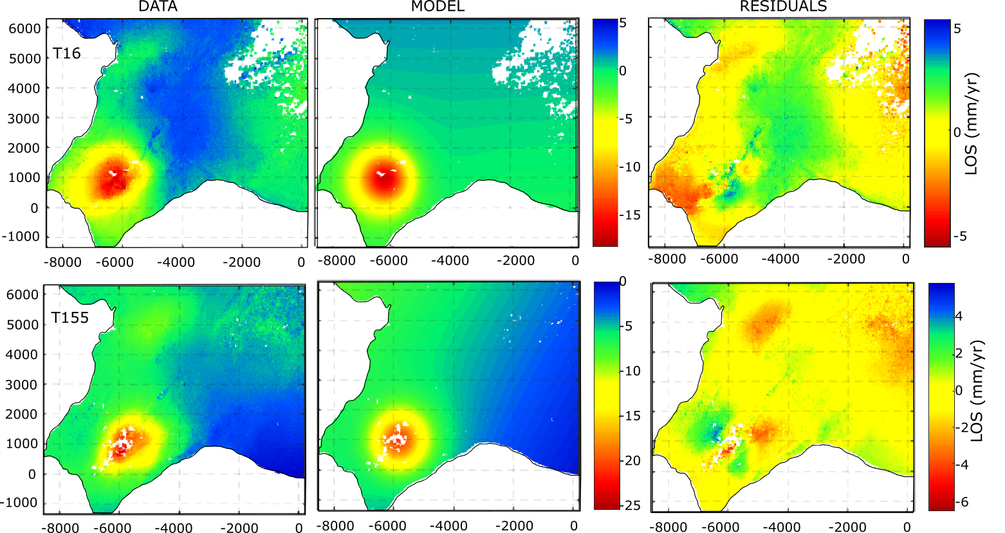

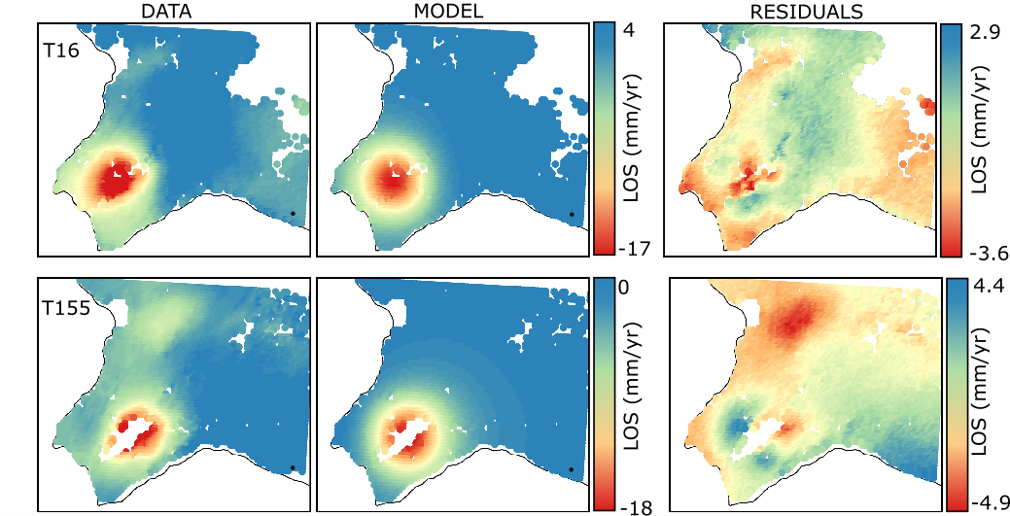

**Figure 4.7.** Unwrapped data, model and residuals for the ascending T16 and descending T155 datasets for the penny shaped crack model (upper two rows) and the horizontal square sill (lower two rows). Before modeling, the InSAR data inverted using the ISCE software (upper two rows) have been sub-sampled using a Quadtree approch with a treshold variance of 1 × 10-6 rad² for both T16 and T155, resulting in 366 observations for T16 and 311 observations for T155 (Appendix A, Fig. A1). The data is here displayed with the original multi-looked resolution of 40 m × 40 m. The InSAR data inverted using the approach of Drouin et al. (2017) have been sub-sampled into a larger grid with a regular spacing of 0.002°E and 0.001°N, resulting in 3846 and 3327 observations for T16 and T155, respectively. The data is displayed here with the sub-sampled resolution. The models are the ones that best fit observations. Residuals indicate the difference between the data and the model. The black dot indicates the location of the reference point situated at the position of coordinate (-22.564°E; 63.814°N) where the displacement is equal to zero.

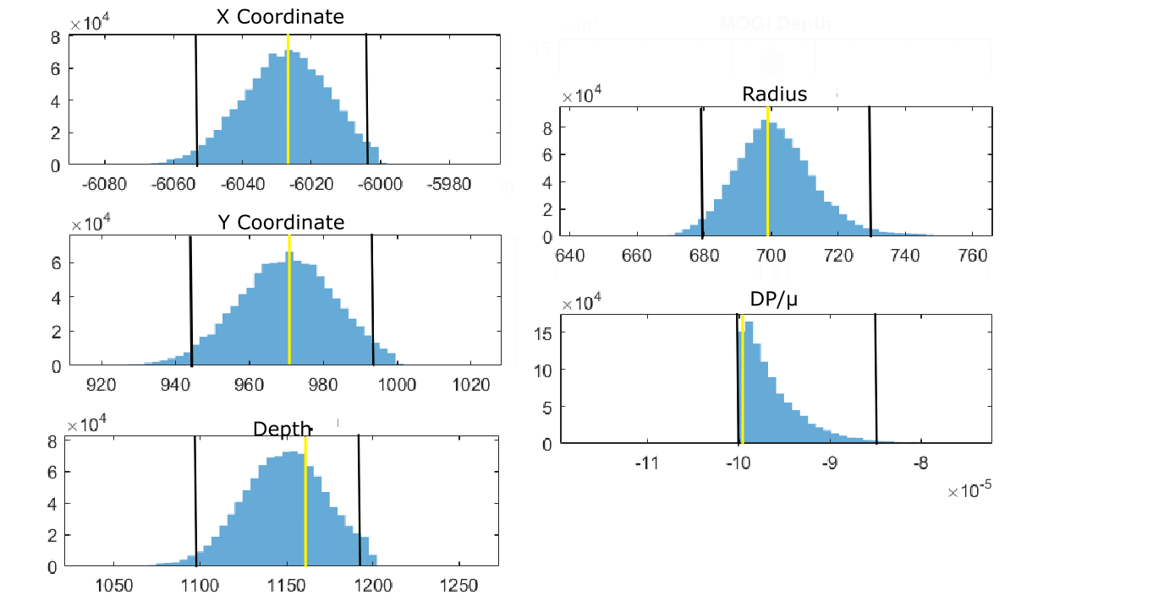 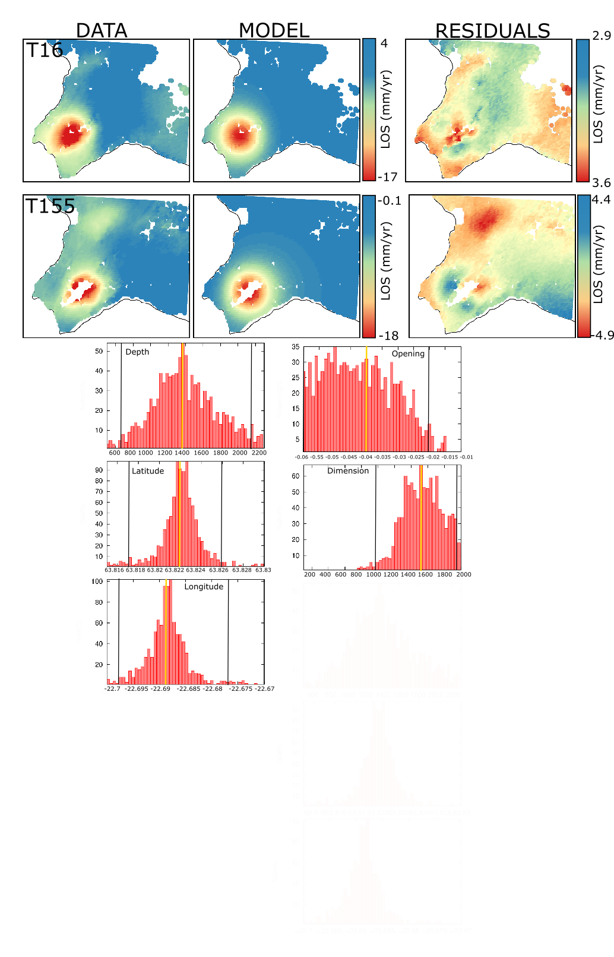

**Figure 4.8.** Histograms showing posterior distributions of values for the model parameters The orange lines correspond to the most probable value and the black lines indicate the boundaries of the 95% confidence intervals. a) Penny shaped crack model: X and Y coordinates relative to the reference point, depth, radius and ratio of pressure change over shear modulus. The histograms (blue bars) show values drawn from 1 milion iterations. b) Horizontal square sill: latitude, longitude, depth, opening rate and lateral dimension. The histograms (red bars) show distributions of values from 1000 bootstrap inversions

The lateral dimension of the deformation source is about 1.5 km for the Okada square, and the diameter for the penny shaped crack is about 1.4 km. Their areal extent thus averages 1.5 to 2.3 km² (Table 4.2), which coincide with the value of 2 km² used by Axelsson *et al.* (2015) to estimate the volume of the central part of the reservoir. The locations and the dimensions of the square sill and the penny shaped crack are shown in Fig. 4.9 relatively to the production field together with the estimated near-vertical velocity field. The centers of the deformation source are clearly situated in the area of maximum production, just north from Gunnuhver fumarole. The dimensions of the sources appear to coincide with the zone of the main upflow, where surface activity and alteration are the highest.

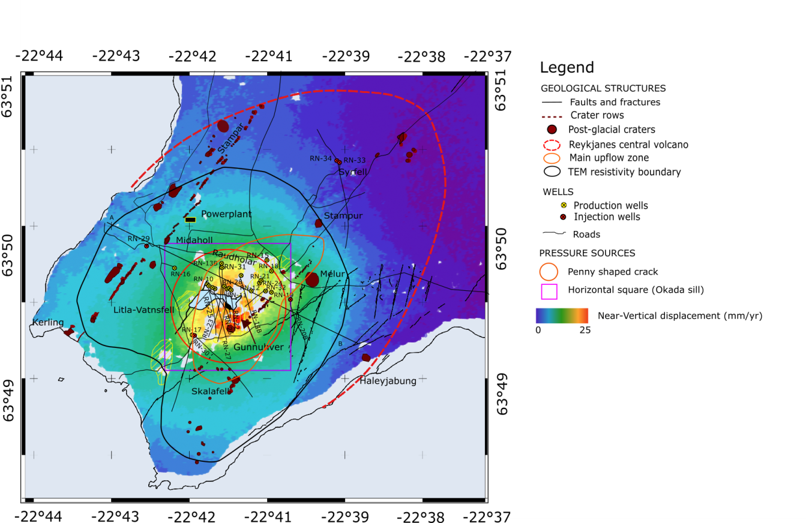

**Figure 4.9.** Near-vertical displacement velocity field together with the location of most probable square sill model calculated using the approach of Drouin et al (2017) and the most probable penny shaped crack model estimated from GBIS. The black outline corresponds to the boundaries of the geothermal system identified as the 8-10 km² caprock at 800 m depth by TEM surveys (Karlsdóttir and Vilhjálmsson, 2014). The NW-SE line indicates the location of the cross section in Fig. 4.11. Geological structures same as in Fig. 4.1.

An additional model based on using 17 point pressure sources with volume change proportional to the injection and extraction rates at each well has also been evaluated (Appendix A) in a similar manner as applied to the study of the deformation at Krafla by Drouin *et al.* (2017). This model, which indicates sources at 2 km depth, gives a significantly higher misfit to the data. We therefore conclude that the volume change during the period 2015-2017 could not be directly related to the production rates and water extraction from the deep liquid dominated zone of the reservoir.

## Relationship between volume change and physical processes

### Comparison with previous results and geological profile

Comparison of our modeling results for the 2015-2017 period with the results from earlier periods (Parks *et al.,* in review) indicates a continued decrease in the rate of volume change since 2006 (Fig. 4.10a). However, the decline in volume contraction in 2015-2017 relative to the period 2009-2016 is minor, and contrasts with the sharp decline observed between the 2005-2008 and 2009-2017 periods. A similar deformation source depth of about 1 km was found for all the best fitting deformation sources obtained from inversion of InSAR data between 2009 and 2017, indicating a migration of deformation processes from an initial depth of 2.2 km obtained from the inversion of the 2005-2008 data (Parks *et al.,* in review). The cumulative volume change (Fig. 4.10b) and the pattern of the decline in the rate of volume change (Fig. 4.10a) appears to correlate well with the decrease in the rate of pressure drop measured at 1625 m b.s.l in the reservoir until end of 2015 (Fig. 4.2). Between 2015 and 2017, minor pressure increase is however reported at 1625 m b.s.l. in the liquid dominated part of the reservoir, while a continued pressure decline cumulating up to 1.7 MPa between 2009 and 2017 was measured at 925 m b.s.l, in the upper steam dominated part of the reservoir.

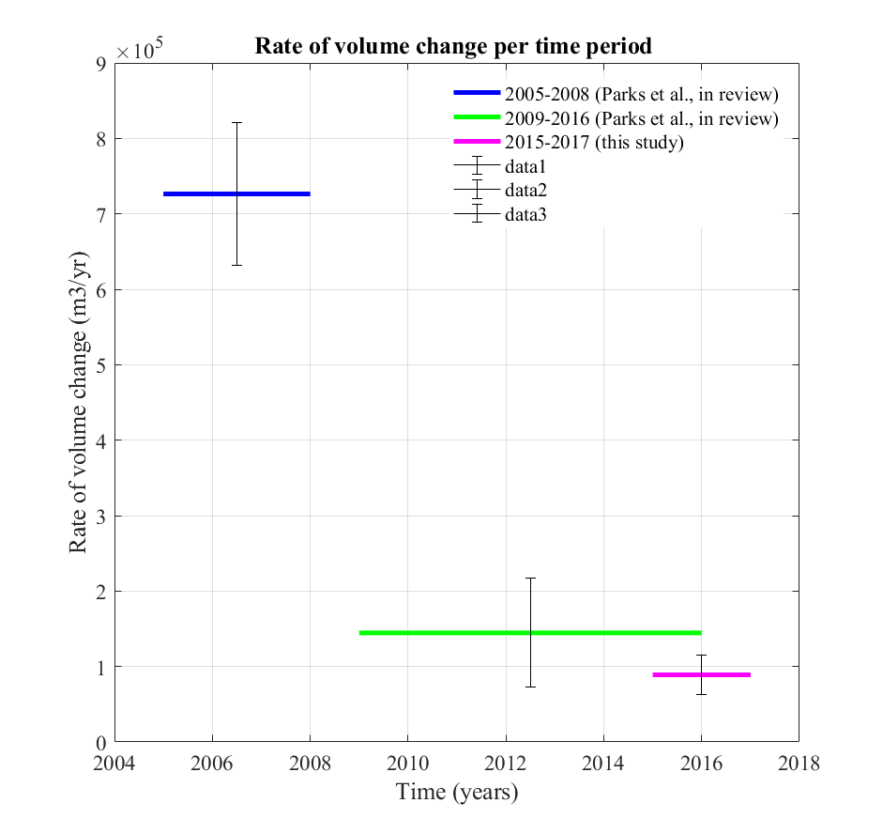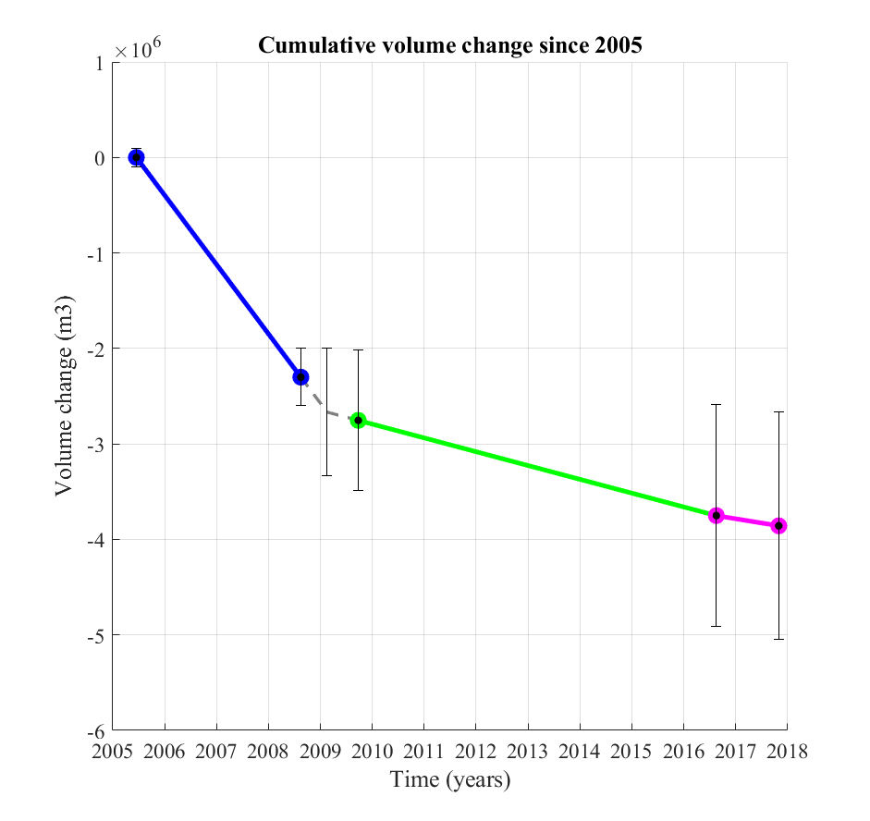

**Figure 4.10.** (a) Average values of the rate of best-fitting volume change for different time periods: 2005-2008 (blue), 2009-2016 (green) and 2015-2017 (purple). The vertical black error bars represent the range of possible values based on the different modeling results for each time period. (b) Cumulative volume change relative to 2005 for the period 2005-2008, 2009-2016 (Parks et al., in review) and 2016-2017 (this study). The vertical black error bars corresponds to the cumulative uncertainty for the total volume change at the beginning and at the end of each time period (dots), based on the uncertainty estimation in (a). The gray dashed line represent inferred average rates to calculate the cumulative volume change, given the lack of data between August 2008 and September 2009.

We compare the location of the deformation sources for each time period with the geological structure of the Reykjanes geothermal system in order to evaluate what geological formations are involved.

During the 2009-2017 period the centre of the best fitting deformation sources is situated at a depth of $1200 m±200 m$, slightly to the southeast of the hottest part of the system (around RN-10) and between the trajectories of some of the most productive wells in 2016, including RN-11, RN-26, RN-12, RN-23, RN-25 or RN-27 (Fig. 4.1c). The comparison of the lateral extent of the inferred source with the NW-SE geological cross-section (Fig. 4.11) indicates that the structure is dominated at that depth by rather fresh and porous breccias and pillow basalts only slightly compacted, with an average density $ρ=2500 kg/m^{3}$ (Friðleifsson *et al.,* 2017). This depth interval also coincides with the inferred location of the steam-water boundary and the depth of major feed zones, located just above the lower boundary of the steam cap (1100-1200 m depth).

From 2008 and until summer 2016, the shallow feed zones indeed supplied wells with dry steam formed from boiling of the geothermal reservoir water (Ó. Sigurðsson, HS-Orka, personal communication, 2017). The boiling zone in the reservoir would have expanded as a result of the initial pressure drop in the central part of the system, caused by the high production rates between 2006 and 2009, resulting in the development of a 300-400 m thick steam zone. Above the feed zones, the geological succession mainly consists of intensely altered hyaloclastite tuffs, intersected by thin layers of marine sediments, showing porosity of 32%, 23% and 19% at 300, 570 and 1370 m depth, respectively. This formation is likely to constitute a cap rock to the geothermal reservoir, extending from about 400 m down to 700 m in the centre and 900 m in the periphery of the system (Franzson *et al.,* 2002, Friðleifsson *et al.,* 2014). The porosity of the crystalline basaltic lava flows is expected to average 3 to 5 % (Sigurdsson, 2010).

The ellipsoidal source estimated to be responsible for the deformation during the period 2005-2008, whose centre is expected to be find at about 2.2 km depth, is located within a similar complex of pillow basalt and breccias, with however a greater density of dykes (extrusive-intrusive transition). This depth appears to coincide with the location of the main deep liquid-dominated feed zones, mainly associated with fractures along dykes.

***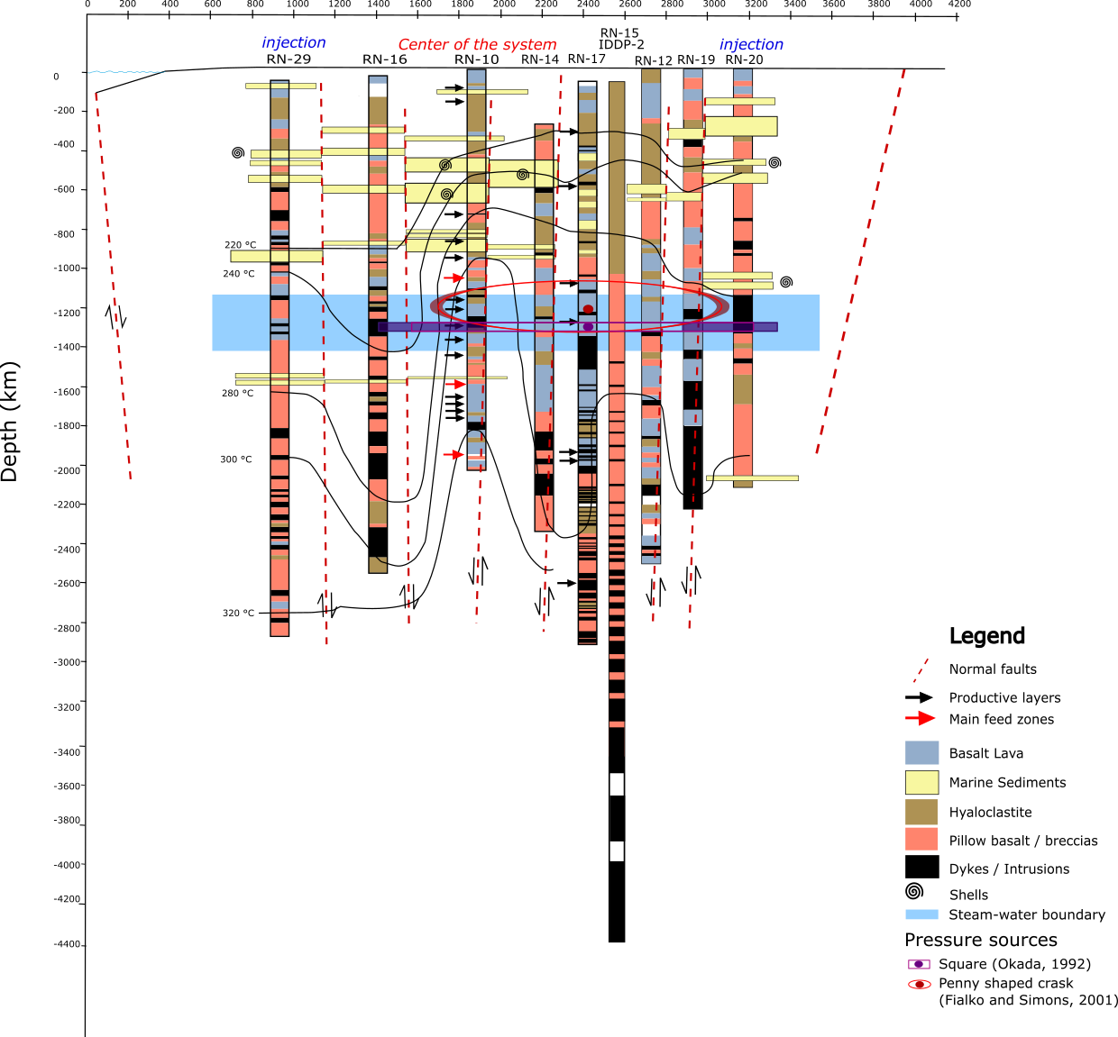***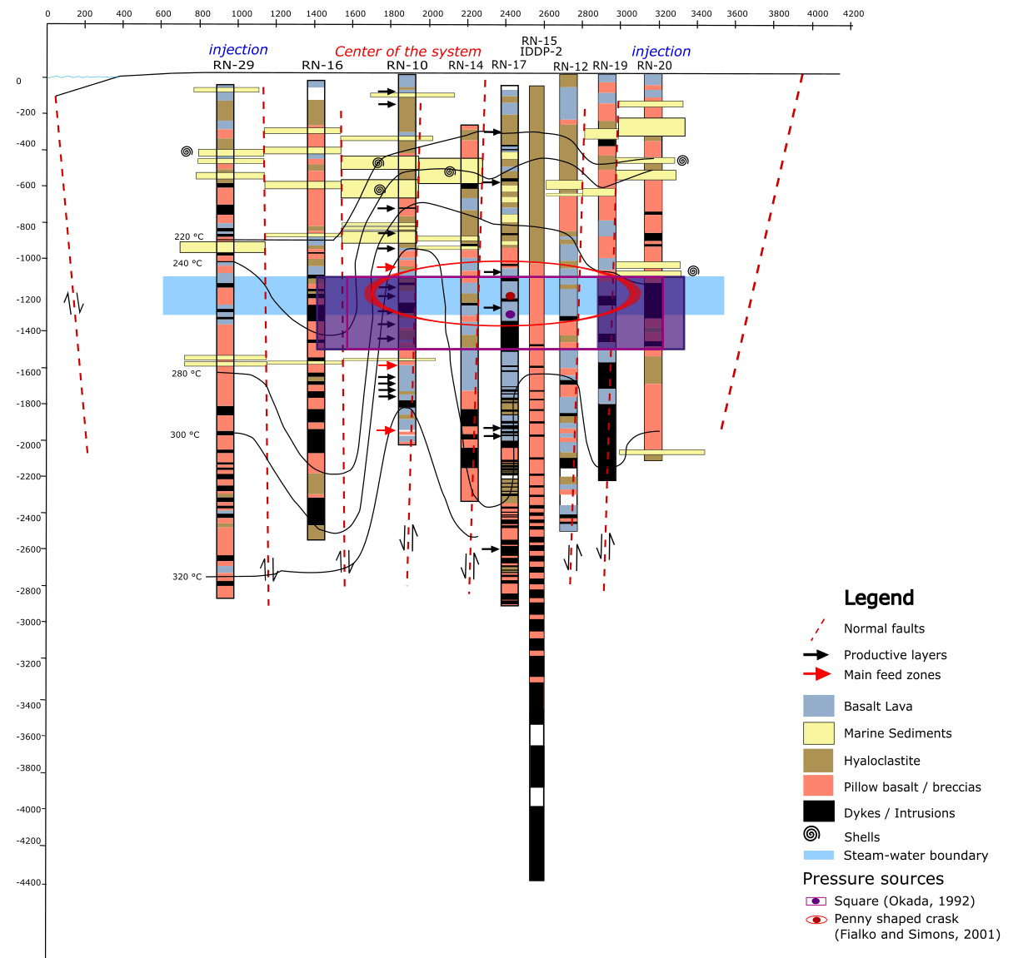

**Figure 4.11.** Geological well logs along a WNW-ESE cross section in the Reykjanes geothermal system together with isotherms, the graben structure (modified from Friðleifsson et al., 2014; Khodayar et al., 2016) and the location of the modeled rectangular square sill and penny shaped crack deformation sources. The purple shading gives the 95% confidence interval for the dimension for the sill source. Red shading shows similarly the 95% confidence interval for the lateral extent of the penny shaped crack, but its thickness is schematic (the model assumed thickness is much less than the lateral dimension). The modeled sources overlap with the inferred steam-water boundary. The blue rectangular shading indicates the possible depth range for this boundary between the end of 2006 and 2017, from 1100-1200 m (Friðleifsson et al., 2014) to 1300 m depth, which corresponds to the depth down to the bottom of the two-phase boiling zone (Franzson et al., 2002).

Laboratory analysis have been made within the IMAGE project on Reykjanes core samples from wells RN-17-b, RN-30 and RN-19, to determine the rock properties and their reaction to an increase in effective stress (Reinsch *et al.*, 2016). Results show that the rock matrix permeability commonly decreases linearly with increasing effective pressure, explained by a reduction of both porosity and permeability (Supplementary Material SM5). Hyaloclastites, which density and porosity are about 2700 kg/m3 and 13% at 2800 m depth (samples from RN-17 b), respectively, appear to be less sensitive to changes in effective pressure compared to dolerites and basalt, explained by the internal structure of the grains and pores of each formation. The hyaloclastite have mainly intra-granular porosity while the porosity of dolerites (about 3% for a density of 2900 kg/m3 at 2200 m depth in well RN-19) is characterized by intergranular micro-cracks situated on the boundaries of the grains. Thus, a smaller increase in mechanical stress is necessary to compact the dolerites, leading to a rapid and irreversible decrease in permeability with pressure. Over the tested effecting pressure range (0 to 100 MPa), the permeability of the dolerite from the RN-19 core sample (2238-2248 m depth) indeed decreased by two orders of magnitude.

We use the average thickness and porosity of each formation rock comprised between 0.8 and 2.8 km depth (Fig. 4.11) to estimate the total effective pore space in the central part of the reservoir (Appendix B). Based on the radius and the lengths of the modeled pressure sources, we estimate the average areal extent of the central part of the reservoir to be about 2 km² (Table 4.2). Using a reservoir thickness of about 2 km, the total volume of the reservoir is thus approximately 3.8 km3. This is comparable to the volume of 3 km3 estimated by Axelsson *et al.* (2015) and to the volume of the 2.6 km3 contracting ellipsoid modeled for the period 2005-2008 (Parks *et al.,* in review), but smaller than the total reservoir volume of 19 km3 estimated by Keiding *et al.* (2010).

**Table 4.2.** Comparison of the length and areal extent for the Penny shaped crack and the Okada sill. The height h of 300-400 m is used to estimate the volume of the Penny shaped crack and Okada sill, based on the inferred thickness of the steam zone, likely to be found between 800 and 1100-1200 m depth.

|  |  |  |  |
| --- | --- | --- | --- |
| Source | Penny shaped crack | Okada sill | Average |
| Radius (m) | 700 | - | - |
| Length (m) | - | 1500 | - |
| Areal extent (m²) | $$1.5×{10}^{6}$$ | $$2.3×{10}^{6}$$ | $$1.9×{10}^{6}$$ |
| Volume source (for a thickness of 300-400 m) | $$0.6-0.8×{10}^{9}$$ | $$0.7-0.9×{10}^{9}$$ | $$0.6-0.9×{10}^{9}$$ |

We assume that the porosity of the hyaloclastites and sedimentary layers, basaltic lavas, pillow basalts and breccias, and the fracture porosity associated with dyke intrusions are ${φ_{hc}=23\%, φ}_{b}=5\%$, $φ_{p}=20\%$ and $φ_{f}=13\%$, respectively (Appendix B). We find that the greatest amount of porous space, about 4 × 108 m3, is contained in the fractured basaltic lava and dyke complex, for a total estimated pore space of about 6 × 108 m3representing an average reservoir porosity of 15%. A total closure of the estimated pore and fracture space within the fractured basalt and dolerites complex would therefore induce a total volume change of -4 × 108 m3, concentrated below 1000 m depth, where these rocks are dominant. This value is about two orders of magnitude higher than the cumulative volume change ${∆V}_{tot}$ of -3.9 × 106 m3, estimated at Reykjanes since 2005 (Fig. 4.10b). We therefore infer that only minor (on the order of 1%) closure of pore space and rock compaction has occurred in the reservoir between 2006 and 2017.

### Deformation and physical processes

Ground deformation above geothermal reservoirs is often attributed to poro-elastic or thermo-elastic processes, associated with pressure change or the cooling of the reservoir rock. All the above mentioned modeling efforts consider either a pressure change or displacement at the boundaries of the inferred deformation sources.

Change in specific volume, $v$, relates to change in pressure, *P*, and temperature, *T*, through the following equation:

$dv=\left(\frac{dv}{dT}\right)dT+\left(\frac{dv}{dP}\right)dP=vα_{v}dT-vcdP$ (4.4)

where $α_{v}$ is the volumetric coefficient of thermal expansion and *c* the uniaxial poro-elastic expansion coefficient of the saturated material. In a liquid-dominated system, the reduction of pore or fracture pressure $dP$ as a result of the depletion of fluid storage, may lead to the compaction of water bearing deposits under increasing effective stress. Volumetric contraction can also be induced by cooling of the rock matrix under natural recharge or reinjection of cooler fluid as well as water vaporization, process requiring the transfer of heat energy from the rock to the fluid (*e.g.,* Im *et al.,* 2017, Ali *et al.,* 2016).

Thermal and poro-mechanical processes may be coupled and can occur on various time scales that can be complex to identify. Moreover, the migration of the modeled source of deformation from 2.2 to 1 km depth together with the change in both the subsidence pattern and the deformation rate since the end of 2008 clearly suggests some modifications in the deformation mechanisms within the Reykjanes geothermal reservoir. Different scenarios have been proposed by Parks *et al.* (2017) to explain the relationship between the deformation rates and the pressure and temperature, two of them suggesting a change in the material properties over time. This includes a possible nonlinear relationship between the deformation and the pressure decline or a change in the reservoir compressibility with time. A third hypothesis suggests that the recent volume change would be linked to thermal contraction of the rock at shallow depth where cooling might occur. We explore each of these processes in details in the following, considering in particular possible pressure and temperature decrease within a shallow steam zone.

### Relationship between volume and pressure changes

The main cause of volume change within a geothermal reservoir is often attributed to the compaction of unconsolidated layers in response to utilization. Compaction process can be related to pressure change through the one dimensional Terzaghi poro-elastic consolidation theory (Terzaghi, 1925). This theory suggests that the reduction in thickness of a layer results from a closure of the pore space in response to slow drainage of the pore water from stressed deposits followed by a reduction of the grain size under inter-granular transfer of the stresses. In absence of temperature change, equation 4.4 can be transformed into:

$∆h=- c h_{0} ∆P$ (4.5)

where $∆$*h* is the amplitude of the compaction, and $h_{0}$ is the thickness of an unconsolidated layer. The compaction therefore mainly depends on the amount of pressure drop $∆P$ and on the total compressibility *c* of the pore fluid and rock matrix (Geertsma, 1957), but also on the initial porosity and permeability of the reservoir rock and its pre-consolidation stress (Bull, 1964; Grant *et al.*, 1982; Zhang *et al.,* 2012; Mondoni *et al.,* 2013). The isothermal compressibility *c* describes the change in volume due to a change in pressure under isothermal conditions. Depending on the nature of the system (*i.e.* confined, unconfined, liquid-or steam-dominated system), it also controls the mass of fluid that can be stored or released per unit volume of rock under a unit pressure change, referred to as storativity (Axelsson*,* 2012a).

With, compaction, the porosity of the volume of rock involved is expected to decrease, causing a progressive decline in the total system compressibility and thus in the rate of deformation (Zang *et al.,* 2009). Change in compressibility *c* might occur in high-temperature geothermal reservoir under production as a result of a change in the pore fluid resulting from boiling or re-saturation processes. Grant *et al.* (1982) showed that for the same reservoir volume, the total compressibility of a confined two-phase system (10-6 Pa-1) is generally one order of magnitude higher than the compressibility of dry steam (10-7 Pa-1) and three orders of magnitude higher than liquid compressibility (10-9 Pa-1).The notion of storativity is preferably used in the case of two-phase systems, where the system compressibility depends on both the compressibility of the solid matrix and the relative proportion of liquid water and steam phases, likely to change under change in pore pressure (Axelsson, 2012a). Change in storativity is therefore likely to impact the storage and deformation mechanisms of the rock that in return will control the reservoir pore pressure and temperature (Bromley *et al.,* 2015).

We explore the relationship between the estimated volume change for each time period and the measured pressure change at 1625 m b.s.l (${∆P}_{1625}$) and 925 m b.s.l (${∆P}_{925}$) to evaluate the change in the storativity of the system. This would be attributed to an increase in the pore fluid compressibility as a result of the replacement of liquid water by steam in the steam zone, developed between 2006 and 2009 from boiling of the initially liquid dominated reservoir. In absence of temperature change, equation 4.4 equals:

$c=\frac{∆V}{∆p}\frac{1}{V}$ (4.6)

We assume that ${∆P}_{1625}$ is the pressure change in the liquid dominated part of the system of initial volume $V_{r}$ during the period 2005-2008, while ${∆P}_{925}$ is representative after 2009 of the pressure change within the steam zone of volume $V_{ur}$ formed in the upper part of the reservoir. In a liquid dominated system, the decrease in pore pressure $∆P$ can be related to the amount of water drawdown $∆l$ by:

$∆P=∆l ρ_{f} g$ (4.7)

where $ρ_{f}$ is fluid density and $g$ the gravity constant.

Using Equation 4.7, we estimate that a 2.9 MPa pressure drawdown (2005-2008) due to the extraction of fluid with a density of 732 kg/m3 at an average reservoir temperature of 290°C would induce a drawdown of the water level of about 400 m. If we assume that all the water is extracted from storage within the 3.8 km3 reservoir of porosity $φ=15\%$, this drawdown would release a pore space on the order of 0.1 km3. The amount of drawdown also represents 20% of the inferred 2 km productive thickness of the reservoir (Appendix B) and thus, the total volume available for the steam cap $V_{ur}$ would be about 0.8 km3. This ratio is slightly higher than the steam fraction estimated from the enthalpy of a 290°C reservoir fluid ( $P_{sat}=$ 7.5 MPa) reaching pressure conditions within the inferred steam zone $P_{sat}=$ 3.5 MPa (Appendix C). This estimated steam fraction might indeed only consider the share of segregated “dry” steam in the steam cap, while a two-phase boiling fluid contained in a porous reservoir can have any steam-water ratio (Grant & Bixley, 2011).

We use $V_{ur}$ = 0.6-0.8 km3 in the following, in accordance with the volume estimated from the average areal extent of the modeled deformation sources and the inferred average thickness of the steam zone (Table 4.2). The ratio $∆V$/ ${∆P}_{1625}$ and $∆V$/ ${∆P}_{925}$ estimated for each time period are summarized in Table 4.3.

**Table 4.3.** Summary of the parameters used for the estimation of the compressibility in the liquid dominated part of the reservoir (based on the 2005-2008 time period) and in the steam zone (based on the 2015-2017 time period). For each time period is given the reservoir volume invloved in the deformation, the estimated volume change as well as the pressure drawdown deduced from pressure measurements at 925 m b.s.l in well RN-27 (Guðmundsdóttir, 2016; Khodayar et al., 2016) and at 1625 m b.s.l in well RN-12 (Þorvaldsson & Arnaldsson, 2017), as shown in Fig. 4.2.

|  |  |  |  |  |  |  |  |
| --- | --- | --- | --- | --- | --- | --- | --- |
| Time period | Reservoir volume V involved in deformation ${(m}^{3}$) | Volume change (m3) | Pressure change (MPa) | (m3/Pa) | Pressure change (MPa) | (m3/Pa) | Total compressibility c ( $Pa^{-1})$ |
| 2005-2008 | $$3.8×{10}^{9}$$ | *- $2.3×{10}^{6}$* | -2.9 | $$0.79$$ | - | - | $$2.0×{10}^{-10}$$ |
| 2016-2017 | $0.6×{10}^{9}$- $$0.8×{10}^{9}$$ | - $0.9×{10}^{5}$ | - | - | -0.15 | $$0.60$$ | $1.0×{10}^{-9}$- $$8.0×{10}^{-10}$$ |

Considering a uniform pressure drop within the whole reservoir of total volume $V=V_{r}$ between 2005 and 2008 (Fig. 4.2), we find a value for the total compressibility of about 2 × 10-10 Pa-1 using /This value is assumed to represent the compressibility of the liquid dominated system and is in accordance with the total compressibility estimated from injection in the deep well RN-30 (Kajugus, 2015). We then use the $∆V$/ ${∆P}_{1625}$ ratio from 2016-2017 together with a volume range $V=V_{ur}$, to estimate the compressibility of the steam saturated material that is assumed to contribute to additional deformation in the upper part of the system, with however uncertainty related to the thickness of the steam zone. We find a lower estimate, in the order of 1 × 10-9 Pa-1 for = 0.6 km3, which is in accordance with the total system compressibility estimated from injection tests in the shallow well RN-32 (Kajugus, 2015). It is also one order of magnitude higher than the compressibility of the liquid dominated zone, as inferred by Grant *et al.* (1982).

The values of compressibility in Table 4.3 indicate that the geothermal reservoir should not be considered as a uniform volume and that heterogeneous compaction might occur at different depth. We can therefore use these values to estimate the amount of compaction that may have occurred as result of the total pressure drawdown within the liquid dominated part of the reservoir and within the steam zone, during different time periods. Between 2005 and 2015, a drawdown of 3.8 MPa has been measured at 1600 m depth in the central part of the system, in well RN-12, and of 2.5 MPa at the periphery, in well RN-16 (O. Sigurdsson, HS-Orka, personal communication, 2018). Using an average pressure drawdown of 3.2 MPa [2.5-3.8 MPa] over the whole 2 km² area, an average compaction of -1.3 m is estimated for a compressibility equal to 2 × 10-10 Pa-1 and a reservoir thickness of 2 km. This would produce a volume change = -2.6 × 106 m3 which is somewhat lower than the cumulative volume change of about -3.5 × 106 m3, inferred between 2005 and 2015 from InSAR (Fig. 4.10b).

We thus examine the amount of compaction that would result from the continuation of pressure decline at the depth of the modeled deformation source from 2009 and until 2017. As mentioned earlier, this compaction may result from the additional 1.7 MPa pressure drop monitored during that time period in the steam cap (Fig. 4.12a), where water has been replaced by steam, resulting in higher system compressibility of 1 × 10-9 Pa-1. We here assume that the steam cap has an initial thickness of 400 m and find that a vertical compaction of -0.7 m might occur at shallow depth, corresponding to a volume change in the steam zone of = -1.3 × 106 m3. The compaction of the liquid dominated part of the reservoir together with the steam dominated does together produce the observed total volume change ${∆V}_{tot}$ over the whole production period 2005-2017 (Fig.4.10b). Comparing the total amount of compaction inferred in this manner and the estimated volume of pores in the reservoir, we can estimate the change in porosity to be about 0.7%.

We can alternatively use the results from the penny shaped crack model for the period 2015-2017 to determine the relation between pressure and the volume change that would occur in an oblate spheroid, considering it to represent the steam cap. In a penny shaped crack model, the pressure change is related to a volume change $∆V$ by:

$∆P=\frac{µ}{2a^{3}}∆V$ (4.8)

The radius estimated in the inversion is well constrained to $a=700 m$, and the inferred volume change of the source is -0.7 × 105 m3/yr. The value of the effective shear modulus *µ* in geothermal areas is uncertain, but we look at the possible range from 1 to 30 GPa. If we consider the estimated ratio of pressure change over shear modulus $∆P$/µ = -9.96 × 10-5 obtained from the penny shaped crack model, with $∆P$ = -0.15 MPa we obtain the inferred volume change of -0.7 × 105 m3/yr for a shear modulus of 1.5 GPa. This is more than one order of magnitude lower than the value of shear modulus used for regional geodynamical models (often 30 GPa).

Given the uncertainty in the actual value of the shear modulus, we also explore the possibility of cooling within or above the steam cap to explain the volume change during the 2015-2017 period in the following section.

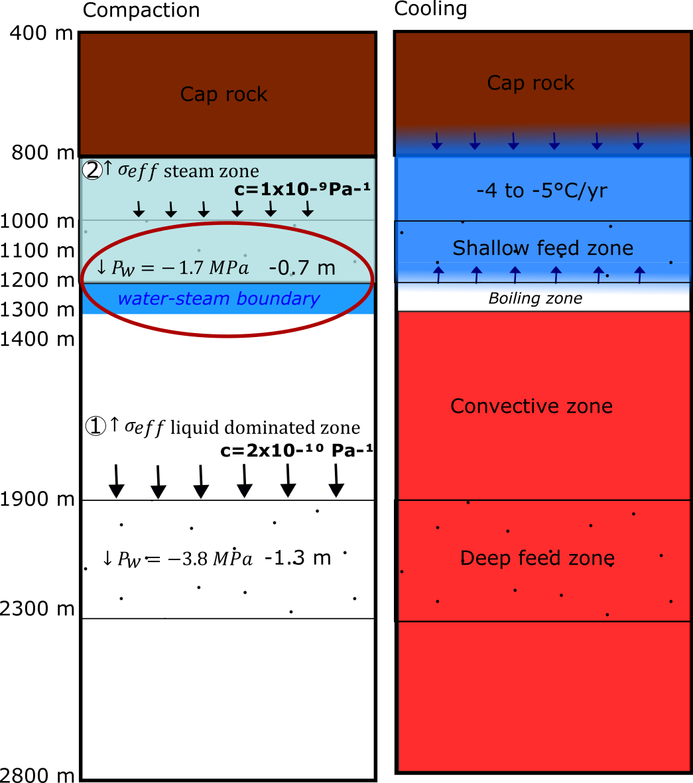

**Figure 4.12**. Interpretative scheme for (a) compacting layers under pressure decrease (Þorvaldsson and Arnaldsson, 2017), and (b) contraction of rock by cooling. Brown area corresponds to cap rock. The black and dark blue arrows indicate poro-elastic compaction and thermo-elastic contraction, respectively In (a), the light blue corresponds to the steam cap, the blue line to the expected water level since the end of 2008 after drawdown. The value of -0.7 m corresponds to the average compaction of a 400 m thick steam zone with a compressibility of 1 × 10-9 Pa-1 and the -1.3 m compaction in the deeper part of the system take into account the average compaction of the total reservoir thickness with a compressibility of 2 × 10-10 Pa-1,since the onset of production in 2006. The oblate spheroid represents the penny shaped crack model inferred from the geodetic measurements. In (b) the red corresponds to the convective part of the reservoir (Franzson et al., 2002), and light blue to cooling zone active at present. The cooling of -4 to -5°C/yr is deduced from the difference in temperature at 925 m b.s.l. between 2008 (270°C) and 2015 (240°C) measured in well RN-27 (Guðmundsdóttir, 2016 In: Khodayar et al., 2016).

### Cooling of a horizontal layer

In addition to the recent shallow depressurization, cooling trends have been suggested close to and within the steam cap (Guðmundsdóttir, 2016). The 2016 conceptual model of the Reykjanes geothermal area by ISOR - Iceland GeoSurvey (Khodayar *et al*., 2016) suggests a decrease in temperature from 270°C in 2008 to 240°C in 2015 at 925 m b.s.l, representing a cooling rate of about -4 to -5°C/yr within a volume of rock situated between about 600 and 1200 m depth (Khodyar *et al.,* 2016). However, no signs of cooling have been detected in the convective liquid dominated part of the reservoir, below 1500 m (Fig. 4.12). There a slight increase in the average temperature from 270-280°C to 280-290°C has been inferred in association with the increase in enthalpy between 2006 and 2010 (Fridriksson *et al.*, 2010). In the absence of pressure change, Equation 4.4 can be written as:

$∆h_{t}=γαh_{t}∆T$ (4.9)

if a new coefficient $γ$ is introduced (see below). This equation relates the amount of contraction in the vertical dimension $∆h_{t}$ of a rock body of initial height $h_{t}$ due to a change in temperature $∆T$. Considering that rock contraction under cooling is a volumetric process, Werner *et al*. (2017) suggested the existence of a coefficient $γ$ to explain how the linear coefficient of thermal expansion $α$ relates to change in elevation. If the volumetric contraction is only accommodated by contraction in the vertical direction due to cooling from above or below and no change in the horizontal dimension is induced, then $γ$ = 3. The product $γα$ is referred to as the effective vertical thermal expansivity. Estimates for the volumetric coefficient of thermal expansion of the rock $α_{v}$ generally vary, including values of 1 × 10-5 °C-1 (Fialko & Simons, 2000, Ali *et al*., 2016), 5 × 10-5 °C-1 (Im *et al*., 2017), of 2 × 10-5 °C-1 in basalt-like composition rocks (Robertson, 1988), and values as low as 3 × 10-6 °C-1 have been suggested by Peck (1978) for Alae Lava Lake in Hawaii.

Using Equation 4.9, we estimate the temperature change that would be necessary to produce the same volume change as observed by InSAR, if cooling occurs near or within the steam zone. One can use the inversion results for a horizontal Okada sill of 1.5 km side contracting by a constant amount of -0.04 m/yr, corresponding to a volume change of 0.9 × 105 m3/yr. This model is chosen for its direct estimation of vertical closing, considered to represent at best the vertical contraction of a horizontal layer due to cooling. We first assume that the sill represents the 400 m thick layer of rock within the steam zone. Using a range of effective vertical thermal expansivity values (0.1 - 2) × 10-5 °C-1, we find that the temperature change required to reproduce the inferred volume change during the period 2015-2017 ranges between -100°C/yr and -5°C/yr. For a temperature change of about -4°C/yr, a contracting layer of about 500 m could produce the observation for 2 × 10-5 °C-1 (Fig. 4.12b).

These results indicate that the thermal contraction of rocks resulting from a 4-5°C/yr cooling within a 400-500 m thick layer can produce the same volume change as a pressure decrease, only with an effective vertical thermal expansivity of about °C-1. This thickness is consistent with the vertical extent of the cooling rocks modeled in the upper part of the geothermal system, between 600 and 1200 m $±$ 100 m depth, in the temperature profiles of the 2016 conceptual model displayed in Fig. 2.9 (Khodayar *et al*., 2016).

The analysis above shows that either poro-elastic or thermo-elastic processes, or a combination of both, in or near the steam cap zone in the Reykjanes geothermal reservoir, may be responsible for the deformation during the period 2015-2017. Temperature change within a steam cap would be closely related to a pressure change under processes linked to the boiling conditions of a two-phase system. Furthermore, explaining the deformation only in terms of pressure change or temperature change requires values for effective shear modules and effective vertical thermal expansivity at an extreme end of the likely value for these parameters. Therefore, deformation mechanisms may be expected to result from the combined action of temperature and pressure decline, requiring more realistic values for the shear modulus and thermal expansivity.

## Discussion

We have explored the different physical processes that may explain the volume change of the Reykjanes geothermal reservoir during the 2015-2017 period, based on the measured surface deflation with InSAR methods. Two main deformation processes have been explored. First, we suggested the possibility of compaction of a layer of reservoir rock under pressure decrease within a steam zone of higher compressibility (Grant & Sorey, 1979). Then, we suggested the thermal contraction of the rocks in the upper part of the reservoir due to cooling within the steam cap.

All GPS, InSAR and gravity modeling results since 2008 indicate that the center of mass/volume change is at about 1-1.3 km depth (Gudnason *et al*., 2018). This depth interval coincides with the location of major productive layers that supplied wells with a dry steam from 2008 and until summer 2016. A slight increase in pressure has been recorded at 1625 m b.s.l between 2015 and 2017, which could indicate a response of the reservoir to reinjection performed from 2009 to February 2017. All these elements suggest that the subsidence observed between April 2015 and October 2017 does originate from a shallow steam zone. The lateral extent of the modeled depressurized source indicates that this steam cap covers a surface area of about 2 km², in accordance with the extent of the geothermal manifestation on surface (Palmason *et al*., 1985), delimited by the two major faults, Litla-Vatnsfell to the west and Skalafell to the east. Assuming a total thickness of 300-400 m, the steam zone would represent an effective volume of about 0.7 km3 compared to a total volume for the productive reservoir of about 3.8 km3.

Modeling results from the inversion of InSAR data for the period 2005-2008 indicated a source of deformation at 2.2 km depth at Reykjanes. Based on the deformation analysis for this time interval, we suggest immediate and irreversible compaction of the basaltic rocks and dolerite in response to the sudden pressure drop of about 3.0 MPa within the three first years of production. The large permeable NE-SW striking faults of the fissure swarms constitute flow path likely to enhance pressure diffusion and compaction in the deepest part of the reservoir, along this direction. Considering the high sensitivity of these rocks to an increase in effective stress (Supplementary Material SM5), they could thus have controlled the pattern of the compaction, explaining the NE-SW elongation of the deformation bowl in 2005-2008.

During the period 2015-2017 (this study), modeling results indicate some residuals elongated in the NE-SW direction, suggestion that NE-SW faults of fissure swarm still have some influence on the deformation field.

A non-linear relationship between pressure change and the volume change of the deformation sources could contribute to our results. Such process has been explored for example at the Ohaaki and Wairakei–Tauhara geothermal fields in New Zealand, where subsidence is inferred to be due to a reduction in pore pressure in a shallow steam zone as a result of geothermal production (Allis, 2000; Koros *et al*., 2016). Non-linear and delayed subsurface compaction at gradually falling rates was explained by a slow drainage of shallow boiling sandstone layers containing locally porous (about 50% porosity) and low-permeability interbeds, weakened by a high alteration level (White *et al*., 2005; Bromley *et al*., 2006; Holes *et al*., 2007; Brockbank *et al*., 2011). Creep deformation appeared to be related to the high compressibility of the fined-grained clay mineralogy such as smectite, present at 5-30% in the Huka Falls Foundation mudstone aquitards and estimated to be about two orders of magnitude higher than the compressibility of typical 5-10% porous basement rock (Bromley *et al*., 2009). This property increases their sensitivity and their chance to compact under increasing normal stresses (Bromley & Reeves, 2013).

At Reykjanes, the continuation of pressure decrease at shallow depth or the existence of a slow diffusion of the effect of this pressure decline might be influenced by zones of lower permeability. Those would be related to high level of smectite and chlorite alteration of the volcano-sedimentary series situated above 1200 m depth. These weakened formations are situated just above and within the inferred steam zone where the pore fluid compressibility is higher, which could explain a non-linear or delayed response of compaction to pressure decrease, responsible for the continued subsidence at lower rate since 2009. However, such process might be buffered by the presence of hard and dense layers consolidated by secondary mineralization (*i.e.* by quartz, anhydrite, calcite) likely to decrease the porosity.

Thermal effect can thus also be considered as a mechanism taking over the initial poro-elastic deformation. It has indeed been shown that subsidence in geothermal systems is generally proportional to the general pressure decline in the field and attributed to poro-elastic compaction during the first years of utilization (Mossop & Segall, 1997). After a while, equilibrium is reached and thermal contraction becomes the main long term deformation mechanism at many systems (Im *et al*., 2017).

Cooling can indeed result from heat exchanges between the host rock and colder reinjected fluid or water naturally inflowing onto the system as a response to geothermal fluid extraction. Thermal effects have been suggested to be the cause of the subsidence observed in the Krafla geothermal field in Iceland (Drouin *et al*., 2017). Despite cold inflow in the upper part of the system at Reykjanes may explain the observed cooling by heat mining, no significant temperature change has been measured in the convective zone (below 1500 m depth) since production started. In addition, a slight but continuous decrease in the discharged enthalpy between 2010 and 2017 (Khodayar *et al.,* 2016) suggested that the steam cap was no longer expanding during the 2015-2017 period. As vaporization of water is not expected to occur, other processes linked to the two-phase nature of the geothermal system are considered in order to explain cooling of the rock in the boiling and steam zones (700-800 to 1200-1300 m), with respect to pressure changes.

Pressure in a steam zone may indeed rise or fall depending on the mass and energy balance related to the displacement of the water-steam boundary, influenced by steam gain from boiling or steam losses (i.e. to surface, to well discharge, or condensation). When cold water is reinjected within a steam cap, steam condenses to provide the system with the energy needed to heat up the inflowing water to reservoir temperature. The volume of steam condensed is generally higher than the volume gained as liquid water from both recharge and steam condensation due to the expansion effect of water, resulting in a loss of volume within the reservoir that can induce surface subsidence. The overall process may reduce both pressure and temperature within the steam zone (Grant *et al.*, 1982). When cold water is re-injected in the liquid dominated part of a system, as is the case at Reykjanes, boiling can be reduced, decreasing the generation of steam and providing less recharge to the steam zone. As no heat is carried up to the surface, cooling will occur together with pressure decline in the zones at boiling point depth (Bromley *et al*., 2009). Thus, reinjection can enhance subsidence by cooling the topmost part of the reservoir more than it counteracts it by providing pressure support in the lower part of the reservoir. This mechanism has been inferred to be responsible for continued subsidence at Spa Bowl, New Zealand (Bromley, 2015). It could also explain the gradual pressure and temperature decrease measured since 2009 in the steam cap at Reykjanes, when reinjection started.

The complexity in discriminating between the domination of poro-elastic or thermal effects developed in the previous chapter leads to the conclusion that a combined effect of temperature and pressure decrease is responsible for the observed volume change during the period 2015-2017. This volume change would represent a decrease in the rock volume within the shallow steam cap and could be explained by the recent production history of the reservoir: increase in the direct extraction of steam from the steam zone between 2009 and 2016, increase in reinjection rate in the liquid dominated part of the reservoir during the period Mid-2009 to February 2017 or related to the general decrease in production rate since 2009. The two last hypotheses would be responsible for steam condensation and re-saturation of the major steam zones in the upper part of the system (e.g. new rise in the steam-water boundary level). In addition, the natural cold seawater recharge might also contribute to the recharge of the system. We also explored possible cooling from above related to the presence of a shallow lens constituting a seawater aquifer above the cap rock. The time required to cool down the upper part of the system by conductive heat transfer through the impermeable cap rock (hundreds of years) cannot explain the observed cooling and therefore suggest the necessity of cooling by fluid convection (see Supplementary Material SM5).

The free access of the Sentinel-1 data with a 6 day acquisition interval has allowed us to create a time series of ground surface deformation with a dense temporal but also good spatial resolution from April 2015 to October 2017. The linear LOS increase of about 16 mm/yr measured in average in both ascending and descending have been associated with an average volume decrease in a steam zone of 0.9 × 105 m3/yr. Models of deformation processes have been realized based on the monitored pressure and temperature at 925 and 1625 m b.s.l, showing that both rock contraction and compaction under temperature and/or pressure decrease in the upper part of the system could explain this rate of volume change. We thus interpret the modeled 2015-2017 volume change to reflect a decline of a shallow steam cap resulting from a lack of steam upflow and/or steam condensation, induced by natural cold recharge or re-injection. These processes led to a decrease in both pressure and temperature in the steam zone as well as an increase in the reservoir pressure in the liquid dominated zone, after the initial years of production when the steam cap expanded.

In spite of their simplicity, the use of analytical model to simulate InSAR observations appears to be a valuable tool to monitor change and to improve understanding of the long term sub-surface processes occurring in utilized geothermal systems. However, only a long-term monitoring of pressure and temperature changes throughout the whole reservoir depth range and a comparison of modeling results with the production data would allow discriminating between the poro-elastic and/or thermo-elastic processes responsible for the reservoir contraction over time. Further analysis of mass and heat transfers can be carried out to explore the plausibility of this conclusion. The use of numerical models such as the non-isothermal multiphase multicomponent fluid flow simulator TOUHGH2 (Pruess *et al.,* 1999) or the parallel finite element code for modeling crustal deformation Defmod (Ali, 2014) combined with the approach of Coco *et al*. (2015), would support the investigation of the deformation processes and the identification of the main hydraulic pathways, by taking into account the heterogeneities of the system (i.e. permeability, compressibility, thermal properties). With a better understanding of pressure and heat diffusion through the system with respect to the production history and the monitored subsidence, it would allow better identifying the cooling effect of fluid advection and the timing of compaction, useful to predict future behavior of the system in response to production/injection.

## Conclusion

Ground deformation at the Reykjanes geothermal area during the 2015-2017 period is well revealed by by interferometric analysis of Sentinel-1A and 1B radar images. LOS changes average - 16 mm/yr in the satellite LOS in the selected area of maximum deformation in both ascending and descending satellite tracks, with a maximum LOS velocity of about - 25 mm/yr observed in Track 155. When results from the two tracks are combined, the observations reveal a subsidence bowl centered on the well field together with a horizontal contraction toward the center of the most deforming area. This subsidence can be fit with different sources of simple geometries, including a penny shaped crack model and a horizontal square layer, contracting at an average rate of 0.9 × 105 m3/yr at about 1200 m depth. Models of deformation mechanisms reveal that this volume change can be explained by a combination of a compaction of a 400 m thick layer under a pressure decrease of 0.15 MPa/yr and by thermal contraction related to a 4-5°C/yr cooling of rocks within or close to a steam zone. Such changes in pressure and temperature have been measured above 1200 m and therefore suggest that during the 2015-2017 time period, subsidence is controlled by the changes in the steam cap of the geothermal system.

## Acknowledgements

We thank HS-Orka, the power company running the Reykjanes geothermal power plant, for its collaboration, support, and for sharing the production and monitoring data. We also acknowledge the German Aerospace Center (DLR) for the access to an intermediate TanDEM-X digital elevation model under project IDEM-GEOL0123. Thanks to the European Space Agency for giving free access to the Sentinel-1 data through the Copernicus Hub. The processing of the interferograms was realized using the ISCE software (Bagnardi & Hooper, 2017), and the figures produced with the GMT (Wessel and Smith, 1998) and QuantumGIS softwares.

## Appendices

#### **Appendix A: Modeling results for the inversion of the average velocities obtained from time series analysis, for the single Mogi source, the McTigue finite spherical source, the rectangular Okada layer and for the inversion based on several Mogi sources with a volume change proportional to the extracted/injected mass at each borehole (well coordinates at 1000 m depth).**

#### Single Mogi source modeled using GBIS: Data (Fig. A1), data, model and residuals (Fig. A2) and corresponding histograms of samples from the posterior distributions of the model parameters (Fig. A3). The results are summarized together with other inversion results in Table 4.1 in main text.

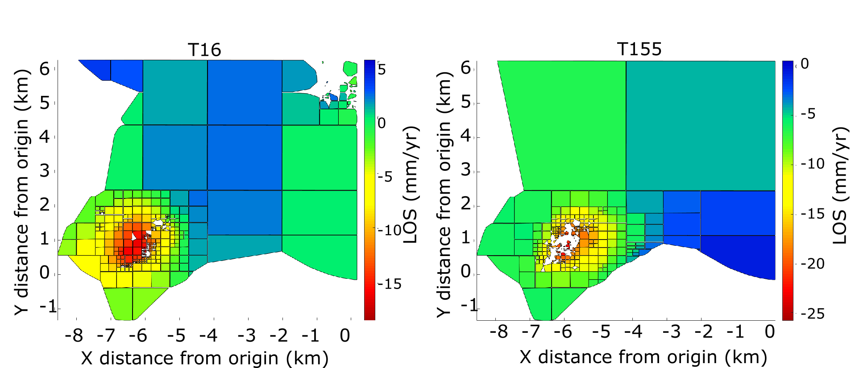

**Figure A1.** Quadtree sub-sampling of the T16 (left) and T155 (right) data using an algorithm integrated to GBIS. A threshold variance of 1 × 10-6 rad² was set for both T16 and T155 dataset, resulting in 366 observations for T16 and 311 observations for T155. The same sub-sampled values were used as input for the Penny shaped crack model presented in Fig. 4.7.

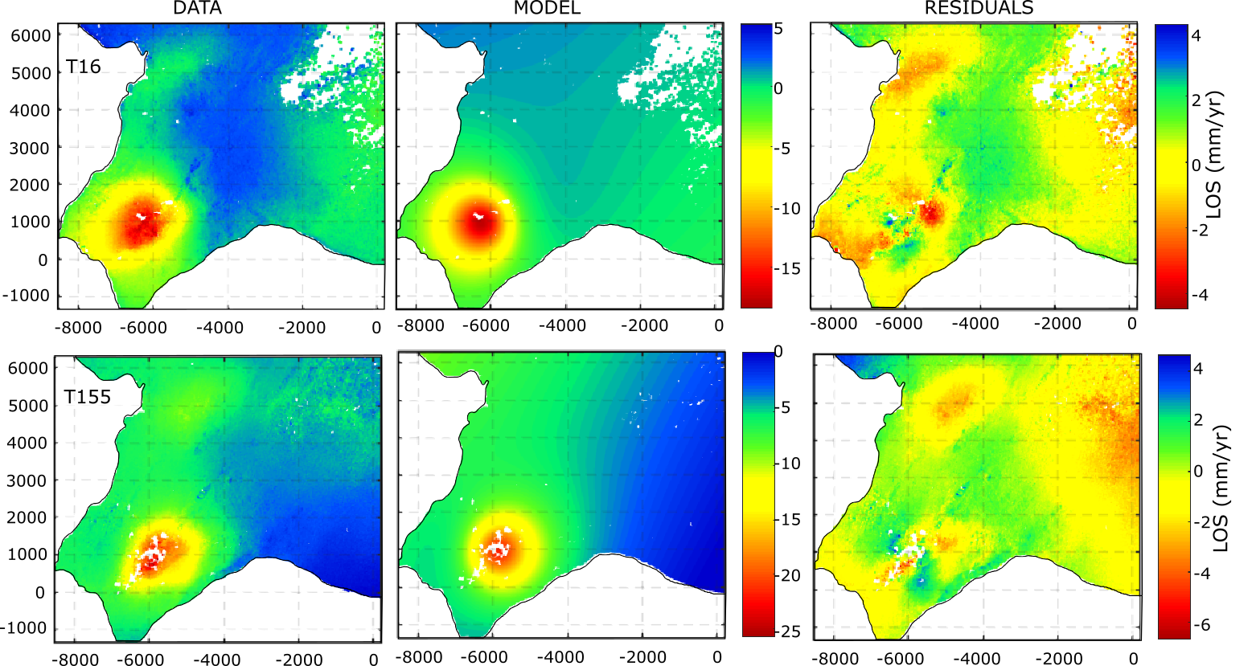

**Figure A2**. Unwrapped data, model and residuals for the T16 and T155 datasets for the best fitting Mogi source calculated from GBIS. The first column corresponds to the unwrapped data at initial resolution (before sub-sampling shown in Fig. A1). The model is the one that best fits observations (Fig. A3). Residuals indicate the difference between the data and the model. Results are displayed relatively to a point situated at the position of coordinates (-22.564°E; 63.814°N).

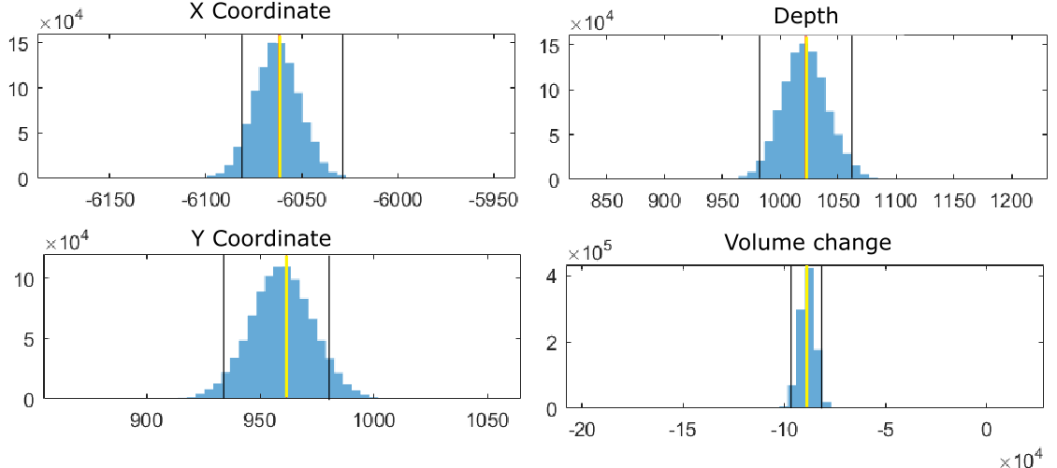

**Figure A3.** Histograms showing posterior distribution of values (blue bars) for all the model parameters of the Mogi source shown in Fig. A2, drawn from 1 milion iterations: X and Y coordinates relative to the reference point (in meters), depth (in meters), and volume change DV (in cubic meter). The orange line indicates the most probable value and the black lines indicate the boundaries of the 95% confidence interval.

#### Single Mogi source processed using the approach of Drouin *et al.* (2017): Data, model and residuals (Fig. A4) and corresponding histograms of samples from the posterior distributions of the model parameters (Fig. A5). The results are summarized together with other inversion results in Table 4.1 in main text.

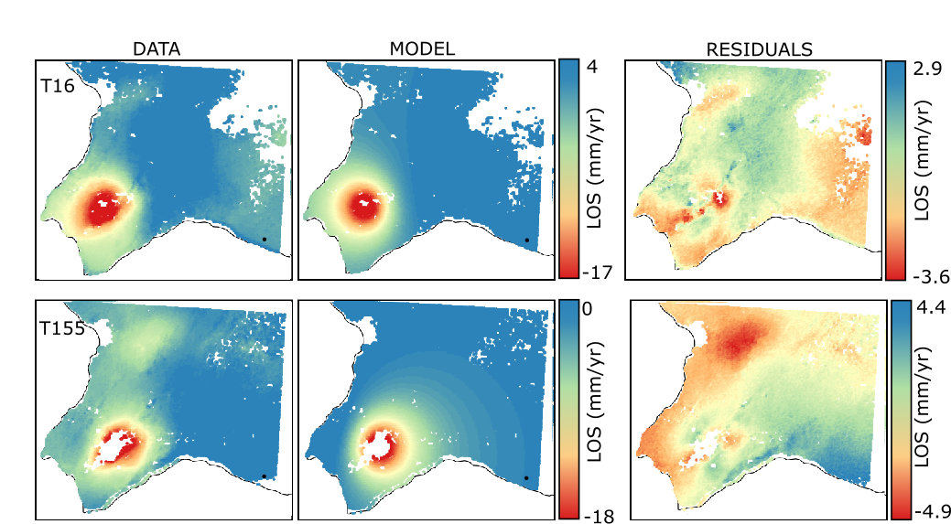

**Figure A4.** Data, model and residuals for the T16 and T155 datasets for the best fitting Mogi source calculated from the approach of Drouin et al. (2017). The data have been sub-sampled into a larger grid with a regular spacing of 0.001° in longitude and 0.0005° in latitude to reduce the computational time, resulting in 16136 observations for T16 and 14298 observations for T155. The model is the one that best fits observations (Fig. A5). Residuals indicate the difference between the data and the model. Results are displayed relatively to a point (black dot) situated at the position of coordinates (-22.564°E; 63.814°N).

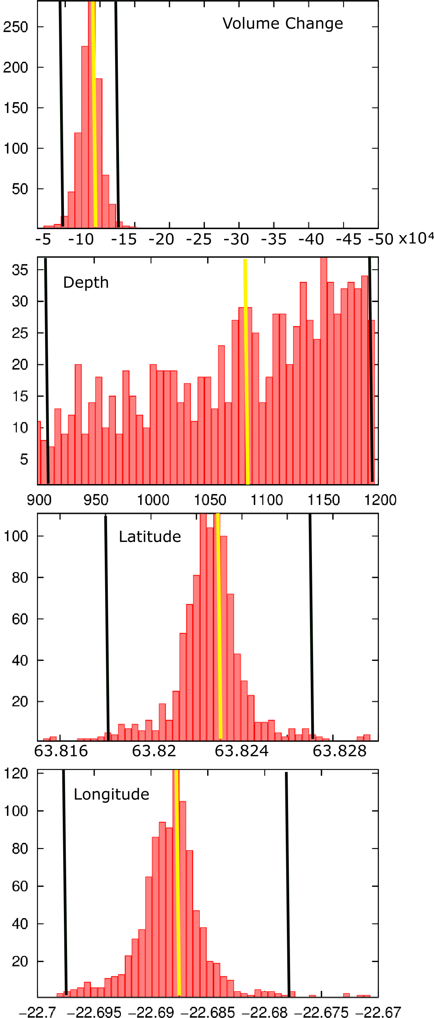

**Figure A5**. Histograms showing the posterior distributions of values (red bars) for all the model parameters of the Mogi source shown in Fig. A4, obtained from 1000 bootstrap inversions: latitude and longitude (decimal degrees), depth and volume change in metric units. The orange lines correspond to the most probable value and the black lines indicate the boundaries of the 95% confidence intervals.

#### McTigue finite spherical pressure source modeled using the approach of Drouin *et al*. (2017): Data, model and residuals (Fig. A6) and corresponding histograms of samples from the posterior distributions of the model parameters (Fig. A7). The results are summarized together with other inversion results in Table 4.1 in main text.



**Figure A6.** Data, model and residuals for the T16 and T155 datasets for the best fitting McTigue spherical source calculated from the approach of Drouin et al. (2017). The data have been sub-sampled into a larger grid with a regular spacing of 0.001° in longitude and 0.0005° in latitude to reduce the computational time, resulting in 16136 observations for T16 and 14298 observations for T155. The model is the one that best fits observations (Fig. A7). Residuals indicate the difference between the data and the model. Results are displayed relatively to a point (black dot) situated at the position of coordinates (-22.564°E; 63.814°N).

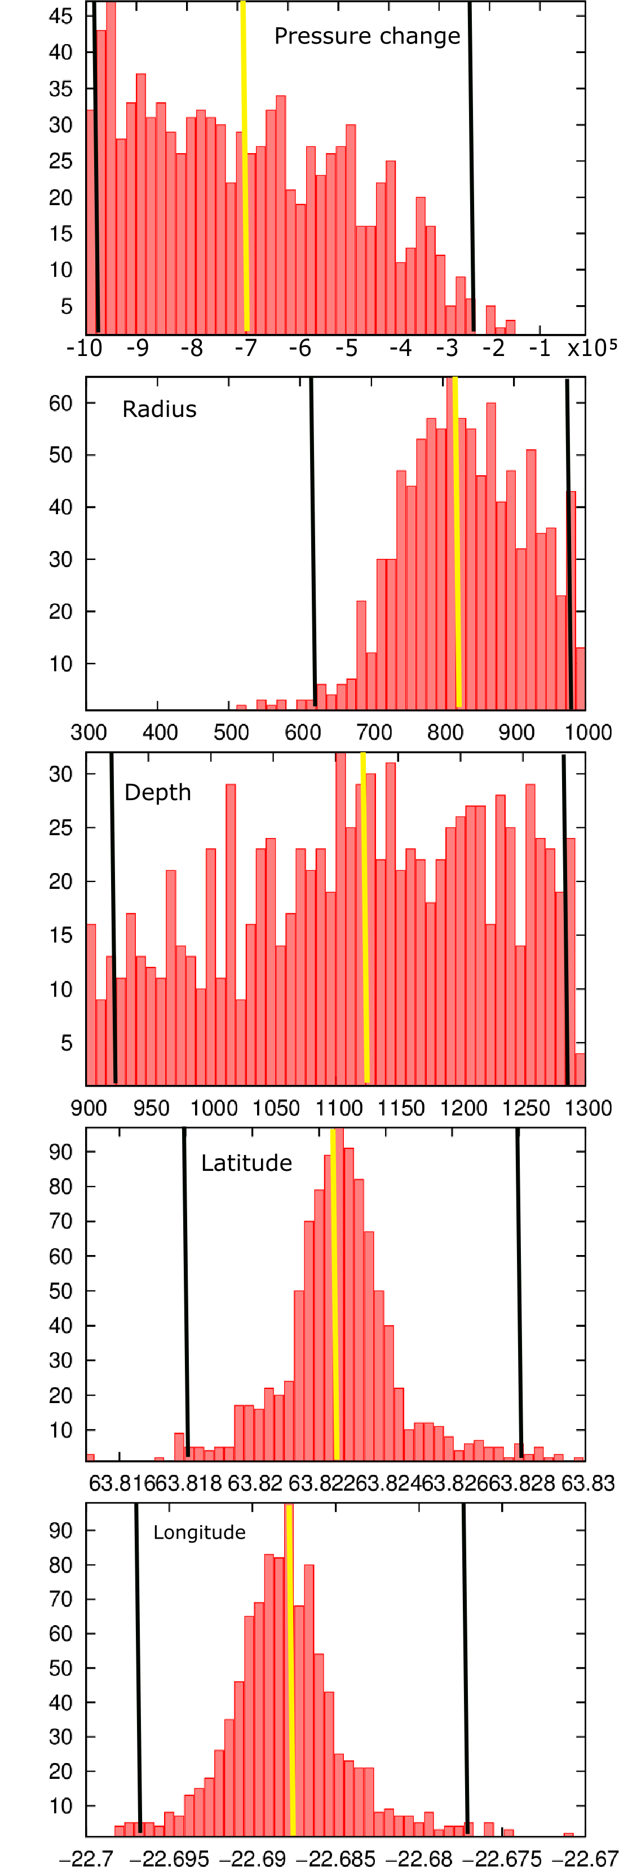 

**Figure A7.** Histograms showing the posterior distributions of values (red bars) for all the model parameters of the finite spherical source shown in Fig. A6, obtained from 1000 bootstrap inversions: latitude and longitude in decimal degrees, depth and radius in meters, and pressure change DP in Pascal. The orange lines correspond to the most probable value and the black lines indicate the boundaries of the 95% confidence intervals.

#### Rectangular Okada layer using the approach of Drouin *et al.* (2017): Data, model and residuals (Fig. A8) and corresponding histograms of samples from the posterior distributions of the model parameters (Fig. A9). The results are summarized together with other inversion results in Table 4.1 in main text.

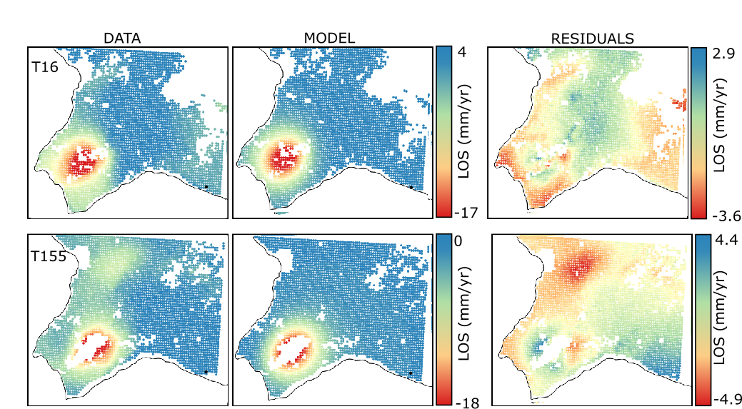

**Figure A8.** Data, model and residuals for the T16 and T155 datasets for the best fitting rectangular Okada layer calculated from the approach of Drouin et al. (2017). The data have been sub-sampled into a regular grid with a larger spacing compared to the one used in the previous models, of 0.002° in longitude and 0.001° in latitude, resulting in 3846 observations for T16 and 3327 observations for T155. The model is the one that best fits observations (Fig. A9). Residuals indicate the difference between the data and the model. Results are displayed relatively to a point (black dot) situated at the position of coordinates (-22.564°E; 63.814°N).

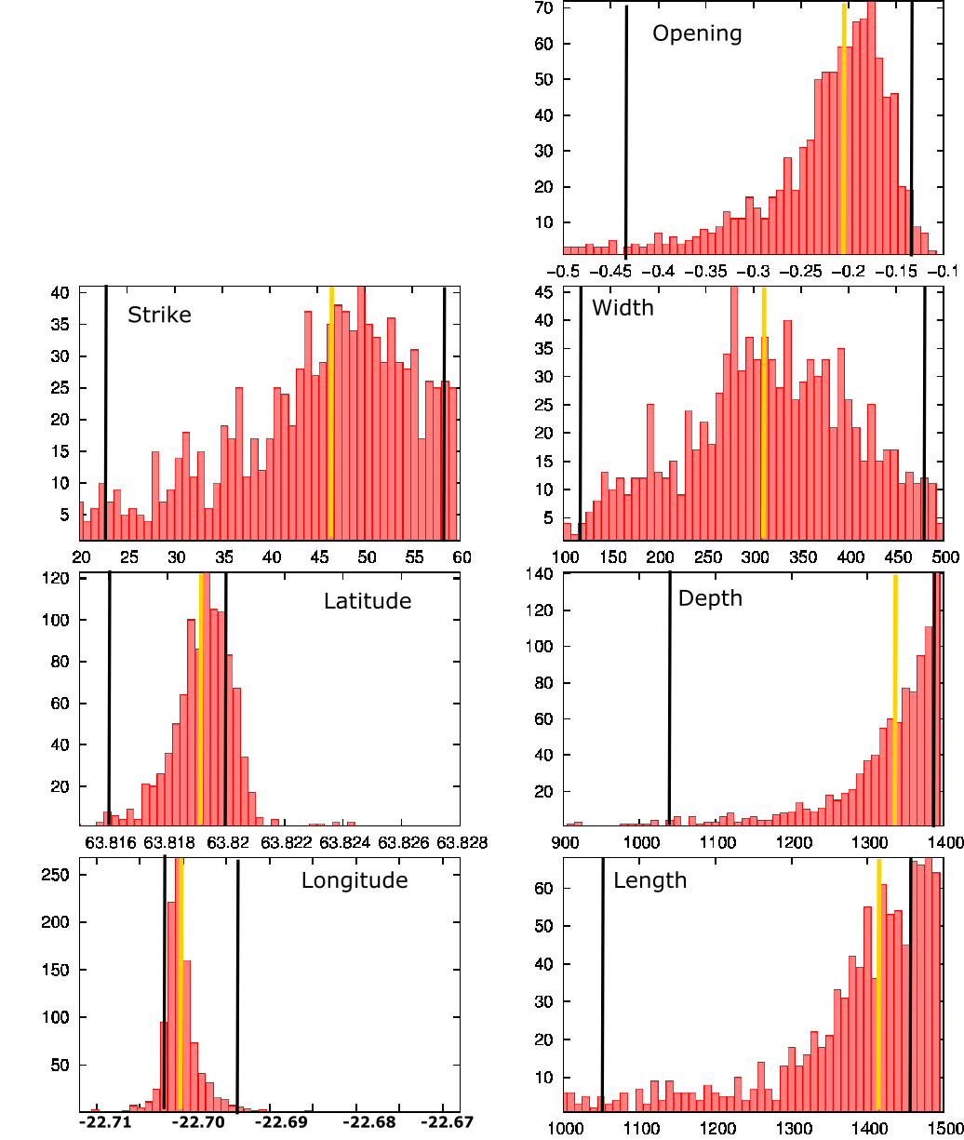

**Figure A9**. Histograms showing the posterior distributions of values (red bars) for the model parameters of the rectangular Okada layer shown in Fig. A8, obtained from 1000 bootstrap inversions: latitude and longitude in decimal degrees, depth, width, length and opening rate in meters, strike in degrees. The dip and shear slip have been set to zero. The orange lines correspond to the most probable value for each model parameter and the black lines indicate the boundaries of the 95% confidence intervals.

#### Mogi sources based on the production/injection data using the approach of Drouin *et al.* (2017).

We explored if localized changes at each borehole could explain the observed deformation signal, by inserting a spherical point source of pressure (Mogi, 1958) at each borehole with a strength parameter scaling with the known amount of extraction/injection, following the method of Drouin *et al*. (2017). In this model, we assume that the rate of volume change of each source is proportional to the average mass extraction/injection rate at each borehole in 2016 (Þorvaldsson & Arnaldsson, 2017). We define a parameter corresponding to the proportion *M* (m3/ton) between the source volume ${∆V}_{mogi}$ and the mass of geothermal fluid extracted/injected $M_{gf}$,

$$M=\frac{{∆V}_{mogi}}{M_{gf}}$$

To simplify the model, we also assume that all the wells are producing / injecting from the same depth. We used the coordinates of the wells at 1000 m depth instead of surface coordinates to avoid offsets in the location of extraction/injection within the reservoir related to the presence of deviated wells.

In a first model (model 1), we only considered the effect of extraction of fluid from the 17 producing wells in 2016 (RN-10, RN-11, RN-12, RN-13B, RN-14B, RN-15, RN-18, RN-19, RN-21, RN-22, RN-23, RN-24, RN-25, RN-26, RN-27, RN-28, RN-31). A total of 419 input files were created for a depth of 900 to 2800 m by step of 100 m and for a *M*-factor in the range from 0 to 0.02 by steps of 1×10-3, representing a total of 419 forward models ran to fit the average velocity maps obtained from the time series analysis. For each forward model, we calculate the global Chi-square value (Chi²), representing the amount of residuals or the difference between the input data and the modeled values (Fig. A10).

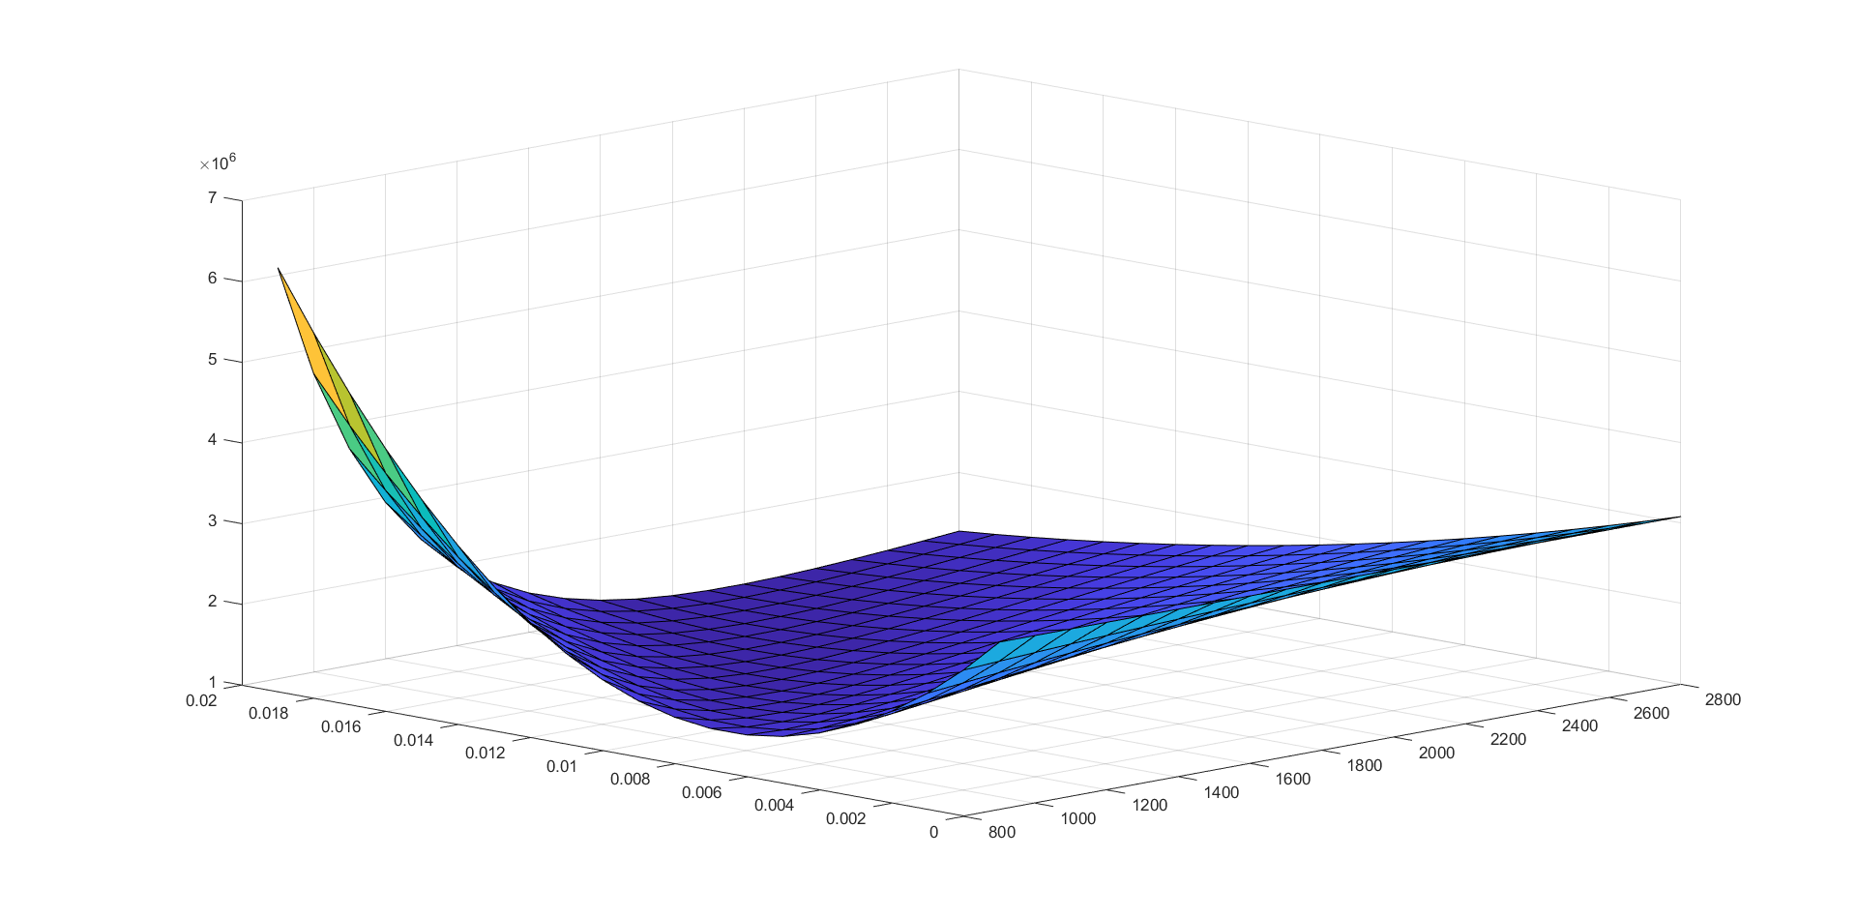

Chi²

Depth (m)

$$\frac{{∆V}_{mogi}}{M_{gf}}$$

***Figure A10****. Chi-square values as a function of the volumetric factor and the depth of the sources, for a model with Mogi sources at each well, with strength related to the production/injection rates (model1). Each square represents the result for one forward model.*

In a second approach (model 2), we added the effects of injection into 5 reinjection wells (RN-20, RN-29, RN-30, RN-33 and RN-34), using the same conversion coefficient *M* as for the extraction. There, a total of 1122 configuration files were prepared, considering a depth from 900 m to 3000 m by step of 100 m and for a factor of 0 to 0.05 by steps of 1×10-3. Results from this analysis are not conclusive since after running successive series of forward model increasing each time the maximum possible value for the depth, the optimal depth (model with the lowest Chi²) was always obtained for the maximal value (and no clear minimum value for the Chi².

In a third approach (model 3), we introduced a separate injection coefficient to convert the total mass injected at the five injection wells to volume change. A total of 3780 configuration files were formed when considering a reinjection factors representing 10 to 90% of the extraction factor by step of 10%, for a factor of 0 to 0.02 by steps of 1×10-3 and a depth of 900 to 2800 m by step of 100 m. With the best fitting value for the extraction coefficient reaching the maximum boundary value of 0.02, we performed another session of forward model with a set of 3348 configuration files displaying a depth of 900 to 2000 m by step of 100 m and for a factor of 0 to 0.03 by steps of 1×10-3. The best source was obtained for a depth of 2000 m with a *M*-ratio of 0.022 and a reinjection factor of 0.015.

Table A1 summarizes results from these modeling efforts.

**Table A1.** Summary of the parameters of the best fitting sources for each set of forward models

|  |  |  |  |  |
| --- | --- | --- | --- | --- |
|  | Inverse model | Model 1: using extraction from 2016 | Model 2: include 5 injection wells | Model 3: include an injection coefficient |
| Depth (m) | 967.92 | 2000 | 3000 | 2000 |
| Extraction factor M (m3/ton) | - | 0.018 | 0.047 | 0.022 |
| Injection factor M (m3/ton) | - | - | - | 70% |
| Global Chi² | 3.00 × 105 | 1.10 × 106 | 1.00 × 106 | 1.06 × 106 |

Results from models considering the average injection/extraction rates do generally display higher optimal value for the Chi² relative to other models considering a single source (Table 4.1). Using the velocity maps as input, the best fit was obtained for a depth of about 2 km, with an extraction factor of 0.022 and a reinjection factor corresponding to 70% of the extraction factor. The data, model and residuals corresponding to this model are shown in Fig. A11, for Track 16 and Track 155.

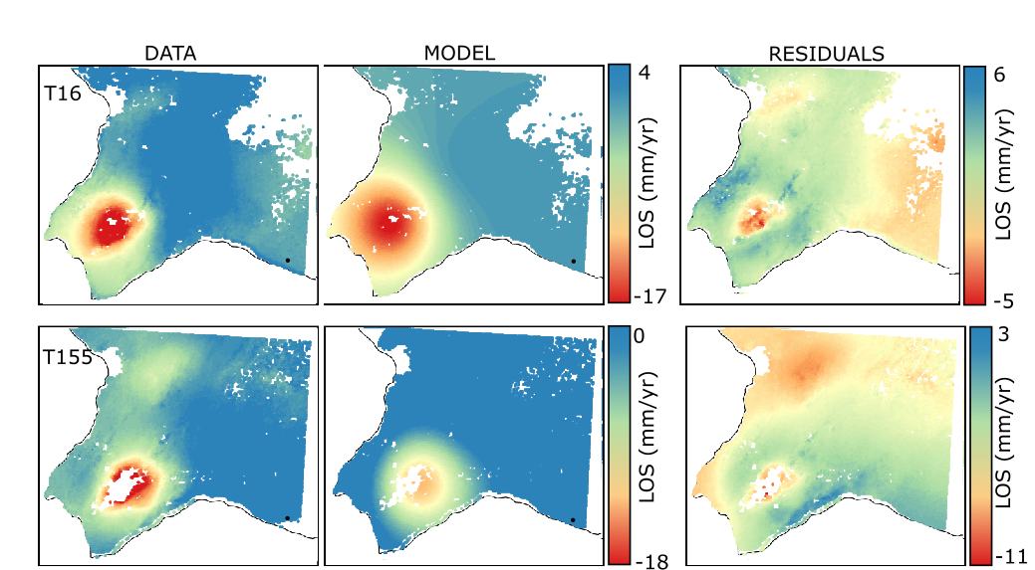

**Figure A11**. Data, model and residuals for the T16 and T155 datasets for a model with Mogi sources at each borehole calculated from the approach of Drouin et al. (2017). The data have been sub-sampled into a larger grid with a regular spacing of 0.001° in longitude and 0.0005° in latitude to reduce the computational time, resulting in 16136 observations for T16 and 14298 observations for T155. The model is the one that best fits observations (Fig. A10). Residuals indicate the difference between the data and the model. Results are displayed relatively to a point (black dot) situated at the position of coordinates (-22.564°E; 63.814°N). Important residuals, indicating the difference between the data and the model can be seen, showing the relatively poor fit of the model compared to models with a single source.

#### **Appendix B: Estimation of the total productive reservoir pore space**

We estimated the cumulative thickness of each rock type within the Reykjanes geothermal reservoir, for the formations situated between 0.8 km (depth to the top of the reservoir zone) and 2.8 km (depth of the deepest producing well), using the geological logs from wells RN-29, RN-16, RN-10, RN-14, RN-17, RN-12, RN-19 and RN-20 displayed in Fig. 4.11 (Friðleifsson *et al.* 2014)*.* Table B1 summarizes these estimated values as well as the average thickness of the upper volcano-sedimentary succession (composed mainly of hyaloclastites, breccias and marine sediments), and the average thickness of the basaltic pillow basalt, extrusive lavas and dolerite dykes that constitute the lower volcanic unit at Reykjanes.

**Table B1.** Summary of the total thickness of each rock type found between 0.8 and 2.8 km. The wells are listed accordingly to their location along the WNW-ESE profile (Fig. 4.11).

|  |  |  |  |  |  |  |  |  |  |
| --- | --- | --- | --- | --- | --- | --- | --- | --- | --- |
| Rock type between 0.8 and 2.8 km depth | Thickness (m) of the rock type in well: | | | | | | | | Average thickness (m) |
| **RN29** | **RN16** | **RN10** | **RN14** | **RN17** | **RN12** | **RN19** | **RN20** |
| Hyaloclastite and upper sediments | 100 | 400 | 200 | 250 | 400 | 250 | 50 | 250 | 238 |
| Basaltic extrusive lava | 300 | 150 | 500 | 500 | 550 | 800 | 600 | 0 | 425 |
| Pillow / breccias | 1300 | 700 | 400 | 450 | 450 | 400 | 150 | 750 | 575 |
| Fractured dolerite dykes | 300 | 550 | 100 | 300 | 600 | 150 | 600 | 200 | 350 |
| Combined lava, pillows, breccias and dykes | 1900 | 1400 | 1000 | 1250 | 1600 | 1350 | 1350 | 950 | 1350 |
| Total Reservoir | 2000 | 1800 | 1200 | 1500 | 2000 | 1600 | 1400 | 1200 | 1588 |

Some of the wells (RN-10, -14, -19, -20) are shallower than 2.8 km and thus no data is available within the whole considered depth interval. We therefore scaled the average thickness of each rock type in each well to obtain an estimate of the porosity over a total reservoir thickness of 2 km (third column in Table B3). Then, we multiplied the scaled thickness estimates by the average porosity of each rock type to calculate a value of productive thickness for each formation. The values of porosity were assumed accordingly to the literature and to the laboratory experiments on rock samples (i.e. Table B2).

**Table B2.** Description of the rock core samples from Reykjanes wells RN-17b and RN-19 used for laboratory analysis of the rock properties (density, porosity), performed at the University of Montpellier, France, in the scope of the IMAGE project (Reinsch et al., 2016)

|  |  |  |  |  |  |  |
| --- | --- | --- | --- | --- | --- | --- |
| **Sample n°** | **Well** | **Depth sample (m)** | **In-situ T° (°C)** | **Sample rock** | **Density (kg/m3)** | **Porosity (%)** |
| 1 | RN-17 b | 2801.6 | 340°C | Heteroclite breccias with hyaloclastite | 2700 | 13.64 |
| 2 | RN-19 | 2246.3 | 320°C | Dolerite dyke | 2920 | 3.24 |

The estimated productive thicknesses were then multiplied by the average reservoir areal extent of about 1.9 km² obtained from the modeled deformation sources to estimate the productive volume within each rock type, in the central part of the reservoir. We obtained a total pore space of about 0.6 km3 for a total reservoir volume of 3.8 km3, which corresponds to an average porosity of about 15 %, including primary and fracture porosity (Table B3).

**Table B3.** Summary of the total average thickness of each rock type found between 0.8 and 2.8 km depth in the central part of the reservoir, scaled up for all the wells to a total thickness of 2 km, the corresponding porosity and the resulting effective thickness/volume for each formation type.

|  |  |  |  |  |  |
| --- | --- | --- | --- | --- | --- |
| Rock type between 0.8 and 2.8 km depth | Average thickness (m) | Scaled thickness (m) | Porosity (%) | Effective thickness (m) | Effective Volume (m3) |
| Hyaloclastite and upper sediments | 238 | 299 | 23 | 69 | 1.3 × 108 |
| Basaltic extrusive lava | 425 | 535 | 5 | 27 | 5.1 × 107 |
| Pillow basalt / breccias | 575 | 724 | 20 | 145 | 2.8 × 108 |
| Dolerite dykes with additional fracture porosity (10%) | 350 | 441 | 13 | 57 | 1.1 × 108 |
| Combined lava, pillows, breccias and dykes | 1350 | 1701 | 13 | 229 | 4.4 × 108 |
| Total Reservoir | 1588 | 2000 | 15 | 298 | 5.7 × 108 |

Assuming a volume of 0.7 km3 for the steam cap (thickness of about 400 m), the resulting pore space in the steam zone based on a porosity of 15% is therefore about 0.1 km3.

#### **Appendix C: Estimation of the steam ratio**

**Table C1.** Fluid enthalpy h, density $ρ$ and heat capacity $β$ values for different boiling conditions, obtained from steam tables.

|  |  |  |  |  |  |  |  |
| --- | --- | --- | --- | --- | --- | --- | --- |
| Phase | Steam | | | Liquid | | | |
| T° (°C) | 290 | 240 | $$210$$ | 290 | 240 | 210 | 160 |
| P (MPa) | 7.5 | 3.5 | 2.0 | 7.5 | 3.5 | 2.0 | 0.6 |
| $ρ(kg/m^{3})$ | 39 | 17 | 10 | 732 | 814 | 853 | 907 |
| $$β (J.kg/m^{3})$$ | 5280 | 3556 | 2985 | 4964 | 4578 | 4438 | 4194 |
| $h (kJ/kg)$ | 2767 | 2803 | 2797 | 1290 | 1038 | 898 | 676 |

In the beginning of the production for the power plant the enthalpy of the fluid $h_{t}$ was around 1290 kJ/kg (1210 - 1400 kJ/kg) (Fridriksson *et al*., 2010), characterizing a liquid-dominating reservoir of average temperature $T_{r}$ equal to 290°C (275-310°C), according to steam tables. The following equation can be used to determine the steam fraction of a fluid of temperature $T_{r}$ brought to different pressure condition (Axelsson*,* 2012a).

$X=\frac{h_{t}\left(T_{r}\right)-h_{l}\left(P\right)}{h_{s}\left(P\right)-h_{l}\left(P\right)}$ (C.1)

Here $h_{t}\left(T_{r}\right)$ is the initial fluid enthalpy at reservoir press/temperature conditions, and $h_{l}\left(P\right)$ and $h_{s}\left(P\right)$ the liquid and steam enthalpy at boiling condition for a pressure *P (Table C1)*. With a separation pressure of about P = 2 MPa (210°C), we find that the steam fraction at the separator on surface was around 21 %.

From 2009, the production of steam directly from the steam cap has progressively increase through the drilling of shallow highly productive wells yielding more than 30 kg/s of saturated steam of 2700 kJ/kg enthalpy. This contributed to the increase in the fluid discharge enthalpy to an average of $h_{t}=1500$ kJ/kg [1450-1950 kJ/kg] in 2010 (Fridriksson *et al*., 2010), increasing the steam mass ratio on surface up to 30%. Since 2010, a slow decline in the average fluid discharged enthalpy has been inferred from regular flow testing, indicating an average of 1270-1600 kJ/kg in 2016 (Weisenberger *et al.,* 2016). Over a total mass of fluid extracted in 2016 of 13.5 Mtons, the total expected mass of steam therefore range between 2.7 and 4.3 Mtons.

When the fluid reaches the surface and that its enthalpy is estimated at the steam-water separators, additional boiling has occurred in the well and thus, the steam fraction at the separator differs from that within the reservoir. We thus use the difference of enthalpy between the fluid at reservoir temperature $h_{t}\left(T_{r}\right)$ and its expected enthalpy at pressure conditions within the steam cap (T= 240°C, P=3.5 MPa) to estimate the steam fraction within the reservoir using Equation C.1, and find a ratio of about 14%. Using the total estimated pore space of 0.6 km3 (Appendix B) and a fluid density of about 800 kg/m3, we estimate a total reservoir liquid mass $m_{f}=$ 500 Mtons, leading to a mass of steam in the steam cap $m_{s}$ = 70 Mtons.

# General discussion

Two data sets have been created from the interferometric analysis of Sentinel-1 images and for the modeling of deformation sources at Reykjanes for the period 2015-2017. The first one consists of two-year stacked interferograms formed in both ascending and descending track and gives the cumulative displacement over the period 2015-2017. The second consists of average velocity maps created from time series analysis. This second set was used as input for modeling and for the interpretation of the deformation processes in the reservoir, in the manuscript in preparation for submission to Geophysical Journal International.

The time series analysis for the period 2015-2017 presented in section 4 has demonstrated a decrease in the average rate of subsidence in the area of maximum deformation at Reykjanes relative to the period 2009-2016, clearly lower at present than during the 2005-2008 period (Parks *et al.,* in review). Due to the difference in the LOS satellite unit vectors used in previous studies (Table 5.1), the LOS rates can however not be directly compared to infer if rates of deformation have varied. We therefore considered it more appropriate to compare the modeled rates of volume change of the best fitting sources for each period.

**Table 5.1.** Parameters for the acquisition geometry for different satellites used in the study of ground deformation at Reykjanes since 2005: the LOS unit vectors for the corresponding satellite ascending and descending track, calculated from the heading direction and the incidence angle. The last column indicates the maximum average LOS displacement rates at Reykjanes for the corresponding study period.

|  |  |  |  |  |  |
| --- | --- | --- | --- | --- | --- |
| Satellite (study period) | Track | Unit vectors [$u_{E},u_{N},u_{Up}$] | Heading (°) | Incidence angle (°) | LOS displacement rate (mm/yr) |
| ENVISAT  (2005-2008) | Ascending T173 | [-0.319, -0.123, 0.940] | 339 | 20 | -33 |
| Descending T138 | [0.395, -0.152, 0.906] | 201 | 25 | -28 |
| TSX  (2009-2016) | Ascending T26 | [-0.670, -0.130, 0.731] | 349 | 43 | -24 |
| Descending T110 | [0.531, -0.123, 0.839] | 193 | 33 | -21 |
| Sentinel1  (2015-2017) | Ascending T16 | [0.545, -0.123, 0.830] | 347 | 34 | -16 |
| Descending T155 | [-0.605, -0.123, 0.787] | 192 | 38 | -15 |

As shown in Fig. 4.10, the rate of best-fitting volume change decreased from about -7.3 × 105 m3/yr for the period 2005-2008 to -1.5 × 105 m3/yr for the period 2009-2016 and to -0.9 × 105 m3/yr for the period 2015-2017 (this study).

The LOS subsidence rates as well as the volume changes obtained from inversions of both the average velocities obtained from time series analysis (Table 4.1) and the cumulative displacements obtained from the 2015-2017 stacked interferograms (Table SM4.1) showed consistent results: a maximum LOS subsidence of about -20 mm/yr in Track 16 and of about -25 mm/yr in Track 155. Moreover, decomposed signals using both data sets indicate a maximum near-vertical displacement rate of -25 mm/yr as well as horizontal contraction toward the center of the deformation at a maximum near-east rate of 7 mm/yr. Due to the use of only the coherent pixels in the time series analysis, and the multiple interferograms involved, we however suggest that the time-series results are more reliable, indicating an average LOS velocity of -16 mm/y in the zone of maximum deformation.

The best fitting modelling sources for the 2015-2017 period (the rectangular Okada sill and Penny shaped crack) confirmed the presence of the deformation source at shallower depth (about 1 km) when compared to results from the 2005-2008 period (about 2.2 km depth).

Not only is the temporal evolution of the subsidence of interest, but also its spatial influence. Modeling results between 2005 and 2017 indeed suggested a modification of the subsidence pattern from a wide NE-SW elongated ellipsoid in 2005-2008 into a more circular and narrow subsidence bowl since 2009. The strike of the modeled rectangular Okada source together with the apparent boundary between the eastward and westward contraction in the decomposed near-east velocity maps suggests that the 2015-2017 deformation might partly be controlled by a NE-SW structure. This is also suggested by the pattern of the residuals in all the models, which show that all the deformation cannot be explained by the inferred shallow source, interpreted as cooling/compaction within a steam cap. The residual signals are indeed partly aligned in the NE-SW direction, similar to strike of the Rauðhólar lineament, which suggests its influence on the observed deformation.

The changes in both the depth of the best fitting deformation sources and in the shape of the subsidence bowl for the periods 2005-2008 and 2009-2017, therefore suggest a modification of the deformation mechanisms in 2008-2009. This time period coincides with the date at which reinjection started at Reykjanes and where two shallow wells started to produce steam directly from the steam cap.

Numerical poro-elastic modelling of the Reykjanes geothermal system with Defmod (Ali, 2014) was also explored during this project. It was initiated to simulate the expected ground subsidence since production started, i.e. using all the existing production and pressure monitoring data. By comparing the results with the actual subsidence measured since 2005, the objective was to get an insight on the reservoir heterogeneities and rock properties, as well as the mechanical behavior of the system responsible for the observed changes. We first intended to consider a simple homogeneous reservoir to better constraint the rock properties (i.e. hydraulic conductivity, porosity, Biot’s coefficient, shear modulus…), given the known production history, the pressure change in the reservoir and the measured ground subsidence between 2005 and 2017. Due to the early stage of this analysis, no conclusive results were achieved. However, numerical poro-elastic and thermo-elastic numerical models of the Reykjanes reservoir system can be seen as important future work to understand better the structure and the mechanical behavior of the system, in combination with high temporal resolution InSAR data and a continuous monitoring of production.

# General conclusion

This project evaluated ground deformation induced by geothermal production at Reykjanes, during the period 2015-2017. We used Synthetic Aperture Radar images from the new Sentinel-1 mission to create maps of the cumulative displacement from April 2015 to October 2017 in both ascending and descending satellite views, as well as average velocity maps generated from time series analysis. The LOS signals have been decomposed in near-east and near-vertical displacement rates. Results indicate a steady and linear rate of subsidence within the study period, where the maximum rate of about -25 mm/yr occurrs in the middle of a sub-circular subsidence bowl centered on the area of maximum production. The characteristics of the deformation source responsible for the observed subsidence have been determined through Bayesian inversion of both the LOS cumulative displacement and average velocity maps. For all the source types tested, results are consistent, indicating a source at about 1–1.2 km depth contracting by about of 0.7 to 0.9 × 105 m3/yr.

In order to get a better understanding of the overall response of the reservoir to production and evaluate the processes potentially responsible for the deformation in 2015-2017, we compared the estimated volume changes of the best fitting deformation sources with pressure and temperature data at 925 and 1625 m depth in monitoring wells since production began in 2006. We showed that shallow deformation processes during the 2015-2017 period can be explained by poro-elastic and thermo-elastic processes in the upper part of the reservoir. The processes include compaction of the less consolidated formations under pressure decline in a steam cap where the pore fluid compressibility is higher than in the lower liquid dominated part, and/or thermal contraction of rocks due the a lack of steam recharge. Both suggest the decline of a steam cap resulting from condensation or a steam recharge deficit. Such process could occur as a result of a reduction of boiling caused by cold recharge into the system since 2009. The steam cap would have formed in the approximately uppermost 400 meters of the reservoir (between 800 and 1200 m depth) as a result of the expansion of the boiling conditions in the reservoir in 2006-2008 caused by a pressure drop of about 3.0 MPa within that time period. The pattern of this pressure drop initially coincided with the NE-SW striking faults situated in the middle of the geothermal field. These deep permeable structures, representing the main flow path within the system, were likely to control an initial compaction in the deep part of the system, explaining the pattern of the subsidence and the depth of the deformation source for the 2005-2008 period.

This study shows the value of ground deformation monitoring with InSAR to understand long term sub-surface processes occurring in utilized geothermal systems. Combined with geophysical surveys, monitoring and production data, such measurements allow a study of the effects of the processes involved over large areas, thanks to the dense spatial coverage of SAR images. With a new image every 6 days since 2016, Sentinel-1 data moreover offers the possibility to create relatively high-resolution time series of deformation at Reykjanes. Applying a quality criterion to remove images with clear contamination due to atmospheric and/or decorrelation noise (60% of the available images in our case), prior to final analysis, we have derived results of good quality despite the relatively short temporal coverage of this study.

# References

Ali, S.T., 2014. Defmod - Parallel multiphysics finite element code for modeling crustal deformation during the earthquake/rifting cycle. 12p

Ali, S.T., Akerley, J., Baluyut, E.C., Cardiff, M., Devatzes, N.C., Feigl, K.L, Foxall, W., Fratta, D., Mellors, R.J., Spielman, P., Wang, H.F., Zemach, E., 2016. Time-series analysis of surface deformation at Bradys Hot Springs geothermal field (Nevada) using interferometric synthetic aperture radar. *In:* Geothermics, Vol. 61, pp. 114-120.

Ali, S.T., Devatzes, N.C., Drakos, P.S., Feigl, K.L., Foxall, W., Kreemer, C.W., Mellors, R.J., Wang, H.F., Zemach, E., 2014. InSAR measurements and numerical models of deformation at Brady Hot Springs geothermal field (Nevada), 1997-2013. *In:* Proceedings, Thirty-Ninth Workshop on Geothermal Reservoir Engineering. SGP-TR-2012. 14p

Allis, R., Bromley, C., Currie, S., 2000. Update on subsidence at the Wairakei-Tahaura system, New Zealand. *In:* Geothermics, Vol. 38, Issue 1, pp. 169-180

Arnadottir, T., Geirsson, H., Jiang, W., 2008. Crustal deformation in Iceland: Plate spreading and earthquake deformation. *In:* Jokull, No. 58. 16p

Arnórsson, S., 1978. Major element chemistry of the geothermal sea-water at Reykjanes and Svartsengi, Iceland. *Mineralogical Magazine, 42,* 209­–220.

Arnorsson, 1985. Geothermal systems in Iceland: structure and conceptual model – 1: High-temperature areas. *In:* Geothermics, Vol. 24, Issue 5-6, pp. 561-602

Axelsson, G, 2012a. The Physics of Geothermal Energy. *In:* Sayigh A, (ed.) Comprehensive Renewable Energy, Vol. 7, pp. 3–50. Oxford: Elsevier.

Axelsson, G., 2012b. Renewability of Geothermal Resources. GEORG Final Report. Project ID: 09-01-012. 47p

Axelsson, G., Arnaldsson, A., Berthet, J.C.C., Bromley, C.J., Gudnason, E.A., Hreinsdóttir, S., Karlsdóttir, R., Magnússon, I.Th, Michalczewska, K.L., Sigmundsson, F., Sigurdsson, O., 2015. Renewability Assessment of the Reykjanes Geothermal System, SW-Iceland. *In:* Proceedings World Geothermal Congress 2015. 10p

Bagnardi, M & Hooper, A., 2017. Geodetic Bayesian Inversion Software (GBIS), v1.0, COMET. University of Leeds. Available on: <http://comet.nerc.ac.uk/gbis/>

Bjornsson, S., Arnorsson, S., Tomasson, J. 1970. Exploration of the Reykjanes thermal brine area, Iceland. *In:* Geothermics, Vol. 2, Part 2, pp. 1640-1650.

Bodvarsson, G.S. and Witherspoon, P.A., 1989: Geothermal reservoir engineering. Part I. Geothermal Science and Technology, Vol. 2, pp. 1-68.

Brock, D.C., 1986. Compressibility effects in modeling two-phase liquid dominated geothermal reservoirs. Master Thesis. Standford University. Department of Petroleum Engineering. 85p

Brockbank, K., Bromley, C., Glynn-Morris, T., 2011. Overview of the Wairakei-Tahaura subsidence investigation program. *In:* Proceedings, Thirty-Sixth Workshop on Geothermal Reservoir Engineering. SGP-TR-191. 7p

Bromley, C.J., Brockbank, K., Glynn-Morris T., Rosenberg, M., Pender M., O’Sullivan, M., Currie S.,2013. Geothermal subsidence study at Wairakei-Tauhara. *In:* Journal of Geotechnical Engineering, Vol. 166, Issue 2, pp. 211-223.

Bromley, C.J., Currie, S., Manville, V.R., Rosenberg, M.D., 2009. Recent ground subsidence at Crown Road, Tahaura and its probable causes*. In:* Geothermics, Vol. 38, Issue, pp. 181-191.

Bromley, C.J., Currie, S., Jolly, S., Mannington, W., 2015. Subsidence: an Update on New Zealand Geothermal Deformation Observations and Mechanisms*. In:* Proceedings World Geothermal Congress 2015. 9p

Bromley, C.J., Reeves, R., 2013. Ohaaki Geothermal Power Plant, Assessment of Environmental Effects: Subsidence, Surface and Shallow Geothermal Effects, GNS Science Consultancy Report No 2012/223.

Bull, 1964. Alluvial fans and near surface subsidence in western Fresno country, California.U.S. geological survey. Vol. 437, Chapter A, pp. 1-71.

Chen, C.W., Zebker, H.A., 2001. Two-dimensional phase unwrapping with use of statistical models for cost functions in nonlinear optimization. In: Journal of the Optical Society of America, Vol. 18, Issue 2, pp. 338-351. doi:10.1364/JOSAA.18.00033

Clifton, A., Schlische, R.W., 2003. Fracture populations on the Reykjanes Peninsula, Iceland: Comparison with experimental clay models of oblique rifting. *In:* Journal of geophysical research, Vol. 108, Issue B2, 2074, doi:10.1029/2001JB000635

Coco, A., Gottsmann, J., Whitaker, F., Rust, A., Currenti, G., Jasim, A., Bunney, S., 2016. Numerical models for ground deformation and gravity changes during volcanics unrest: simulating the hydrothermal system dynamics of a restless caldera. *In:* Solid Earth 7, pp. 557-277.

Drouin, V., Sigmundsson, F., Verhagen, S., Ofeigsson, B.G., Spaans, K., Hreinsdottir, S., 2017. Deformation at Krafla and Bjarnaflag geothermal areas, Northern Vocanic Zone of Iceland, 1993-2003. *In:* Journal of Volcanology and Geothermal Research, Vol. 344, pp. 92-105. ISSN: 0377-0273.

Dzurisin, D., Lu, Z., 2007. Chapter 5: Interferometric synthetic-aperture radar (InSAR). *In:* Volcano deformation--Geodetic monitoring techniques. ISBN: 9783540493020. 441p

Einarsson, P., 1991. Earthquakes and present-day tectonism in Iceland. *In:* Tectonophysics, Vol. 189, pp. 261-279.

Einarsson, P., 2008. Plate boundaries, rifts, and transforms in Iceland. *In:* Jökull, No. 58, pp. 35-58.

Einarsson, P., 2010. Mapping of Holocene surface ruptures in the South Iceland Seismic Zone. *In:* Jökull, Vol. 60, pp. 121-138.

Eneva, M., Adams, D., Falorni, G., Novali, F., Hsio, V., 2014. Surface deformation at the Salton Sea Geothermal Field from High precision radar interferometry. *In:* Geothermal Resources Council Transaction, Vol. 38. 10p.

ETB, 2011. The engineering toolbox. Solids: speciﬁc heat capacities.

Eysteinsson, H., 2000. Elevation and gravity change at geothermal fields on the reykjanes Peninsula, SW Iceland. *In:* Proceedings World Geothermal Congress 2000. 6p

Falorni, G., Morgan, J., Eneva, M., 2011. Advanced InSAR Techniques for Geothermal Exploration and Production. *In:* Geothermal Resource Council Transactions, Vol. 35, 6p.

Ferretti, A., Monti-Guarnieri, A., Prati, C., Rocca, F., 2007. InSAR Principles: Guidelines for SAR Interferometry Processing and Interpretation. *In:* European Space Agency Publications. TM-19. 252p. ISBN: 92-9092-233-8

Fialko, Y., Simons, Y., 2000. Deformation and seismicity in the Coso geothermal area, Inyo Country, California: Observations and modeling using satellite radar interferometry*. In:* Journal of geophysical research, Vol. 105. No. B9. 21p.

Fialko,Y., Khazan,Y., Simons,M., 2001. Deformation due to a pressurized horizontal circular crack in an elastic half-space, with applications to volcano geodesy. *In*: Geophysical Journal International, Vol. 146, pp. 181–190.

Fielding, E., 2014. ISCE Short Course. UNAVCO. Jet Propulsion Laboratory, California Institute of Technology. 46p

Fletcher, 2012. Sentinel-1: ESA’s Radar Observatory Mission for GMES Operational Services. 88p. ISBN 978-92-9221-418-0.

Flovenz, O., Agustsson K., Gudnason, E.A., Kristjansdottir, S., 2015. Reinjection and induced seismicity in geothermal fields in Iceland. *In*: Proceedings World Geothermal Congress 2015. 15p

Franzson, H., Thordarson, S., Bjornsson, G., Gudlaugsson, S., Richter, B., Friðleifsson, G. Ó., Thorhallsson, S., 2002. Reykjanes high-temperature field, SW Iceland. Geology and hydrothermal alteration of well RN-10. *In:* Proceedings, Twenty-Seventh workshop on geothermal reservoir engineering, Stanford University. 8p. SGP-TR-171

Franzson, H., 2004. Háhitakerfið á Reykjanesi (The high temperature system at Reykjanes) (in Icelandic). Report, ISOR-2004/012, 68 p.

Friðleifsson, G.Ó, Armannsson, H., Arnason, K., Bjarnson, I.Þ, Gilason, G., 2003. Iceland Deep Drilling Project (IDDP): Drilling Targets for Supercritical Fluid. In: International Geothermal Conference, Reykjavik. Session 6, pp. 8-14.

Fridleifsson, G.Ó, Elders, W.A., 2005. The Iceland Deep Drilling Project: a search for deep unconventional geothermal resources. *In*: Geothermics, Vol 34, Issue 3, pp. 269-285

Friðleifsson, G.Ó and Richter, B., 2010. The Geological Significance of Two IDDP-ICDP Spot Cores from the Reykjanes Geothermal Field, Iceland. *In*: Proceedings World Geothermal Congress 2010, Bali, Indonesia, 6p. Also available at: www.iddp.is

Friðleifsson G.O., Albertsson, A., Elders, W.A., Sigurdsson, O., Karlsdottir, R., Palsson, B., 2011. The Iceland Deep Drilling Project (IDDP): Planning for the second deep well at Reykjanes. *In*: Geothermal Resources Council Transaction, Vol.35.

Friðleifsson, G.Ó., Sigurdsson, Ó., Thorbjörnsson, D., Karlsdottir, R., Gilason, Th., 2014. Preparation for drilling well IDDP-2 at Reykjanes. *In*: Geothermics, Vol. 49, pp.119-126

Friðleifsson, G.O., Elders, W.A., Zierenberg, R.A., Stefansson, A., Fowler, A.P.G., Weisenberger, T.B., Hardarson, B.S., Mesfin, K.G., 2017. The Iceland Deep Drilling Project 4.5 km deep well, IDDP-2, in the seawater-recharged Reykjanes geothermal field in SW Iceland has successfully reached its supercritical target. *In*: Scientific Drilling, Vol. 23, pp.1-12

Friðleifsson, G.O., Elders, W.A., Zierenberg, R.A., Fowler, A.P.G., Weisenberger, T.B., Mesfin, K.G., Sigurdsson, O., Albertsson, A.L., Níelsson, S., Einarsson, G., Óskarsson, F., Guðnason, E.A., Tulinius, H., Hokstad, K., Jóhannesson, Th., Benoit; G., Nono, F., Loggia, D., Parat, F., Cichy, S.B., Escobedo, D., Mainprice, D., in review. The Iceland Deep Drilling Project at Reykjanes: Drilling into the root zone of an analog of a black smoker. Draft report. *In*: Journal of Vulcanology and Geothermal Research

Fridriksson, T., Oladottir, A.A., Jonsson, P., Eyjolfsdottir, 2010. The response of the Reykjanes geothermal system to 100MWe Power production: fluid chemistry and surface activity. *In*: Proceedings World Geothermal Congress 2010. 7p

Geertsma, J., 1957. The eﬀect of ﬂuid pressure decline on volumetric changes of porous rocks. *In:* Petroleum Transactions, AIME, Vol. 210, pp. 331–340.

Goldstein, R.M., and Werner, C.L., 1998, Radar interferogram ﬁltering for geophysical applications. *In:* Geophysical Research Letters, Vol. 25, pp. 4035-4038

González, P.J., Bagnardi, M., Hooper, A.J., Larsen, Y., Marinkovic, P., Samsonov, S.V., Wright, T.J., 2015. The 2014–2015 eruption of Fogo volcano: Geodetic modeling of Sentinel-1 TOPS interferometry. *In:* Geophysical Research Letters, Vol. 42, pp. 9239–9246, doi:10.1002/2015GL066003.

Grant, M.A., and Sorey, M.L., 1979. The compressibility and hydraulic diffusivity of water-steam flow. *In:* Water resources research, Vol. 15, Issue 3.

Grant, M.A. and Bixley, P.F., 2011., Geothermal reservoir engineering. Second Edition. 378p. ISBN: 978012383881.

Grant, M.A., Donaldson, I.G., Bixley, P.F., 1982. Geothermal Reservoir Engineering. *In:* Energy science and engineering: resources, technology, management. Academic press. 369p

Guðmundsdóttir, V., 2016. Svartsengi-Reykjanes. Reservoir Temperature and Pressure Monitoring Report 2015**.** Íslenskar orkurannsóknir, ÍSOR-2016/032. Unnið fyrir HS Orku hf. 85 s. Lokuð skýrsla.

Gudmundsson, A., 1987. Formation and mechanics of magma reservoirs in Iceland*. In:* Geophysical Journal International, Vol. 91, Issue 1, pp. 27-41

Guðnason, E. Á., Flóvenz, Ó. G., 2014. Seismic Activity on Reykjanes, January 2013 – May 2014. Iceland GeoSurvey, report, ÍSOR-2014/038, 29 p.

Guðnason, E. Á., Ágústsson, K., Gunnarsson, K., Flóvenz, Ó. G., 2015a. Seismic Activity on Reykjanes December 2014 – November 2015. Iceland GeoSurvey report, ÍSOR-2015/068. 31 p.

Guðnason, E.A., Arnaldsson, A., Axelsson, G., Berthet, J.C., Hallsorsdottir, S., Magnusson, I., T., 2015b. Analysis and Modeling of Gravity Changes in the Reykjanes Geothermal System in Iceland, During 2004-2010. *In*: Proceedings World Geothermal Congress 2015. 8p

Gudnason, E.A., Axelsson, G., Arnaldsson, A., Arnaldsson, A., Berthet, J.C., Hreinsdottir, S., Karlsdottir, R., Magnusson, I.Th., Michalczweska, K.L., Sigmundsson, F., Sigurdsson, O., 2018. Assessment of the renewability of the Reykjanes Geothermal System, SW-Iceland, since Operation of a 100 MWe Power plant started in 2006. *In*: Journal of Vulcanology and geothermal research (unpublished)

Hanssen, R. F., 2001. Radar interferometry: data interpretation and error analysis. Springer. Science and Business Media, Vol. 2. ISBN: 0-7923-6945-9.30. 275p

Haque, D.M.E., 2016. 3D Surface deformation model from sub-pixel correlation of optical imagery and InSAR. Master Thesis. Faculty of Geo-Information Science and Earth Observation of the University of Twente. The Netherlands. 71p

Hastings, 1970. Monte Carlo sampling using Markov chains and their applications. *In*: Biometrika, Vol. 57, pp. 97–109.

Hole, J.K., Bromley, C.J., Stevens, N.F., Wadge, G., 2007. Subsidence in the geothermal fields of the Taupo Volcanic Zone, New Zealand from 1996 to 2005 measured by InSAR. *In:* Journal of Volcanology and Geothermal Research, Vol. 166, Issue 3-4, pp. 125-146

Hooper, A., Segall, P., Zebker, H., 2007. Persistent scatterer interferometric synthetic aperture radar for crustal deformation analysis, with application to Volcán Alcedo, Galápagos. *In:* Journal of Geophysical Research: Solid Earth, Vol. 112, Issue B7. 19p

Hreinsdottir, S., Einarsson, P., 2001. Crustal deformation at the oblique spreading Reykjanes Peninsula, SW Iceland: GPS measurements from 1993 to 1998. *In*: Journal of geophysical research, Vol. 106, Issue B7, pp. 13.803-13.816.

Hung, W., Hwang, C., Liou, J., Lin, Y., Yang, H., 2012. Modeling aquifer-system compaction and predicting land subsidence in central Taiwan. *In:* Engineering geology, Vol. 147-148, pp.78-90

Juncu, D., Arnadottir, Th., Geirsson, H., Gunnarsson, G., 2018. The effect of fluid compressibility and elastic rock properties on deformation of geothermal reservoirs. Submitted to Geophysical Journal International. 35p

Im, K., Elsworth, D., Guglielmi, Y., Mattioli, G.S., 2017. Geodetic imaging of thermal deformation in geothermal reservoirs – production, depletion and fault reactivation. *In*: Journal of Volcanology and Geothermal Research (unpublished). 13p

Jonsson, S., 2009. Anthropogenic and Natural Deformation on Reykjanes Peninsula, Southwest Iceland, observed using InSAR Time-Series Analysis 1992-2008. *In:* Geophysical Research Abstracts, Vol. 11, EGU2009-5142.

Kajugus, S.I., 2015. Geothermal reservoir evaluation using well resting and analytical modelling – case example: Reykjanes geothermal system, SW-Iceland. *In:* UNU-GTP Report 2015, No. 2. ISBN 978-9979-68-373-5. 64p

Karlsdóttir, R., 2005. TEM-survey at Reykjanes 2004. ÍSOR-2005/002, 23p (in Icelandic).

Karlsdóttir, R., Árnason, K., Vilhjálmsson, A.M., 2012. Reykjanes Geothermal Area, Southwest Iceland: 3D Inversion of MT and TEM data. Iceland Geosurvey, ÍSOR-2012/059.

Karlsdóttir, R. & Vilhjálmsson, A.M., 2014: Reykjanes Geothermal Area, Southwest Iceland. Extension of 3D Inversion of MT Data. Iceland GeoSurvey, ÍSOR-2014/016, 134p

Keiding, M., Árnadóttir, Th., Sturkell, E., Geirsson, H., Lund, B., 2008. Strain accumulation along an oblique plate boundary: the Reykjanes Peninsula, south-west Iceland. *In:* Geophysical Journal International, Vol. 172, Issue 1, pp. 861-872.

Keiding, M., Lund, B., Árnadóttir, Th., 2009. Earthquakes, stress and strain along an oblique plate boundary: the Reykjanes Peninsula, southwest Iceland. *In:* Journal of Geophysical Research: Solid Earth, Vol. 114, Issue B9. doi:10.1029/2008JB006253.

Keiding, M., Arnadottir, T., Jonsson, S., Decriem, J., Hooper, A., 2010. Plate boundary deformation and man-made subsidence around geothermal fields on the Reykjanes Peninsula, Iceland. *In*: Journal of Volcanology and Geothermal Research, Vol. 194, Issue 4, pp. 139-149.

Khodayar, M., Nielson, S., Hickson, C., Gudnason, E.A., Hardarson, B.S., Gudmundsottir, V., Halldorsdottir, S., Oskarsson, F., Weisenberger, T.B., Bjornsson, S., 2016. The 2016 Conceptual Model of Reykjanes Geothermal System, SW Iceland. ISOR Report. Project No: 15-0230. 110p

Klein, F. W., Einarsson, P., Wyss, M., 1977. The Reykjanes Peninsula, Iceland, earthquake swarm of September 1972 and its tectonic significance. *In:* Journal of Geophysical Research, Vol. 82, pp. 865-888

Koros, W., O’Sullivan, J., Pogacnik, J., O’Sullivan, M., 2016. Modeling of subsidence at the Wairakei geothermal field, New Zealand. *In:* Proceedings, Thirty-eighth New Zealand Geothermal Workshop. 8p

Libbey, R.B., Williams-Jones, A.E., 2016. Lithogeochemical approaches in geothermal systems characterization: an application to the Reykjanes geothermal field, Iceland*. In:* Geothermics, Vol. 64, pp.61-80

Lippmann, M.J., 2010. Numerical simulation of reservoir compaction in liquid dominated geothermal reservoir (peer reviewed). Lawrence Berkeley National Laboratory. 18p

Lisowski, M., 2007. Analytical volcano deformation source models. *In:* Volcano Deformation. Springer Praxis Books, pp. 279-304. ISBN: 978-3-642-51763-1.

Liu, F., Fu, P., Mellors, R.J., Plummer, M., Ali, S.T., Reinisch, E.C., Liu, Q., Feigl, K.L., 2017. Inferring geothermal reservoir processes at the Raft River Geothermal Field, Idaho, USA through modeling InSAR-measured surface deformation. *In:* Proceedings, Forty-Second Workshop on Geothermal Reservoir Engineering. SGP-TR-212. 11p.

McTigue, 1987. Elastic stress and deformation near a finite spherical magma body: Resolution of the point source paradox. *In:* Journal of Geophysical Research: Solid Earth, Vol. 92, Issue B12, pp. 931-940

Maghsoudi, Y., Van der Meer, F., Hecker, C., Perosso, D., Saepuloh, A., 2017. Using PS-InSAR to detect surface deformation in geothermal areas of West Java in Indonesia. *In*: International Journal of Applied Earth Observation and Geoinformation (unpublished paper). 11p.

Magnússon, I. Þ, 2009, GNSS- og þyngdarmælingar á utanverðum Reykjanesskaga 2008, Iceland GeoSurvey ISOR-2009/029, 60 p

Magnússon, I. Þ, 2013. GNSS- og þyngdarmælingar á utanverðum Reykjanesskaga 2010, Iceland GeoSurvey, ÍSOR-2013/066. 74p.

Magnússon, I. Þ, 2015. GNSS- og þyngdarmælingar á utanverðum Reykjanesskaga 2014, Iceland GeoSurvey, ÍSOR-2015/053. 84p.

Magnússon, I. Þ, 2016, GNSS-mælingar á Reykjanesi 2016, Iceland GeoSurvey, short report, ÍSOR-17009. Short report

Malinverno, A., 2002. Parsimonious Bayesian Markov chain Monte Carlo inversion in a non-linear geophysical problem. *In*: Geophysical Journal International, Vol. 151, pp. 675–688.

Marks, N., Schiffmann, P., Zierenberg, R.A., Franzson, H., Friðleifsson, G.O., 2010. Hydrothermal Alteration in the Reykjanes Geothermal System: Insights from the Iceland Deep Drilling Program Well RN-17. *In*: Journal of Volcanology and Geothermal Research, Vol. 189, pp. 172-190

Massonnet, D., Feigl, K.L., 1998. Radar interferometry and its application to changes in the Earth's surface. *In:* Geophysics, Vol. 36, Issue 4, pp.441-500. Doi:10.1029/97RG03139

Mellors, R.J., Xu, X., Matzel, E., Sandwell, D., Fu, P., 2018. New potential of InSAR for geothermal Systems. *In*: Proceedings, Forty-Third Workshop on Geothermal Reservoir Engineering. SGP-TR-213. 4p

Menke, W., 2012. Geophysical data analysis - Discrete Inverse Theory. MATLAB Edition, Third Edition, Vol. 45, Elsevier, Amsterdam. ISBN: 978-0-12-397160-9

Michalczewska, K., Hreinsdóttir, S., Dumont, S., Sigmundsson, F., 2014. Crustal deformation on the Western Reykjanes Peninsula 2009 to 2014 mapped by InSAR and GPS measurements, Institute of Earth Sciences report, JH1401, University of Iceland. 71 p.

Modoni, G., Darini, G., Spacagna, R.L., Saroli, M., Russo, G., Croce, P., 2013. Spatial analysis of land subsidence induced by groundwater withdrawal. *In:* Engineering Geology, Vol. 167, pp. 59-71.

Mogi, K. 1958. Relations between the eruptions of various volcanoes and the deformations of the ground surfaces around them. *In:* Bulletin of the Earthquake Research Institute, Tokyo, Vol. 36, pp. 99-134

Mora, O., Ordoqui, P., Iglesias, R., Blanco, P., 2016. Earthquake rapid mapping using ascending and descending Sentinel-1 TOPSAR interferograms. *In*: Procedia Computer science, Vol. 100, pp. 1135-1140.

Mosegaard, K., Tarantola, A., 2002. Probabilistic approach to inverse problems. *In*: International Handbook of Earthquake and Engineering Seismology: Part A, pp. 237–265, Academic, San Diego, California.

Mossop, A., Segall, P., 1997. Subsidence at the Geysers geothermal ﬁeld N. California from a comparison of GPS and leveling surveys. *In*: Geophysical Research Letters, Vol. 24, Issue 14, pp.1839–1842.

Okada, Y. 1985. Surface deformation due to shear and tensile faults in a half-space. *In*: Bulletin of the Seismological Society of America, Vol. 75, pp. 1135–1154.

Oskarsson, F., Fridriksson, T., Thorbjornsson, D., 2015. Geochemical monitoring of the Reykjanes Geothermal Reservoir 2003 to 2013*. In:* Proceedings world geothermal congress 2015. 9p

Palmason, G., Johnsen, G.V., Torfason, H., Saemundsson, K., Ragnars, K., Haraldsson, G.I., Halldorsson G.K., 1985. Assessment of geothermal energy in Iceland. National Energy Authority Report OS-85076/JHD-10

Parks, M., Sigmundsson, F., Sigurdsson, O., Hopper, A., in review. InSAR Analysis of the Western Reykjanes Peninsula: 2003 to 2016. Draft report.

Peck, D.L., 1978. Cooling and vesiculation of Alae Lava Lake, Hawaii. *In:* Washington Department of Interior, Geological Survey. 935-B

Pruess, K., Oldenburg, C., and Moridis, G.: TOUGH2 User’s Guide, Version 2.0, Lawrence Berkeley Natl. Lab., Berkeley, CA, USA, 1999.

Ravazdezh, F., 2015. A study on operation and maintenance of flash steam geothermal power plants: Reykjanes power plant. *In:* United Nations University. Geothermal training program. Report number 31. 38p

Reinsch, T., Liotta, D., Hersir, G.P., 2016. Physical properties of rock at reservoir conditions. *In:* IMAGE Public Report, No. D3-03. Version 2016.11.04. 70p

Robertson, E.C., 1988. Thermal properties of rocks. *In:* United state department of the interior-geological survey. Open report, pp. 88-441.

Rosen, P., Gurrola, P., Sacco, F., Zebker, H., 2012. The InSAR Scientific Computing Environment. Proceedings of the Ninth European Conference on Synthetic Aperture Radar, pp. 730-733.

Rosen, P., Gurrola, E., Agram, P., Lavaller, M., Powell, M., 2015. ISCE Tutorial. *In:* NASA Jet Propulsion Laboratory, California Institute of Technology. 214p

Rutqvist., 2015. Fractured rock stress‐permeability relationships from in situ data and effects of temperature and chemical‐mechanical couplings. *In:* Geofluids. Vol. 15. Issue 1-12. 19p

Sandwell, D.T., Price, E.J., 1998. Phase gradient approach to stacking interferograms. *In:* Journal of Geophysical Research: Solid Earth, Vol. 103, Issue B12.

Saemundsson, K., 1979. Outline of the geology of Iceland. *In:* Jökull, Vol. 29, pp. 7-28

Saedmundsson K., Einarsson S., 1980. Geological map of Iceland, Southwest-Iceland, Second Edition. *In:* Icelandic Museum of Natural History, Reykjavik.

Samieie-Esfahany, S., Hanssen, R., Van Thienen-Visser, K., Muntendam-Bos, A., 2009. On the eﬀect of horizontal deformation on InSAR subsidence estimates. *In:* Proceedings of the Fringe 2009 Workshop, Frascati, Italy, Vol. 30.

Samsonov, S. V., d’Oreye, N., Gonzalez, P. J., Tiampo, K. F., Ertolahti, L., Clague, J. J., 2014. Rapidly accelerating subsidence in the Greater Vancouver region from two decades of ERS-ENVISAT-RADARSAT-2 DInSAR measurements. *In:* Remote Sensing of Environment, Vol. 143, pp. 180-191. doi:10.1016/j.rse.2013.12.017848

Sarychikhina, O., Glowacka, E., Mellors, R., Vidal, F.S. 2007. Land subsidence in the Cerro Prieto Geothermal Field, Baja California, Mexico, from 1994 to 2005. *In:* Journal of Volcanology and Geothermal Research, Vol. 204. 14p

Sigurdsson, Ó., 2010. The Reykjanes Seawater Geothermal System, It’s exploitation under regulatory constraints. *In:* Proceedings World Geothermal Congress, Bali, Indonesia, 7p.

Sigmundsson, F., Einarsson, P., Hjartardottir, A.R., Drouin, V., Li, S., Jonsdottir, K., Arnadottir, T., Geirsson, H., Hreinsdottir, S., Ofeigsson, B.G., in review. Geodynamics of Iceland and the Signature of Plate Spreading.

Simons, M., Rosen, P.A., 2007. Interferometric Synthetic Aperture Radar Geodesy. *In:* Geodesy, Vol.3, 57p.

Sturkell, E., Sigmundsson, F., Einarsson, P., Bilham, R., 1994. Strain accumulation 1986-1992 across the Reykjanes Peninsula plate boundary, Iceland, determined from GPS measurements. *In:*  Geophysical Research Letters, Vol. 21, pp. 125-128

Terzaghi, 1925. Erdbaumechanik auf Bodenphysikalischer Grundlage. Franz Deuticke, Liepzig-Vienna

Þorvaldsson, L., Arnaldsson, A., 2017. Svartsengi-Reykjanes. Vinnslueftirlit fyrir árið 2016. Vatnaskil report for HS Orka. 54p

Vadon, H., Sigmundsson, F., 1997. Crustal deformation from 1992 to 1995 at the Mid-Atlantic Ridge, southwest Iceland, mapped by satellite radar interferometry. *In:* Science, Vol. 275, pp. 193-197.

Weisenberger, T. B., Sveinbjörnsson, B. M., Ásgeirsdóttir, R., 2016. Reykjanes power plant. Tracer flow testing of production wells in spring 2016. Iceland GeoSurvey, short report, ÍSOR-16031, 17p.

Werner, W., Sigmundsson, F., Dumont, S., Lavallée, Y., 2017. Post-emplacement cooling and contraction of lava flows: InSAR observations and a thermal model for lava fields at Hekla volcano, Iceland. *In:*  Journal of Geophysical Research: Solid Earth. 20p

White, P.J., Lawless, J.V., Terzaghi, S., Okada, W., 2005. Advances in subsidence modeling of exploited geothermal fields. *In:* Proceedings World Geothermal Congress. 10p

Wortham, CB., 2014. Vector deformation time-series from spaceborne motion compensation insar processors. *In:* A dissertation submitted to the department of electrical engineering. Standford University.

Wright, T. J., Parsons, B. E., Lu, Z., 2004. Toward mapping surface deformation in three dimensions using InSAR. *In:* Geophysical Research Letters, Vol. 31, Issue 1.

Xu, X., Sandwell, D.T., Tymofyeyeva, E., Gonzalez-Ortega, E., Tong, X. 2017. Tectonic and Anthropogenic Deformation at the Cerro Prieto Geothermal Step-Over Revealed by Sentinel-1A InSAR. *In:* IEEE Transactions on Geoscience and Remote Sensing, Vol. 55, Issue 9. DOI: 10.1109/TGRS.2017.2704593

Zhou, L., Guo, J., Hu, J., Li, J., Xu, Y., Pan, Y., Shi, M., 2017. Wuhan Surface subsidence analysis in 2015-2016 Based on Sentinel-1A data by SBAS-InSAR. *In:*  Remote sensing, Vol. 9 (10), 982, 21p. doi:10.3390/rs9100982

Zhang, Y., Xue, Y., Wu., J., Wang, H., He, J., 2012. Mechanical modeling of aquifer sands under long term groundwater withdrawal. *In:*  Engineering Geology, Vol. 125, pp. 74-80.

# Supplementary Material

#### **SM1. Sensitivity analysis on the interferogram processing parameters**

A study has been made on the impact of the number of multi-looking on the final image resolution, together with the image size and the processing time required. The multi-looking consists of averaging adjacent pixels in azimuth and range directions to increase the phase accuracy, which also results in a decrease of the interferogram resolution (Ferretti *et al.,* 2007). For this example, a two-year interfergram of good quality from Track 155 spanning 20150719-20170720 was used. Given the small area selected for this analysis, only 3 common bursts from the sub-swath 2 were processes in each of the master and slave images. Each burst originally contains a total of about 1514 lines each composed of 24639 pixels.

**Table SM1.1.** Comparative study of the impact of the multilooking on the interferogram appearance, geocoded within a similar box of coordinates [-22.74°E; -22.626°E; 63.79°N; 63.85°N].

|  |  |  |  |  |  |
| --- | --- | --- | --- | --- | --- |
| Number of looks (azimuth × range) | Pixel size (m) | Result | Geocoded length × width (in pixel) | Processing time | Final image size |
| 7 × 19 (default value in ISCE) | 140 x 95 |  | 599 × 1296 | 9 min | 9.8 G |
| 2 × 8 (selected multi-looking) | 40 x 40 |  | 2098 × 3079 | 33 min | 11 G |
| 1 × 3 | 20 x 15 |  | 4197 × 8213 | 1h52 min | 12 G |

Similar analysis was made on the impact of spectral filtering on the final quality of the interferogram (Table SM1.2). Spectral filtering is generally applied before the interferogram generation to overcome the shifts of the master and slave images with respect to each other in both range and azimuth. It allows increasing the signal to noise ratio (SNR) in the area overlapped by both images and thus improves the phase co-registration of the SLC images (Hooper *et al.,* 2007). In ISCE, Goldstein-Werner power spectral smoothing filters (Goldstein & Werner, 1998) are applied to the interferograms after correction for topography and before unwrapping, to reduce the phase noise (Rosen *et al.*, 2015). Filter strength (power-spectral smoother) of 0.5 is set as a default value in ISCE. The coherence or effective correlation of the phase is estimated for the filtered interferogram, based on the data variance (Fielding, 2014).

**Table SM1.2.** Analysis of the filtering parameter of ISCE on the quality of the final interferograms, for a filtering of 1, 0.5 and 0.3.

|  |  |  |  |
| --- | --- | --- | --- |
| Filter Strength | 1 | 0.5 | 0.3 |
| Result |  |  |  |

The number of multi-looking 2 × 8 in range and azimuth, respectively, was estimated to be the best one in terms of final image resolution (40 × 40 m), considering the reasonable time required to process the interferogram compared to the finest one (1 × 3). This resolution was therefore chosen to process all the interferograms from the time series, together with the default filtering value of 0.5.

#### **SM2. Sentinel-1 ascending T16 and descending T155 data for the time series analysis**

**Table SM2.1.** Track 16 (T16) interferograms used in the time series analysis, with the corresponding temporal baseline (time spanned by the interferogram), the perpendicular baseline, and the altitude of ambiguity (Equation 3.6), displayed in Figure 3.8a.

|  |  |  |  |
| --- | --- | --- | --- |
| Image Pair | Temporal Baseline (days) | Perpendicular Baseline (m) | Altitude of Ambiguity (m) |
| 20160820-20150802 | 384 | 3 | 18196 |
| 20160820-20150814 | 372 | -28 | -2518 |
| 20160820-20150919 | 336 | 96 | 735 |
| 20160820-20151013 | 312 | -40 | -1763 |
| 20160820-20151025 | 300 | -64 | -1104 |
| 20160820-20160117 | 216 | 71 | 990 |
| 20160820-20160329 | 144 | 86 | 820 |
| 20160820-20160422 | 120 | -26 | -2737 |
| 20160820-20160703 | 48 | -22 | -3193 |
| 20160820-20160715 | 36 | 44 | 1599 |
| 20160820-20160727 | 24 | 90 | 787 |
| 20160820-20160808 | 12 | 48, | 1459 |
| 20160820-20160901 | 12 | -111 | -639 |
| 20160820-20160913 | 24 | 24 | 2897 |
| 20160820-20160925 | 36 | 66 | 1070 |
| 20160820-20161007 | 48 | 59 | 1189 |
| 20160820-20161031 | 72 | -68 | -1042 |
| 20160820-20161206 | 108 | 68 | 1034 |
| 20160820-20170216 | 180 | 41 | 1715 |
| 20160820-20170312 | 204 | -30 | -2368 |
| 20160820-20170318 | 210 | 95 | 746 |
| 20160820-20170330 | 222 | 21 | 3380 |
| 20160820-20170405 | 228 | 61 | 1151 |
| 20160820-20170423 | 246 | 30 | 2334 |
| 20160820-20170429 | 252 | 22 | 3200 |
| 20160820-20170511 | 264 | 17 | 4010 |
| 20160820-20170523 | 276 | -51 | -1396 |
| 20160820-20170529 | 282 | 61 | 1169 |
| 20160820-20170604 | 288 | 68 | 1040 |
| 20160820-20170610 | 294 | -4 | -17832 |
| 20160820-20170616 | 300 | 85 | 832 |
| 20160820-20170628 | 312 | 53 | 1339 |
| 20160820-20170803 | 348 | 16 | 4218 |
| 20160820-20170815 | 360 | 134 | 531 |
| 20160820-20170827 | 372 | 63 | 1115 |
| 20160820-20170908 | 384 | -47 | -1511 |
| 20160820-20171002 | 408 | 25 | 2752 |
| 20160820-20171008 | 414 | 27 | 2622 |
| 20160820-20171014 | 420 | 93 | 762 |

The figure below (Fig. SM2.1) represents the above-mentioned perpendicular baseline of an interferogram. In repeat-pass interferometry, it represents the perpendicular distance to the look directions of the satellite at its location during the two acquisition times. In deformation studies, small perpendicular baselines are preferred since the contribution of topography to the interferometric phase and thus the impact of DEM errors is minimized (Ferretti *et al.*, 2007).

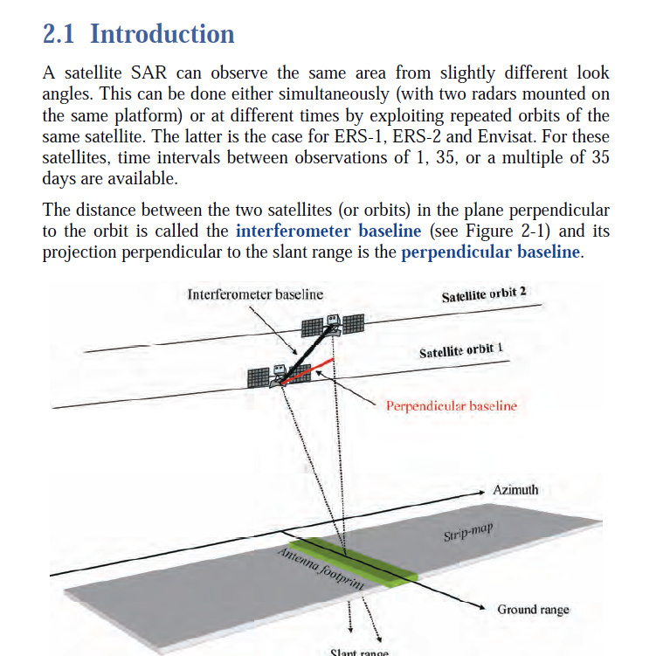

Slant range

**Figure SM2.1.** Geometry of a satellite interferometric SAR system. The orbit separation is called the interferometer baseline, and its projection perpendicular to the slant range direction is one of the key parameters of SAR interferometry (Ferretti et al., 2007).

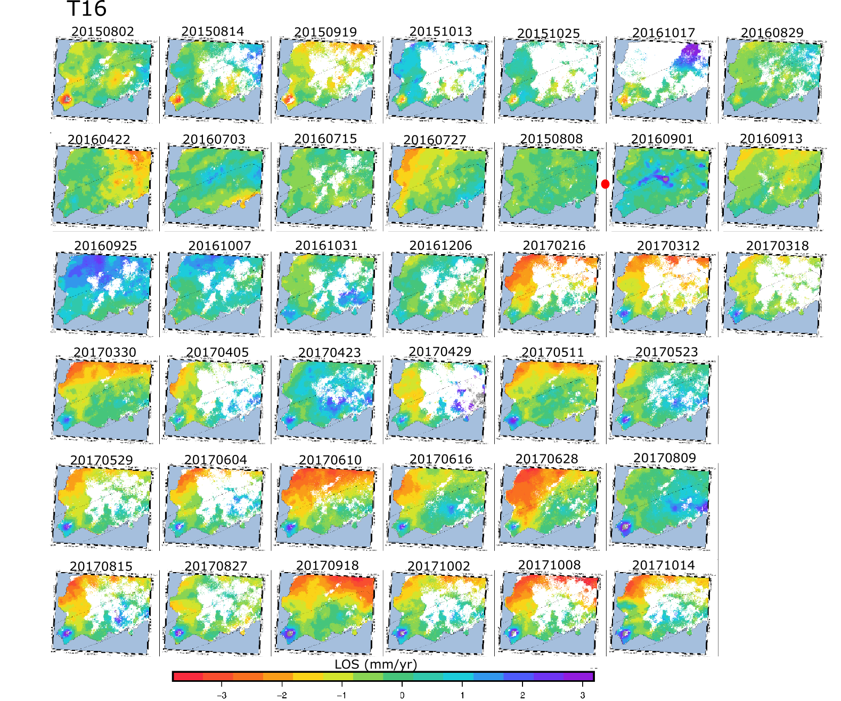

**Figure SM2.2**. Interferograms from the T16 time series analysis reported in Table SM2.1. The temporal evolution is displayed line by line, from the left to the right (the last 20160820-20171014 interferogram corresponds to the image on the last line, sixth column). The same color scale is used for all the images. The red point indicates the location of the Master image (20160820).

**Table SM2.2.** Track 155 (T155) interferograms used in the time series analysis, with the corresponding temporal baseline (time spanned by the interfergram), the perpendicular baseline and the calculated altitude of ambiguity (Equation 3.6), displayed in Fig. 3.8b.

|  |  |  |  |
| --- | --- | --- | --- |
| Image Pair | Temporal baseline (days) | Perpendicular Baseline (m) | Altitude of Ambiguity (m) |
| 20160830-20150402 | 468 | -72 | 546 |
| 20160830-20150426 | 492 | 44 | -888 |
| 20160830-20150520 | 468 | -37 | 1073 |
| 20160830-20150613 | 444 | -100 | 392 |
| 20160830-20150625 | 432 | -24 | 1651 |
| 20160830-20150707 | 420 | 64 | -619 |
| 20160830-20150719 | 408 | -63 | 626 |
| 20160830-20150824 | 372 | -34 | 1158 |
| 20160830-20150917 | 348 | -13 | 3045 |
| 20160830-20160701 | 60 | -72 | 551 |
| 20160830-20160713 | 48 | 56 | -708 |
| 20160830-20160725 | 36 | 16 | -2454 |
| 20160830-20160806 | 24 | -79 | 498 |
| 20160830-20160818 | 12 | -117 | 338 |
| 20160830-20160911 | 12 | 29 | -1352 |
| 20160830-20160923 | 24 | -16 | 2473 |
| 20160830-20161110 | 72 | 24 | -1632 |
| 20160830-20161122 | 84 | -1 | 28511 |
| 20160830-20170328 | 210 | -112 | 352 |
| 20160830-20170403 | 216 | 40 | -981 |
| 20160830-20170409 | 222 | -62 | 633 |
| 20160830-20170415 | 228 | -12 | 3174 |
| 20160830-20170427 | 240 | -80 | 494 |
| 20160830-20170509 | 252 | -100 | 394 |
| 20160830-20170521 | 264 | -34 | 1145 |
| 20160830-20170527 | 270 | -21 | 1873 |
| 20160830-20170602 | 276 | 55 | -713 |
| 20160830-20170614 | 288 | -7 | 5936 |
| 20160830-20170620 | 294 | -21 | 1900 |
| 20160830-20170626 | 300 | -78 | 506 |
| 20160830-20170702 | 306 | 34 | -1163 |
| 20160830-20170708 | 312 | -77 | 514 |
| 20160830-20170714 | 318 | -13 | 3153 |
| 20160830-20170720 | 324 | 4 | -9458 |
| 20160830-20170726 | 330 | 8 | -4693 |
| 20160830-20170801 | 336 | -24 | 1644 |
| 20160830-20170813 | 348 | 20 | -2004 |
| 20160830-20170825 | 360 | -67 | 593 |
| 20160830-20170906 | 372 | -72 | 545 |
| 20160830-20170912 | 378 | 17 | -2317 |

*(Continued)*

**Table SM2.2.** T155 interferograms used in the time series analysis, with the corresponding temporal and perpendicular baseline and the calculated altitude of ambiguity (Continued).

|  |  |  |  |
| --- | --- | --- | --- |
| Image Pair | Temporal baseline (days) | Perpendicular Baseline (m) | Altitude ambiguity (m) |
| 20160830-20170918 | 384 | -85 | 461 |
| 20160830-20170930 | 396 | 23 | -1660 |
| 20160830-20171012 | 408 | 42 | -957 |
| 20160830-20171018 | 414 | -73 | 544 |
| 20160830-20171024 | 420 | -51 | 777 |
| 20160830-20171030 | 426 | -23 | 1729 |

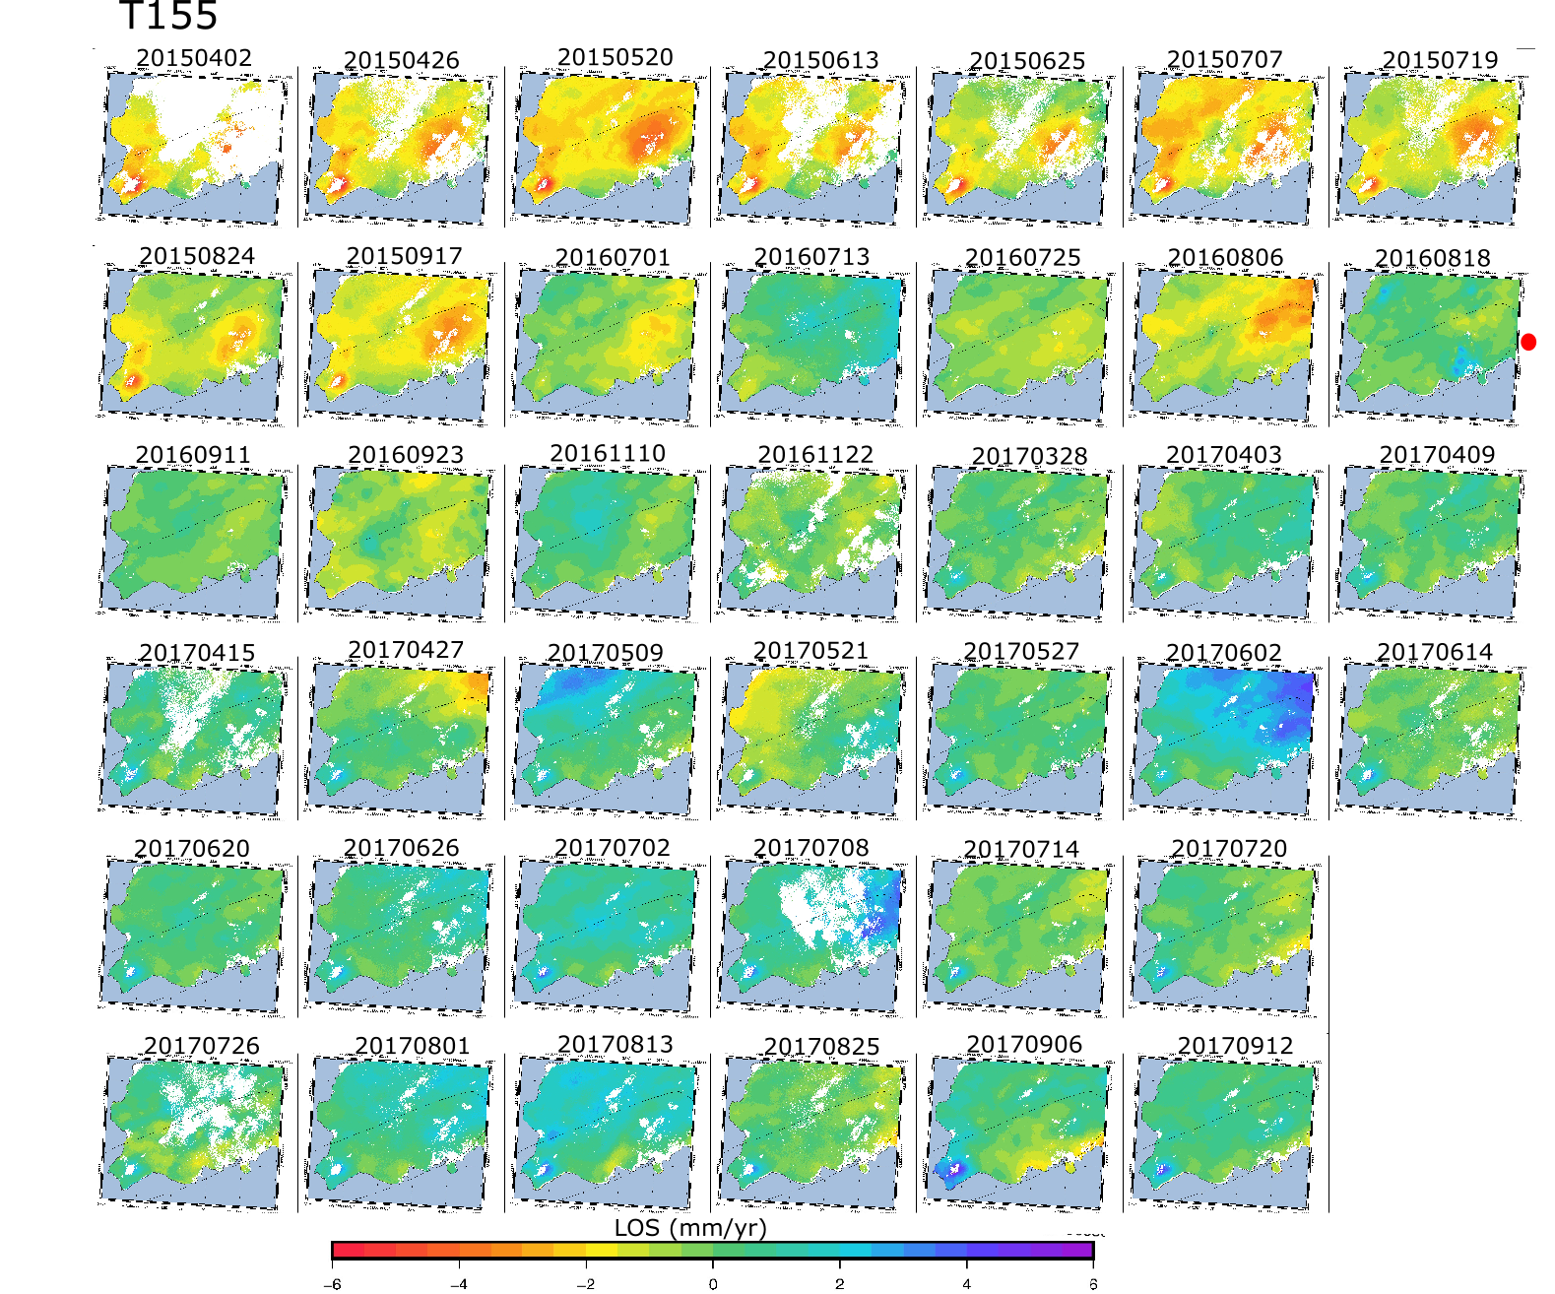

**Figure SM2.3.** Interferograms from the T155 time series analysis reported in Table SM2.2. The temporal evolution is displayed line by line (the last 20160830-20171030 interferogram corresponds to the image on the last line, sixth column). The same color scale is used for all the images. The red point indicates the location of the Master image (20160830).

#### **SM3. Data quality analysis**

Interferograms contain spatially correlated random noise due to atmospheric disturbance that can be expressed by autocorrelation functions (Mosegaard & Tarantola, 2002). The GBIS v1.0 ©2017 Marco Bagnardi considers such a function in an exponential form, used to determine the parameters of the semi-variogram of each data set before performing the Bayesian inversion:

$C\left(r\right)= σ_{d}^{2}e^{-\frac{r}{a}}$ (SM3.1)

Where $C\left(r\right)$ is the correlation factor for a certain distance *r* between two data points (spatial lag), $σ_{d}^{2}$ the variance of the noise (sill) and $a$ the correlation length (range). This function indicates that the noise of two data points separated by a distance higher than the correlation length is almost uncorrelated, assuming that errors in the data are drawn from a zero-mean Gaussian distribution. The sill corresponds to the value that the semi-variogram reaches at the range (when the function flattens). At *r* = 0, the variance of the data is expected to be 0, but due to measurement errors or noise, it is often not the case and an offset called *nugget* is generally observed at the origin of the semi-variogram. GBIS was used to calculate automatically the spatially correlated noise (*i.e.* atmospheric noise) by inserting a mask on the Reykjanes area, where the deformation of interest occurs (thereby analyzing only data outside the area of deformation). The parameters of the semi-variograms estimated for the ascending and descending two-year stacked interferograms are summarized in Table SM3.1 and those obtained for the average LOS velocity maps deduced from the time series analysis are summarized in Table SM3.2. From the variances, we inferred an accuracy of the displacement estimates in the order of 6 ×10-3 mm.

**Table SM3.1**. Parameters of the semi-variogram for the T16 and T155 cumulative phase change in range obtained from the two-year stacked interferograms. In these interferograms, all the pixels are considered.

|  |  |  |
| --- | --- | --- |
|  | T16 | T155 |
| Data variance (rad²) | 2 × 10-6 | 1 × 10-6 |
| Range (m) | 1480 | 1570 |
| Nugget (rad²) | 1.5 × 10-8 | 1.6 × 10-7 |

***Table SM3.2.*** *Parameters of the semi-variogram for the T16 and T155 average phase change in range derived from time series analysis. Only pixels with coherence > 0.3 are considered. Lower phase variance compared to data in Table SM3.1 is interpreted as a result of the removal of the pixel with low coherence (better phase accuracy).*

|  |  |  |
| --- | --- | --- |
|  | T16 | T155 |
| Data variance (rad²) | 7 × 10-7 | 4 × 10-7 |
| Range (m) | 1540 | 1550 |
| Nugget (rad²) | 4.6 × 10-8 | 6.5 × 10-8 |

#### **SM4. Modeling results for the inversion of the 2015-2017 cumulative displacement (stacked interferograms) for the single Mogi source, the rectangular Okada layer and for the inversion based on several Mogi sources with a volume change proportional to the extracted/injected mass at each borehole.**

**Table SM4.1**. Summary of the inversion models from the two-year cumulative LOS displacement from the approach of Drouin et al. (2017) and using GBIS. See Table 4.1 for comparison with results from inversion based on average LOS velocities from time series analysis of interferograms.

|  |  |  |  |  |
| --- | --- | --- | --- | --- |
|  | Mogi (Drouin *et al.*, 2017) | Mogi (GBIS) | Okada (Drouin *et al.*, 2017) | PSC (GBIS) |
| **Longitude** | $$-22,687$$ $$[-22.690;$$ $$-22.684]$$ | $$-22,685$$ $$\left[\begin{aligned}-22,686; \\ -22,684\end{aligned}\right]$$ | $$-22,70$$ $$[-22.70;$$ $$-22.697]$$ | $$-22,686$$ $$\left[\begin{aligned}-22,688; \\ -22,684\end{aligned}\right]$$ |
| **Latitude** | $$63,823$$ $$\left[63.821;63.824\right]$$ | $$63,823$$ $$\left[63,821;63.824\right]$$ | $$63,820$$ $$[63.819;63.821]$$ | $$63,821$$ $$\left[63.820;63.822\right]$$ |
| **Depth (m)** | $$968$$ $$\left[908;1242\right]$$ | $$961$$ $$\left[916;1037\right]$$ | $$1249$$ $$\left[1135;1370\right]$$ | $$1212$$ $$\left[1117; 1286\right]$$ |
| **Volume change (m)** | $$-1.68×{10}^{5}$$ $$\left[\begin{aligned}-2.11×{10}^{5} ; \\ -1.51×{10}^{5}\end{aligned}\right]$$ | $$-1.62×{10}^{5}$$ $$\left[\begin{aligned}-1.9 ×{10}^{5}; \\ -1.5×{10}^{5}\end{aligned}\right]$$ |  |  |
| **Radius (m)** |  |  |  | $$419$$ $$\left[408,554\right]$$ |
| **DP/mu** |  |  |  | $$-9.55×{10}^{-4}$$ $$\left[\begin{aligned}-8.2×{10}^{-4}; \\ -9.9×{10}^{-4}\end{aligned}\right]$$ |
| **Length (m)** |  |  | $$1371 [1227;1452]$$ |  |
| **Width (m)** |  |  | $$329 \left[300 ;466\right]$$ |  |
| **Strike °)** |  |  | $$53$$ |  |
| **Dip (°)** |  |  | 0 |  |
| **Opening (m)** |  |  | $$-0.39$$ $$[-0.44; -0.27]$$ |  |
| **Global WRMS** | $$3.56×{10}^{-3}$$ |  | $$3.49×{10}^{-3}$$ |  |
| **Global Chi² $χ_{v}^{2}$** | $$5.66×{10}^{6}$$ |  | $$5.44×{10}^{6}$$ |  |

We note that the improvement in error of the Okada model relatively to the model using a point pressure source is not as clear as when using the average velocities from the time series analysis (Table 4.1), containing only the most coherent data points.

In general, a model containing more parameters will fit better the data and generate less residual (difference between the modeled values for a specific set of model parameters and the data) than simpler models. The significance of the improvement in errors of a more complicated model can be evaluated using F-tests (Menke, 2012). This test requires considering the initial variance of the data noise (presented in Supplementary Material SM3) as well as the variance of the prediction error (difference between the true and estimated data for a set of model parameters). As this value also includes a contribution for a potential poor fit of the model, it is generally higher than the true variance of the data.

The attempt to perform F-test analysis on all the best fitting models using the different data set has not been conclusive due to difficulties to access the residual values from the inversion using GBIS. Further work could be dedicated to the analysis of the improvement in errors offered by all the different modeling approaches used in this study.

#### Single Mogi source modeled using GBIS: Data (Fig. SM4.1), data, model and residuals (Fig. SM4.2) and corresponding histograms of samples from the posterior distributions of the model parameters (Fig. SM4.3). The results are summarized together with other inversion results in Table SM4.1.

The input files correspond to the ascending and descending cumulative displacements (total LOS change in range in radians) obtained from the two-year stacked interferograms. Given the high number of data points in the original interferograms, the InSAR data have been sub-sampled into a larger grid using a Quadtree approach integrated to GBIS, in order to reduce the modeling computational time (Bagnardi & Hooper, 2017). This approach consists in averaging neighbor data points within squares until their variance reaches a pre-set threshold variance. In GBIS, this threshold was set to $9×{10}^{-6}$ rad² for the ascending Track 16 and $1.6×{10}^{-5}$ rad² for the descending Track 155 stacked inputs, resulting in 224 observations for Track 16 and 130 observations for Track 15.

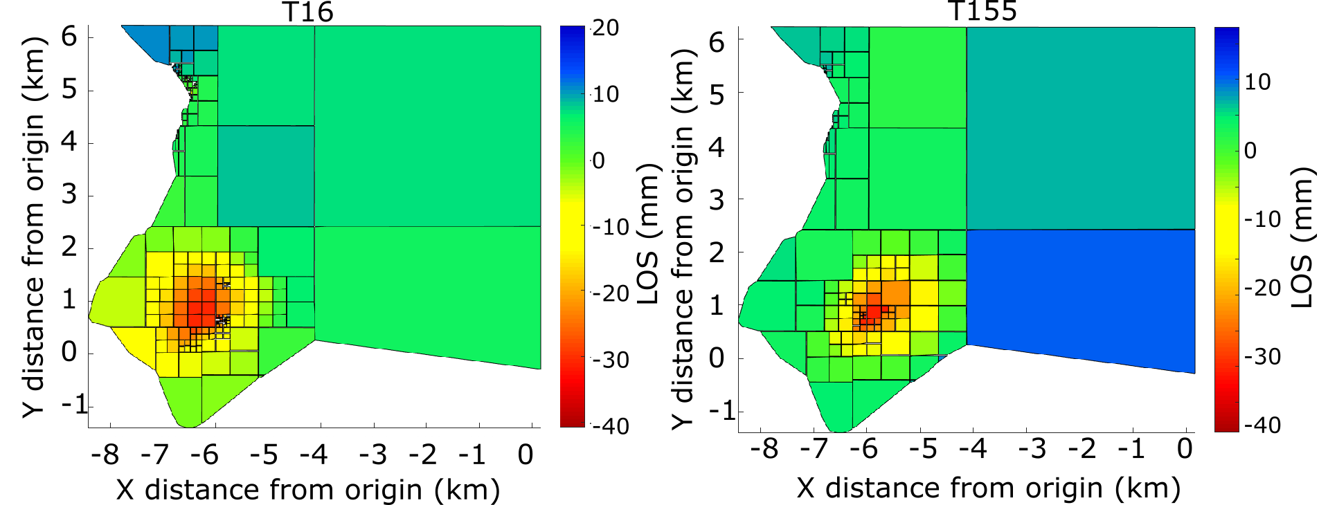

**Figure SM4.1.** Quadtree sub-sampling of the T16 (left) and T155 (right) data using an algorithm integrated to GBIS, resulting in 224 observations for T16 and 130 observations for T155 within a box of coordinates [-22.74°E; -22.50°E; 63.79°N; 63.90°N].

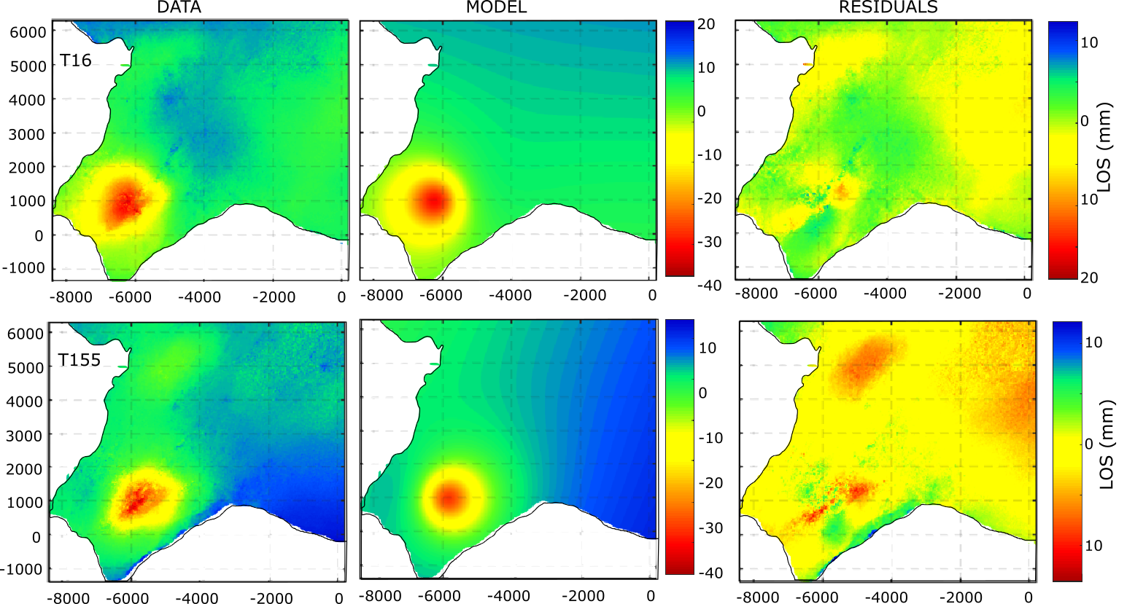

**Figure SM4.2.** Unwrapped data, model and residuals for the T16 and T155 datasets for the best fitting Mogi source calculated from GBIS. The first column corresponds to the data at the initial resolution (before sub-sampling shown in Fig. SM4.1). The model is the one that best fits observations (Fig. SM4.3). Residuals indicate the difference between the data and the model. Results are displayed relatively to a point situated at the position of coordinates (-22.564°E; 63.814°N).

|  |  |
| --- | --- |
|  |  |
|  |

**Figure SM4.3.** Histograms showing the posterior distribution of values (blue bars) for all the model parameters of the Mogi source shown in Fig. SM4.2, drawn from 1 milion iterations: X and Y coordinates relative to the reference point of coordinates (-22.564°E; 63.814°N), depth (in meters), and volume change DV (in cubic meter). The orange line indicates the most probable value and the black lines indicate the boundaries of the 95% confidence interval.

#### Single Mogi source obtained using the approach of Drouin *et al.* (2017): Data, model and residuals (Fig. SM4.4) and corresponding histograms of samples from the posterior distributions of the model parameters (Fig. SM4.5). The results are summarized together with other inversion results in Table SM4.1.

The input files correspond to the ascending and descending LOS cumulative displacements (in meters) obtained from the stacked interferograms. Here, we initially cropped the data within a smaller box zoomed over the Reykjanes geothermal field. Thus, the reference point is different from the one used in the other models, and is situated in the north-east of the geothermal field at (-22.650°E; 63.839°N). Moreover, the InSAR data have been sub-sampled into a larger regular grid, consisting in averaging the data points situated within intervals of 0.002° in the east direction and 0.001° in the north direction.

The search for the Mogi model that best fit the data has been performed through a succession of inversions. Following the approach proposed by Drouin *et al.* (2017), we first used a grid search to get an initial guess on the best fitting parameters and determine the order of magnitude of the upper and lower boundary values for each of them. These boundary values were then integrated in successive inversions based on a simulated annealing approach. Using this approach, we first ran 1000 bootstrap inversions to determine the four parameters of the Mogi source. Then, we performed a second series of 1000 bootstrap inversions to define more accurately the latitude and the longitude of the source, by fixing the volume change and the depth. Finally, a third inversion was done by fixing the previously determined latitude and longitude to determine more accurately the volume change and the depth of the source. At each bootstrap inversion, observations are re-sampled randomly within their 1-sigma uncertainties (Drouin *et al.,* 2017). Below are displayed the data, model and residuals obtained after the last inversion, as well as the associated histograms representing the posterior probability distribution for each model parameter.

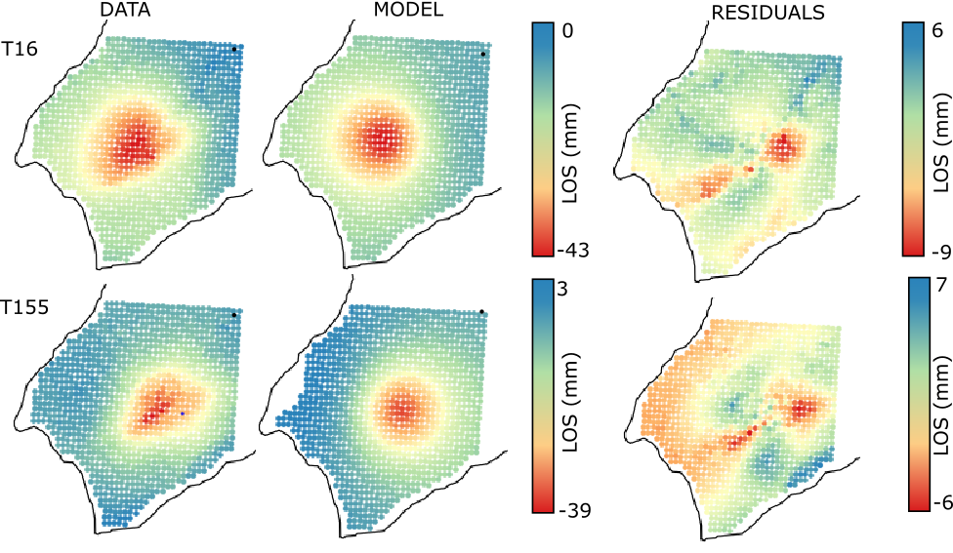

**Figure SM4.4.** Data, model and residuals for the T16 and T155 datasets for the best fitting Mogi source calculated using the approach of Drouin et al. (2017). The data have been sub-sampled into a larger grid with a regular spacing of 0.002° in longitude and 0.001° in latitude, resulting in a total of 1119 observations in each track. The model is the one that best fits observations (Fig. SM4.5). Residuals indicate the difference between the data and the model. Results are displayed relatively to a point situated at (-22.650°E; 63.839°N), in the north-east of the geothermal field (back dot).

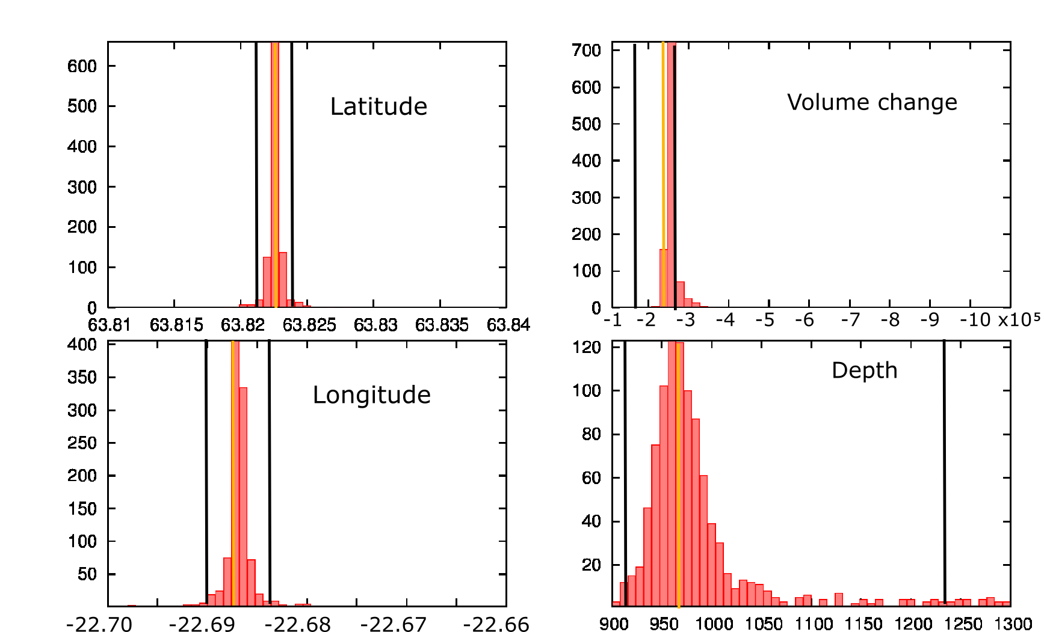

**Figure SM4.5**. Histograms showing the posterior distributions of values (red bars) for all the model parameters of the Mogi source shown in Fig. SM4.4, obtained from 1000 bootstrap inversions: latitude and longitude (decimal degrees), depth and volume change in metric units. The orange lines correspond to the most probable value and the black lines indicate the boundaries of the 95% confidence intervals.

#### Rectangular Okada layer using the approach of Drouin *et al.* (2017): Data, model and residuals (Fig. SM4.6) and corresponding histograms of samples from the posterior distributions of the model parameters (Fig. SM4.7). The results are summarized together with other inversion results in Table SM4.1.

The input files correspond to the ascending and descending LOS cumulative displacements (in meters) obtained from the two-year stacked interferograms. The outline of the data used in the inversion and the data sub-sampling has been done in a similar manner as for the Mogi source described above. As previously described, we performed the inversions in several steps. First, a grid inversion was run to get a first estimate of the model parameters, assuming that the dip and the shear slip parameters of the source, only appropriate when modeling fault dislocations, are equal to 0. We constrained the inversions by fixing the strike to 53°. Two successive set of inversions consisting of 1000 bootstrap inversions were then performed using the simulated annealing algorithm with a Chi-square estimator (Chi²). In the first series of inversions, we kept free only the latitude, longitude and strike parameters to determine precisely the location of the source. In the second inversion, we fixed those parameters to determine more precisely the length, width and opening of the source.



**Figure SM4.6.** Data, model and residuals for the T16 and T155 datasets for the best fitting rectangular Okada layer calculated using the approach of Drouin et al. (2017). The data have been sub-sampled into a larger grid with a regular spacing of 0.002° in longitude and 0.001° in latitude to reduce the computational time, resulting in a total of 1119 observations for each track. The model is the one that best fits observations (Fig. SM4.7). Residuals indicate the difference between the data and the model. Results are displayed relatively to a point (black dot) situated at the position of coordinates (-22.650°E; 63.839°N).

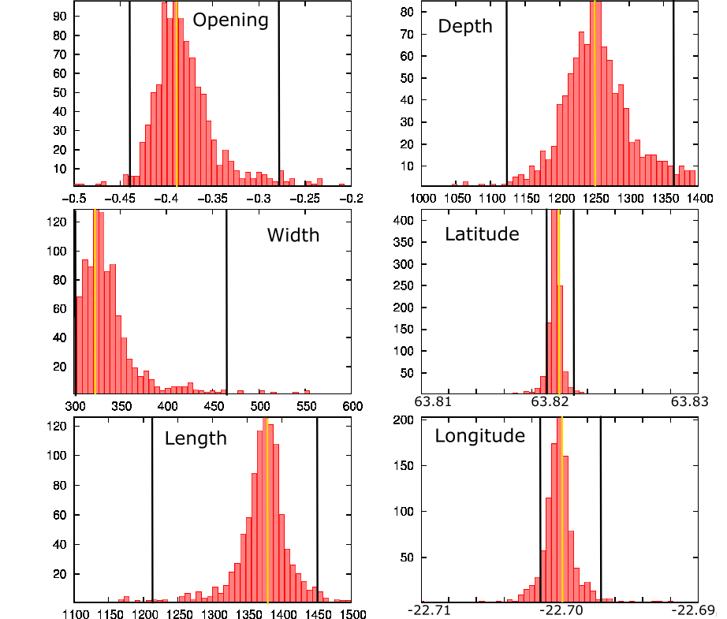

**Figure SM4.7.** Histograms showing the posterior distributions of values (red bars) for the model parameters of the rectangular Okada layer shown in Fig. SM4.6, obtained from 1000 bootstrap inversions: latitude and longitude in decimal degrees, depth, width, length and opening rate in metric units. The strike has been fixed to 53° and the dip and dislocations have been set to zero during the inversion. The orange lines correspond to the most probable value and the black lines indicate the boundaries of the 95% confidence intervals.

#### Penny shaped crack obtained from GBIS: Data (Fig. SM4.8), data, model and residuals (Fig. SM4.9) and corresponding histograms of samples from the posterior distributions of the model parameters (Fig. SM4.10). The results are summarized together with other inversion results in Table SM4.1.

The input files correspond to the ascending T16 and descending T155 LOS cumulative displacements (change in range in radians) obtained from the stacked interferograms. The data have been subsampled using the Quadtree algorithm integrated to GBIS, based on the same sub-sampling threshold variances of $9×{10}^{-6}$ rad² for T16 and $1.6×{10}^{-5}$ rad² for T155 as for the Mogi source (Fig. SM4.1). The region of interest has been cut in the north of the Reykjanes area as a result of the important computational time for the inversions using the same area as in the Mogi model (Fig. SM4.1). This cropping allowed reducing the number of data point down to 166 for Track 16 and 182 for Track 155, without increasing the threshold variance of the subsampling, which would have decreased the number of observation in the area of maximum deformation.

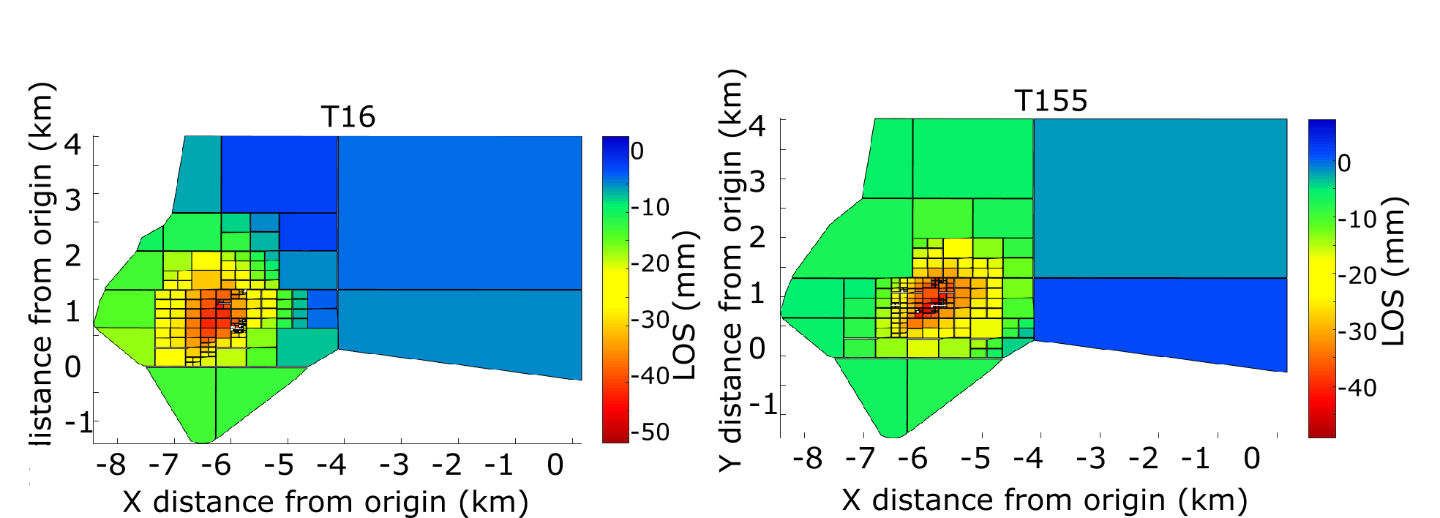

**Figure SM4.8.** Quadtree sub-sampling of the T16 (left) and T155 (right) data using an algorithm integrated to GBIS. After Quadtree sub-sampling, the T16 and T155 input data contains 166 and 182 observations, respectively, within a box of coordinates [-22.74°E; -22.56°E; 63.85°N; 63.80°N].

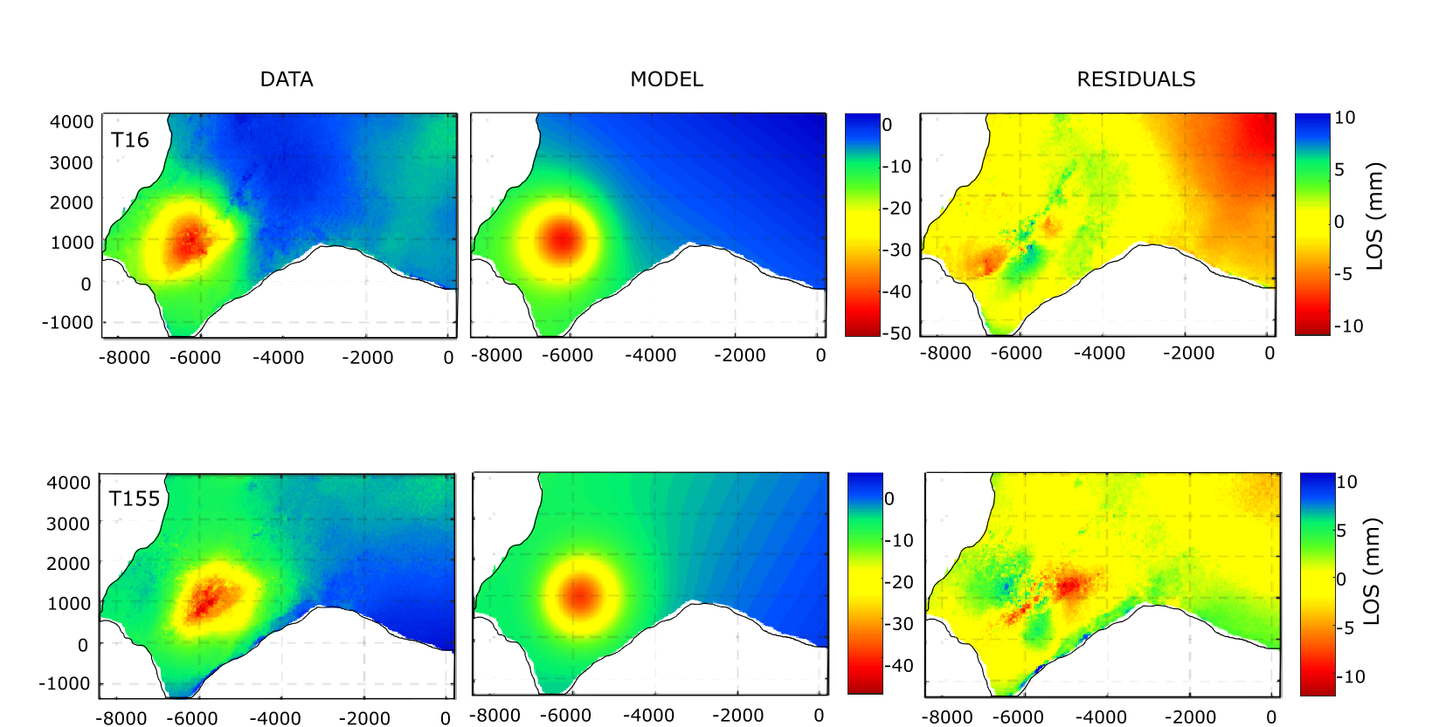

**Figure SM4.9.** Unwrapped data, model and residuals for both T16 and T155 datasets for the best fitting Penny shaped crack model calculated from GBIS. The first column corresponds to the data at the initial resolution (before sub-sampling shown in Fig. SM4.8). The model is the one that best fits observations (Fig. SM4.10). Residuals indicate the difference between the data and the model. Results are displayed relatively to a point situated at (-22.564°E; 63.814°N).

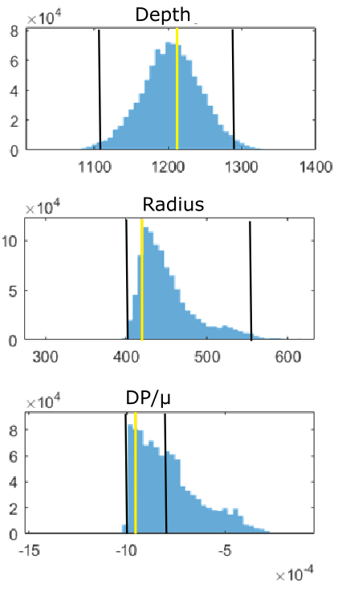

**Figure SM4.10.** Histograms showing the posterior distribution of values (blue bars) for the model parameters of the Penny shaped crack shown in Fig. SM4.9, drawn from 1 milion iterations: radius, ratio DP/µ and depth. As the latitude and longitude have been fixed during the second inversion, the histograms representing their posterior probability distributions are erased by the software to construct new histograms during the last run. The orange lines correspond to the most probable value and the black lines indicate the boundaries of the 95% confidence intervals.

#### Mogi sources based on the production/injection data using the approach of Drouin *et al.* (2017).

The input files correspond to the ascending and descending LOS cumulative displacements (in meters) obtained from the stacked interferograms. After regular grid sub-sampling, the T16 and T155 input data contains 1119 observations each.

In this approach, we want to relate the cumulative surface displacement observed in 2015-2017 obtained from the two-year stacked interferograms to the mass of fluid extracted/ injected in the geothermal reservoir. The best model (the one that minimizes the Chi²) is defined through a series a forward model ran automatically thanks to a set of configuration files (see Appendix A, last paragraphs, for more details).

We first created a set of configuration files based on the mass production rate of 17 wells in 2016, scaled up to approximate the total extracted mass over the two years of the study, in accordance with the input data (732 days). In a second set of configuration files, we added the estimated total reinjected mass into 5 wells. Comparing the results from both approaches, we found that the model with the lowest Chi² value was obtained when considering that no injection is performed in the system. For the models considering extraction only, the best fit (Chi² = 1.98 × 107) was obtained for sources at 1000 m depth and a production factor of 0.006. Fig. SM4.11 displays the data, model and residuals for this model.

All the models based in the extraction/injection rates in the geothermal wells initially used the coordinates of the wells at the wellhead to locate the Mogi sources. To take into account the fact that most of the wells are deviated, we ran a new time the set of forward models based on extraction only, using the coordinates of the boreholes at 1100 m depth. However, no improvement in the Chi² value was obtained, indicating that the location of the wells do not impact the deformation in the considered time interval. Moreover, the general poor fit of these models (high residuals) relatively those considering single sources, in spite of the considerably higher number of model parameters (a scaling factor and depth parameter for each of the 17 or 22 sources), were interpreted as the fact that the production and injection rates are not responsible for the deformation in this period of time, in opposition to the results from the study at Krafla (Drouin *et al.,* 2017).

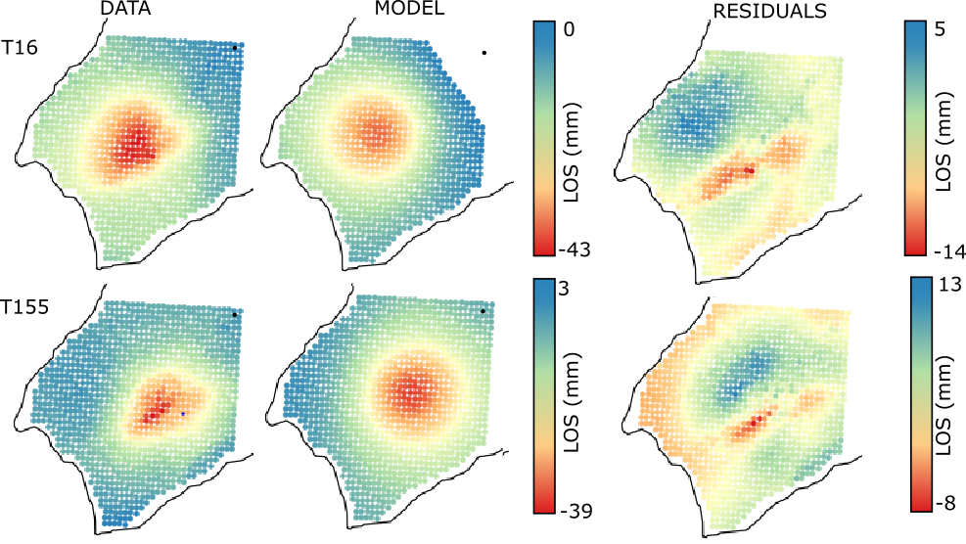

**Figure SM4.11.** Data, model and residuals for the T16 and T155 datasets for 22 Mogi sources with volume change proportional to the mass production/extraction at each borehole, calculated from the approach of Drouin et al. (2017). The data have been sub-sampled into a larger grid with a regular spacing of 0.002° in longitude and 0.001° in latitude to reduce the computational time, resulting in a total of 1119 observations for each track. This modeling approach consists in solving for a succession of forward model and thus no posterior probability function are drawn. The model is the one that best fits observations. Results are displayed relatively to the point of coordinates (-22.650°E; 63.839°N) in the north-east of the geothermal field (black dot).

#### **SM5. Additional analysis on the relation between production and deformation processes**

In order to understand the inferred continuous subsidence despite the increase in pressure at 1600 m depth in the 2015-2017 period, considering also the suggestion that expansion of a steam cap occurred during the three first years of production and not thereafter, we initiated additional analysis of the relation between the modeled volumetric deformation rates and the production, pressure and temperature changes. We divided the processes into two parts, those likely to create a loss of volume within the reservoir and those responsible for volume gain (Table SM5.1).

**Table SM5.1.** Summary of the processes occuring in the reservoir for each time period of the deformation studies

|  |  |  |
| --- | --- | --- |
|  | Volume loss | Volume gain |
| 2006-2008 | Decrease in water level and compaction of the deep unconsolidated basaltic formations (Reinsch *et al*., 2016) in the area of major pressure drop. Liquid and two-phase compressibility | Increase in steam production – mixed phase system |
|  |
| 2009-2015  &  2015-2017 | Compaction due to pressure decrease in the liquid/steam zones under fluid extraction. Liquid, steam and two-phase compressibility  Thermal contraction of the shallower rocks due to cooling within or from above a steam zone | Condensation of steam (water re-saturation) |

Subsidence above groundwater reservoirs is often attributed to the increase in effective stress $σ_{e}$ caused by water level / pore-pressure decline $p_{w}$ relatively to an overburden or total load $σ_{T}$, and the compaction of unconsolidated water-bearing deposits, defined as:

$σ_{e}=σ_{T}-p_{w}$ (SM5.1)

In general, it is proportional to the general pressure decline in the field, and mainly depends on the production rate, on the natural properties of the reservoir (i.e. size, permeability, porosity, storage capacity, the rock and pore-fluid compressibility) as well as the existence of natural or artificial recharge (Mossop & Segall, 1997; Axelsson, 2012a).

Analysis of rock properties and especially permeability changes under increase in effective stresses have been done in laboratory on Reykjanes rock samples, as part as the IMAGE project (Fig. SM5.1). The results, developed in section 4.4.1, allowed concluding that high permeability can be expected in volcanoclastic rocks, even at high effective pressure (until 4-5 km depth) where magmatic intrusions and dolerites would mainly constitute flow barriers. Thus, high permeability contrasts can exists in the deep part of geothermal system where the weight of the overburden exerts high pressures, with hyaloclastite having permeability around 10-15 and 10-16 m2 and dolerites and basalt having a permeability of about 10-18 to 10-19 m2.

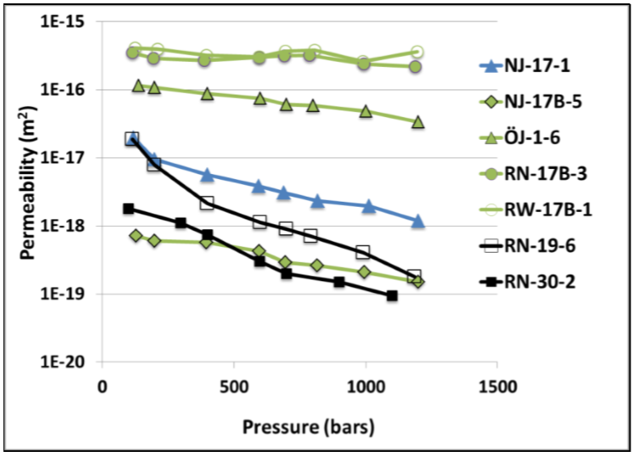

**Figure SM5.1.** Comparison of the effect of effective pressure on the permeability of different types of samples in Iceland. The black lines correspond to permeability decrease in dolerite samples from well RN-19 and RN-30 at Reykjanes (see Table B2, in Appendix B to the manuscript in preparation for submission to Geophysical Journal International). The green lines correspond to analysis on hyaloclastites samples from Reykjanes (RN-17B-3, RW-17B-1), Ölkelduhals (OJ-1-6) and Nesjavellir (NJ-17B-5) in the Hengill area and the blue corresponds to basalt (sample NJ-17-1 from Nesjavellir). Hyaloclastites exhibit the lowest effect, while effects are stronger on dolerites (Reinsch et al., 2016).

Heating of volcanic rock is moreover expected to increase the ductile behavior and enhance the closing of pores and cracks, especially for basalts and dolerites. A strong and rapid irreversible decrease in permeability with increasing temperature was indeed observed in basalts, especially at high effective pressure (Fig. SM5.2b). However, thermal cracking in low-porosity rock might also be induced by cooling even at high pressure. This has been observed in dolerites for temperature between 200 and 300°C (Fig. SM5.2c & Fig. SM5.2d) (Reinsch *et al*., 2016).

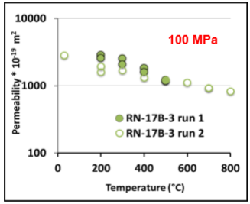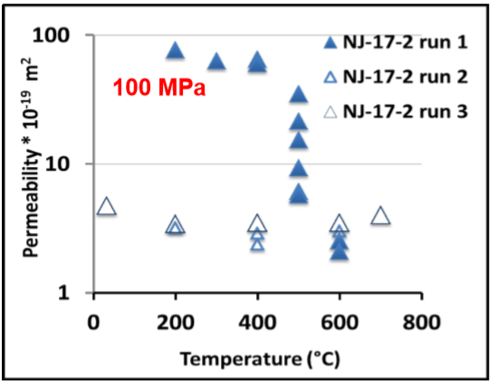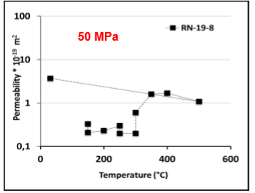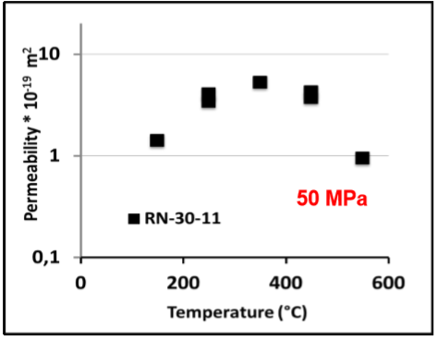

d)

c)

a)

b)

**Figure SM5.2**. Effect of temperature on the permeability of a) hyaloclastite and c,d) dolerites from Reykjanes samples and on the permeability of b) basalts from Nesjavellir samples, for different effective pressures indicated in red. For a given run, measurements are performed from low to high temperature. Two to three successive heating runs were usually performed on the samples in order to characterize irreversible changes within the samples during heating (Reinsch et al., 2016)

Those results would support the possibility of irreversible compaction in the system, resulting from pressure drop that would have had increased the effective stresses, especially below 1000 m depth where basalts and dolerites are dominant.

We here make an attempt to i) estimate the amount of natural recharge to the system given the known production rates (Fig. SM5.3), and ii) evaluate the cooling of rock that would be induced due to inflow of cold water, to then estimate the steam that need to condense to provide the system with necessary heat. A set of equations will be used to derive these estimations, aiming to address the issues related to volume change within the reservoir in relation to complex processes resulting from production (i.e. compaction, steam formation and condensation, recharge). The objective is to explain the proposed hypothesis used to describe the reservoir volume change and the deformation observed at Reykjanes since 2006, or disprove this hypothesis.

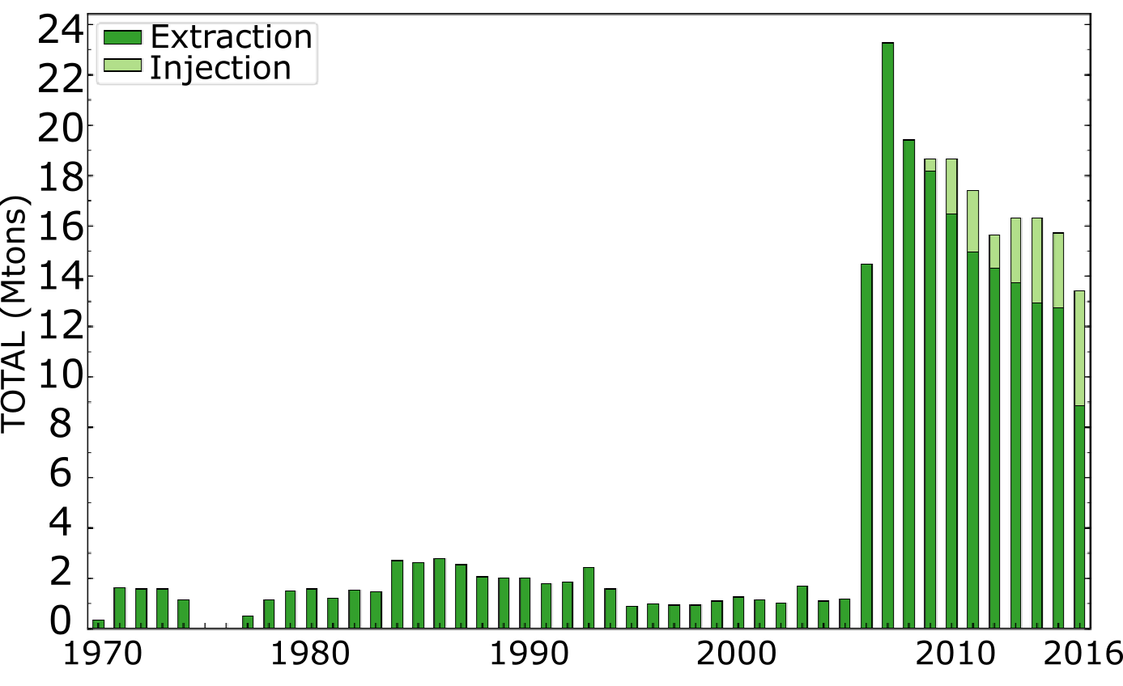

**Figure SM5.3.** Extraction and injection rates between 1970 and 2016 (mofified from Thorvaldsson & Arnaldsson, 2017)

#### Estimation of the recharge during 2005-2008 and 2009-2017

We mentioned in section 4.4.3 the relation between pressure change and change in the water level. Using the pressure drawdown in the initial years of production of -2.9 MPa (June 2005- May 2008), we estimated a decline in the water level of about 400 m. The pressure drop of 0.7 MPa at 1625 m b.s.l between April 2009 and August 2015 would lead, using Equation 4.7, to an additional drawdown of 100 m, therefore cumulating to about 500 m. The amount of drawdown ∆*d* in a porous media of porosity *φ* and areal extent *A* is ∆d=V/Aφ, with *V* the change in the volume of fluid in the reservoir. We can then use Equation SM5.2 to relate the expected drawdown to the volumetric production $Q_{p}$ and recharge rate (m3/s) for a period of time *t* (G. Gunnarsson, Orkuveita Reykjavíkur, personal communication, 2017):

(SM5.2)

(m3/s) can be estimated from the ratio of the known average mass extraction rate $m_{p}$ during the considered time period (kg/s) over the average fluid density (kg/m3). The volumetric recharge rate $Q_{r}$ corresponds to the ratio of the recharged mass over the density of the inflowing fluid. *A* is the areal reservoir extent (A=1.9 km²), $φ$ the average porosity of the reservoir ( $φ=15\%)$ and *t* the time spanned during each time period (Table SM5.2). The average fluid density is estimated using the steam fraction *X* in the reservoir (Appendix C)and the water and steam densities $ρ_{w}$ and $ρ_{s}$ at a temperature of 210°C (Ravazdezh, 2015), which is the estimated temperature at the separator of the power plant, where the extracted mass and fluid enthalpy are measured (Table C1). We assume that the inflowing cold water has a density of about 907 kg/m3 (T°=160°C).

(SM5.3)

**Table SM5.2.** Summary of the production data for the period 2005-2016 (Þorvaldsson & Arnaldsson, 2017). The estimation of the steam fraction for each time period is also calculated in this Appendix C to the manuscript.

|  |  |  |  |  |  |
| --- | --- | --- | --- | --- | --- |
|  | Steam fraction X (%) | Average mass production rate $m_{p}$ (kg/s) | Average fluid density at wellhead (kg/m3) | Average mass injection rate $m_{i}$ (kg/s) | Assumed natural recharge $m_{n}$ (%) |
| 2005-2008 | 20 | 462 | 679 | - | 50 |
| 2009-2015 | 30 | 538 | 586 | 70 | 50 |
| 2009-2016 | 30 | 524 | - | 80 | 50 |

During the period 2009-2015, the recharge $m_{r}$ is the sum of a natural recharge $m_{n}$ and re-injection $m_{i}$. Assuming that natural recharge represents 50% of the mass extracted for both time periods, we find using Equation SM5.2 that a production rate of 462 and 538 kg/s would induce a total drawdown of 140 and 380 m for the period 2005-2008 and 2009-2015, respectively, cumulating to 520 m, which is in the order of magnitude of the total drawdown estimated from the total pressure drop. The inferred natural recharge rate is thus approximately 250 kg/s.

#### Estimation of cooling

Geothermal reservoirs are likely to cool down with time, as a result of induced natural recharge of cold fluid or reinjection. According to Ali *et al*. (2016), the energy lost by the reservoir rock $E_{r}$ is equal to the energy gained by the fluid $E_{f}$, with

$E_{r}=m_{r}β_{r}{∆T}_{r}=ρ_{r}β_{r}V_{r}{∆T}_{r}$ (SM5.4)

$E_{f}=m_{f}β_{f}{∆T}_{f}=m_{p}β_{p}T_{p}-m_{i}β_{i}T_{i}$ (SM5.5)

where $m_{r}$ and $m_{f}$ are the mass of rock and fluid, respectively, $V_{r}$ the volume of rock, $β$ the heat capacity, ${∆T}_{r}$ the temperature change of the rock and ${∆T}_{f}$ the difference of temperature between the produced and inflowing fluid. The subscript *p* refers to the produced fluid (generally two-phase) and *i* to the injected/recharge liquid water.

When boiling conditions are reached in a system as a result of pressure drop, steam can be formed. The release of latent heat necessary to vaporize the steam can be at the origin of cooling of the host rock. These conditions can be found in the uppermost part of the central region of the reservoir, where the pressure and temperature follow the boiling point curve. The fluid vaporized gains temperature through a transfer of heat from the rock to the fluid and expands to replace the fluid withdrawn (Grant & Bixley, 2011).

This process results in a cooling of rock by an amount $E_{s}=Xm_{f}L$ (Drouin *et al*., 2017), where *X* is the steam fraction and *L* the latent heat of vaporization. Thus, the total energy lost by the rock under reinjection and steam vaporization is ${E_{r}=E}_{s}+E_{f}$ resulting in a cooling of rock equal to:

${∆T}_{r}=\frac{\left(m_{p}β_{p}T_{p}-m_{i}β_{i}T_{i}+Xm_{f}L\right)}{β_{r}ρ_{r}V_{r}}$ (SM5.6)

At Reykjanes, temperature profiles indicated the presence of a cold groundwater system surrounding the fumarole field and extending down to the cap rock at 400 m depth (Sigurdsson, 2010). It consists of a thin layer of meteoric water floating on the cold seawater, which infiltrates the porous rock at Reykjanes especially below 1000-1500 m depth. However, no cooling has been observed in the convective zone below 1500 m depth, but only in a 600 m thick layer in the upper part of the system (Khodayar *et al.*, 2016). We therefore consider possible cooling from above through the thermally conductive cap rock and try initially to estimate the time necessary to cool down by 30°C a 600 m thick aquifer by conduction through a cap rock, knowing that such cooling has been observed in 7 years (Fig. 2.8). Then, we tried to estimate the cooling that would be necessary to heat the inflowing water (considering a recharge in the order of 50%) to reservoir temperature.

* Cooling due to conduction through a cap rock

We first want to estimate the total time necessary to cools down by 30 °C the upper part of the reservoir from an initial uniform temperature $T_{R}=270°C$ to $T_{0}=240°C$, if cooling occurs from above or below. We consider a 1-dimensional (1D) layer where a 10°C cold layer is present at y = 0. We assume that the change in temperatures in each 50 m long elements in the vertical direction are only due to conduction of heat between the elements, with the amount of energy transferred $Q_{ij}^{t}$ between the elements *i* and *j* at the time step *t* is

$Q_{ij}^{t}=kA\frac{dT}{dt}=\frac{kA}{d}\left(T_{i}^{t}-T_{j}^{t}\right)$ (SM5.7)

The heat flow out of the element *j* becomes the heat flow in the element $i$ (G. Gunnarsson, Orkuveita Reykjavíkur, personal communication, 2017). Based on the heat diffusion equation,

$<ρβ>V\frac{dT}{dt}=\sum{Q_{ij}^{t}}$ (SM5.8)

where $<ρβ>$ is the volumetric heat capacity of the wet rock (J/m3°C) and *V* the volume of each element, the temperature decrease in the element $i$ at time $t+1$ is (Axelsson, 2012a):

$T_{i}^{t+1}=T_{i}^{t}+\frac{1}{<ρβ>V}\frac{kA}{d}\left(T_{i+1}^{t}-2T_{i}^{t}+T_{i-1}^{t}\right)∆t$ (SM5.9)

With the $ρ=2200 kg/m^{3}$ and $β=1300 J/kgK$ the density and heat capacity of the “wet” rock (average rock and fluid density and heat capacity estimated considering a porosity of 15%), respectively, the reservoir area A = 1.9 km², the thickness of each element *d* = 50 m, *k* = 2.5 W/(K.m) the conductive heat coefficient and $∆t$ the time step (assumed to be 1 year). The inferred cooling of points situated 50, 100 and 300 m away from the cooling zone with time is displayed in Fig. SM5.4.

We find that the decrease in temperature by 30°C of a point situated 200 m away from a 10°C cold aquifer would take about 250 years to be cooled. This is therefore not likely that conduction is responsible for such a rapid cooling of the reservoir.

**Figure SM5.4.** Temperature variation of three points situated at a vertical distance y= 50, 100 and 200 m below a reference point at y = 0. At t<0, the 1D vertical model has a uniform temperature of 270°C. At t>0, cooling is applied at y=0 by setting a temperature of 10°C representing a cold layer above the reservoir. We simulate the cooling due to heat transfer by conduction for y>0 at t>0. The intersection of the horizontal black line with the three curve indicate the time at which the corresponding depth in the 1D layer has reached a temperature of 240 °C.

* Cooling due to cold inflow

We therefore try to estimate the rate of temperature change of the reservoir rockthat would be due to the replacement of a fraction of the mass extracted by cold inflowing water. Here we consider two special situations: i) the heating of groundwater by mining heat from the host reservoir rock without steam generation and ii) all the energy comes from cooling steam in the steam cap. We combine these two results to estimate the proportion of steam that would need to condense to prevent the reservoir below 1500 m from cooling.

We use the average production rate during the period 2009-2016 (Table SM5.2) and the properties in Table SM5.3 to estimate the cooling due to cold recharge. As mentioned earlier, no vaporization of steam is expected to take place in the reservoir during this period of time, as indicated by the decrease in the discharged enthalpy and the partial re-saturation of shallow feed zones (O. Sigurdsson, HS-Orka, personal communication, 2018). Equation SM5.6 is therefore simplified to (see also Im *et al.*, 2017):

$\dot{{∆T}_{r}}=\frac{m_{p}β_{p}T_{p}-m_{i}β_{i}T_{i}}{β_{r}ρ_{r}V_{r}}t$ (SM5.10)

Here $\dot{{∆T}_{r}}$ is the expected rate of cooling of the reservoir rock due to production, $m_{p}$ the average mass extraction rate (Table SM5.2), $m_{i}$ = 340 kg/s the rate of mass recharge (considering both natural and injected mass) and 3.8 km3, the reservoir volume. *T*, $ρ$ and $β$ refer to the temperature, density and heat capacity of the produced fluid (*p*), inflowing fluid (*i*) and rock (*r*), respectively (Table SM5.3). The heat capacity of the produced two-phased fluid is determined using the steam and water properties at an average temperature $T_{p}=$ 240°C (Table C1) and Equation SM5.11 (Axelsson, 2012a), for a steam fraction X = 14% (Appendix C)

$β=β_{w}\left(1-X\right)+β_{s}X$ (SM5.11)

**Table SM5.3:** Rock and fluid properties used for the estimation of cooling due to fluid recharge in the Reykjanes system: inferred density of the unconsolidated volcanoclastic and basaltic rocks (Friðleifsson et al., 2017), assumed heat capacity of basalts (ETB, 2011), and estimated heat capacities of the reservoir two-phase fluid at 250°C and of the inflowing fluid at 160°C (based on Table C1).

|  |  |  |  |
| --- | --- | --- | --- |
|  | Rock | Two-phase fluid | Inflowing fluid |
| Density (kg/m3) | 2500 | - | - |
| Heat capacity $β$ (J/kg.K) | 840 | 4500 (at $T_{p}=240°C$) | 3500 (at $T_{i}=160°C)$ |

Ignoring the effect of steam vaporization in the reservoir, we infer that the total cooling rate of the rock necessary to heat cold inflowing water to the average reservoir temperature is about $\dot{{∆T}_{r}}=$ 1.5°C/yr. However, as mentioned above, no cooling has been observed in the deep part of the system. If all the cooling occurs in the upper part of the system, in a volume corresponding to the steam zone $V_{r}$ = 0.7 – 0.9 km3, about 20% of the reservoir volume), we find $\dot{{∆T}_{r}}=$ 6-8°C/yr, which is comparable or slightly over-estimated compared to the actual measured cooling rate of 4-5°C/yr. Knowing that steam condensation release the latent heat absorbed during vaporization back to the host rock, we suggest estimating the amount of steam that would be required to condense to provide the system with the necessary energy to heat up the inflowing cold water, considering ${E_{r}=E}_{s}$:

${Xm}_{s}L=ρ_{r}β_{r}V_{r}{∆T}_{r}$ (SM5.12)

Using the estimated steam mass $m_{s}$ = 70 Mtons (Appendix C), the latent heat of vaporization $L=$ 1700 kJ/kg, 3.8 km3 and the total expected change in reservoir temperature over 10 years ${∆T}_{r}=1.5$ °C/yr × 10 = 15°C, we get

$X=\frac{ρ_{r}β_{r}V_{r}{∆T}_{r}}{m_{s}*L}=1\%$ (SM5.13)

Condensing 1% of the inferred steam mass would therefore provide the system with sufficient energy to heat up inflowing cold water (160°C) to an average reservoir temperature of 240°C. The existence of steam condensation indicates that cold water recharge in a system would prevent boiling and steam recharge in a steam zone. As no heat is carried up to the surface, both temperature and pressure would decrease in the upper part of the system, which could explain rock compaction/contraction at shallow depth, responsible for the continuation of the subsidence since 2009. In addition, this analysis shows that direct recharge of colder water in the upper part of the system could produce the inferred cooling of the host rock in the steam zone through mining of heat.